Student Guide for [School Name]

Table of Contents
A Student's Guide to Getting Started with “Edulink One” 3
Web Browser Instructions 3
Downloading and Using the App 4
Main Screen 5
Behaviour 6
Behaviour Records Tab 6
Achievement 8
Catering 9
Documents 9
Medical Info 9
Update Information 10
Links 11
Exams 12
Exam Timetable 12
Exam Entries 12
Timetable 13
Account Info 13
Messages 14
Sending a new message 14
Homework 16
Forms 18
SEN 19
Attendance 20
Assessment 21
21
Noticeboard 21
Calendar 22
Manage Your Calendar 22
Clubs 23

A Student's Guide to Getting Started with “Edulink One”
All schools have their own way of working with Edulink One. It is customisable, meaning each school can adapt the product to meet their individual needs. The features covered in this guide are subject to the options your school chooses to use and should be viewed with this in mind. We request that you contact your school directly with any questions you may have.
There are two ways to use Edulink One: through a web browser like Google Chrome or through an app you can download to use on your mobile device. The Edulink One app is available for iOS and Android devices.

Web Browser Instructions
To start, go to https://www.edulinkone.com/ and input your school’s code. This would have been emailed to you when your account was created. Or if you have already signed in, you can use your school’s direct link https://www.edulinkone.com/#!/login?code=YYYY inputting your school’s code in place of YYYY.
If you do not have a direct link, you will need to enter your School ID or Postcode and press Next. Your School ID will have been sent to you by the school. If you forget your username or password, please contact the school.
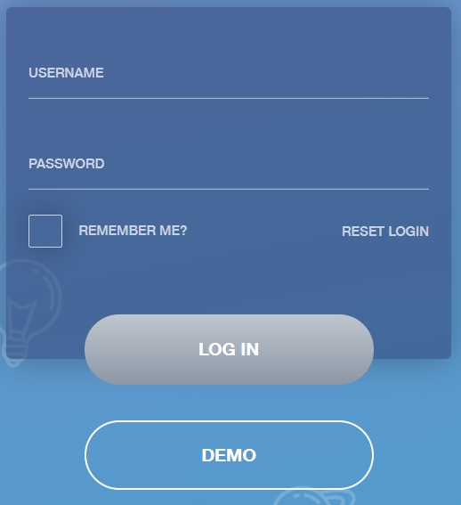
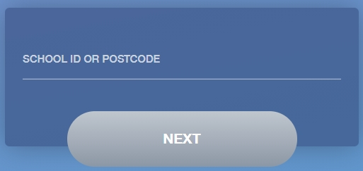
Enter your normal Username and Password that you use for your school computer. If your school uses Google or Microsoft platforms, once you log in to them, you will automatically be taken to Edulink One. Your school will let you know which method you are using to log in.
Some schools will email you a username and password; use these to log in if they have sent you the login details over email. If you have not received an email with your login details, please contact your school to resolve this issue. (Delete where not applicable to your school)
It is important to note that if you are using your school login details to log in to Edulink One (known as LDAP), it is subject to the same rules as your school password. So, if your school password expires when you are on holiday, your Edulink One password will expire as well. Reset your passwords before holidays to avoid issues.
Once you have filled in the username and password boxes with your login details, click LOG IN to get started.

Downloading and Using the App
The Edulink One app is available for iOS and Android devices. You can download from these links or search in the App or Play stores.
Apple App Store
https://itunes.apple.com/gb/app/edulink-one/id1188809029?mt=8&ign-mpt=uo%3D4
Android Google Play
https://play.google.com/store/apps/details?id=com.overnetdata.edulinkone&hl=en
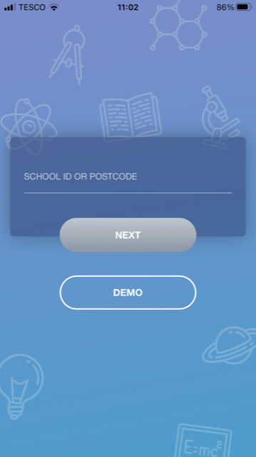
If you are using the mobile app you will see the screen to the left. You must input your School ID or Postcode and click the Next button to continue.
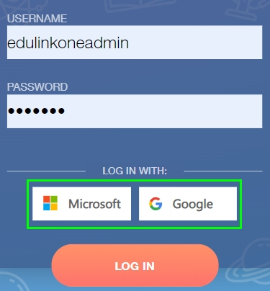
This is followed by the USERNAME and PASSWORD screen where you need to enter the login details your school has sent you. If you are using Google or Microsoft, click the appropriate button on the login page to log in to Edulink One.
Once you have filled in all three boxes with your login details, click LOG IN to get started.
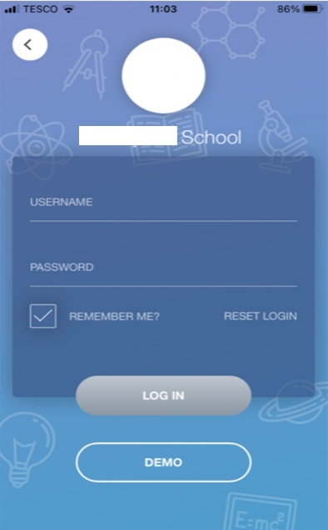
If you forget your username or password, please contact your school

Main Screen
Once logged in, you will see the main screen in Edulink One. You will be able to navigate through the different sections of Edulink One by clicking on the icons, e.g. to view your timetable, click the Timetable icon.
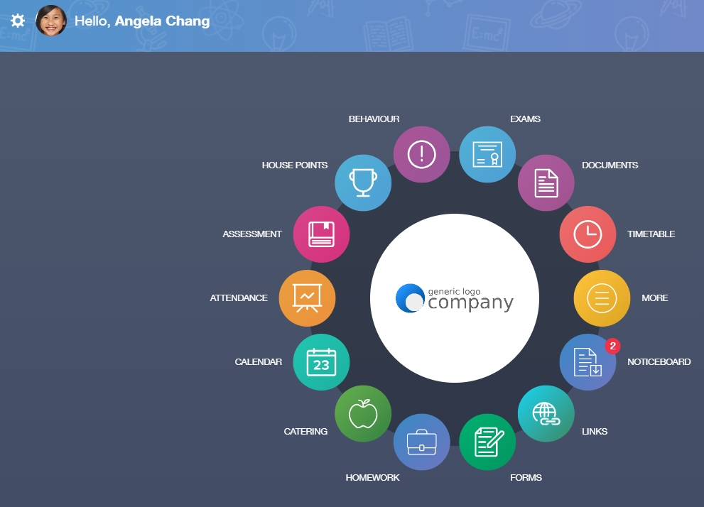
Please see an example of the main screen below. The options may vary between schools as not all schools use all Edulink One’s functions.
Web Browser View

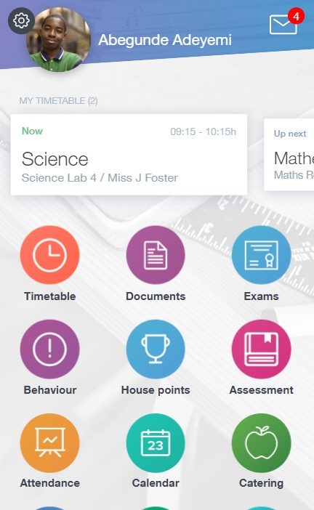
App View

Behaviour
The behaviour button will give you access to view your behaviour records and points, detentions, report cards and lesson behaviour (only if enabled). Information on detentions and graphs on lesson behaviour are also shown.

Behaviour Records Tab
This tab will show you detailed information about any behaviour incidents which have been logged on Edulink One by staff. As the example below shows, each behaviour incident that has been recorded will show you when the incident occurred and details about the incident such as the type, location and the action taken.
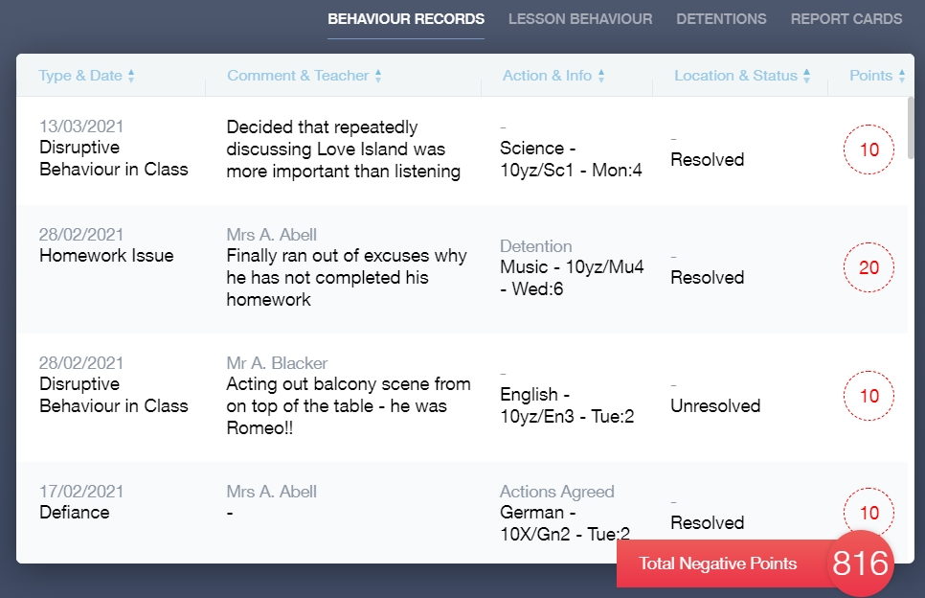
Detentions Tab
The detentions tab will show you any detentions you have, including the date, start and finish times, the location and whether you attended. 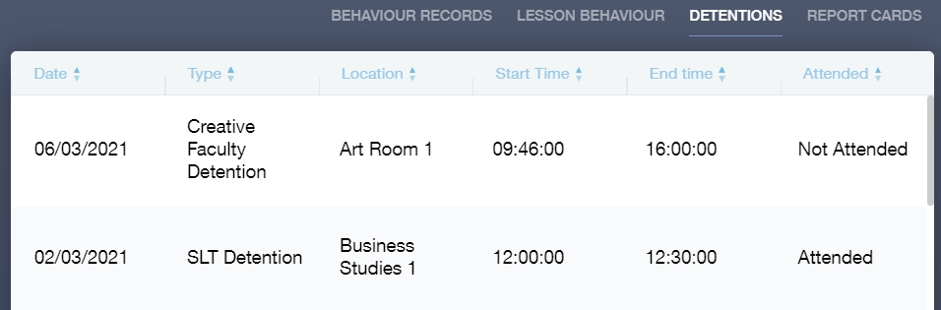
You may also see lesson behaviour and report cards, but only if your school has enabled them.

Achievement
This section is where you can view information on positive achievements that have been awarded to you. Very similar to the behaviour section, you are able to see who awarded the points and the reason for the award.
See the example below.
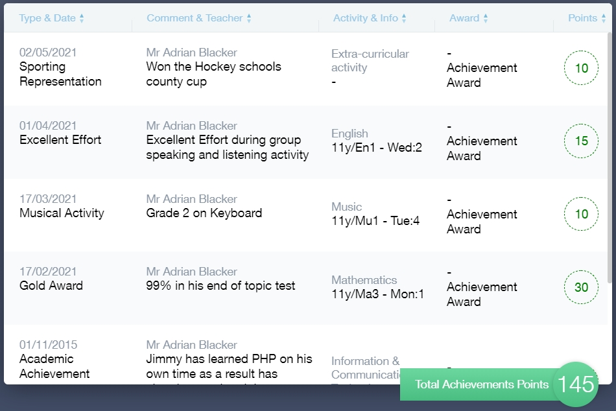

Catering
Here you can check the remaining balance of your school cashless catering account. Details of purchased items from the canteen are also broken down into a list, including dates and times, so you can see what you have purchased each day.
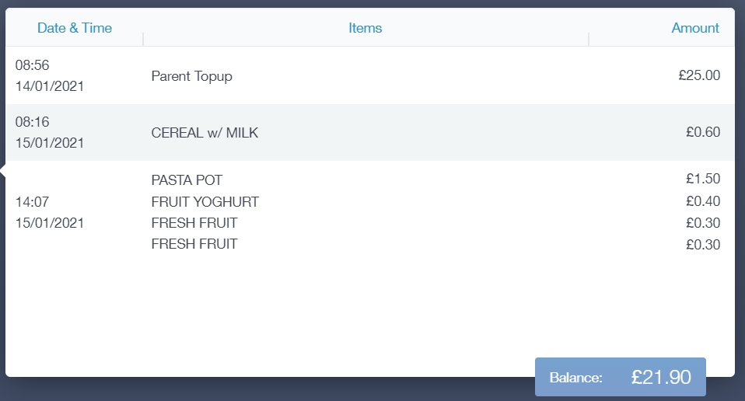

Documents
In this section you will find all your reports.
This includes profile reports and progress checks. Historical reports from previous years will be stored here and will be available for you to download in PDF format whenever you choose.

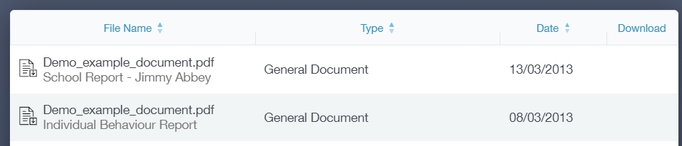

Medical Info
This section contains medical information that you or your parents have supplied to the school. Details on medical conditions, medical notes, medical practices, and medical events such as appointments can all be viewed here. Allergy lists and other attachments can be downloaded in PDF format.
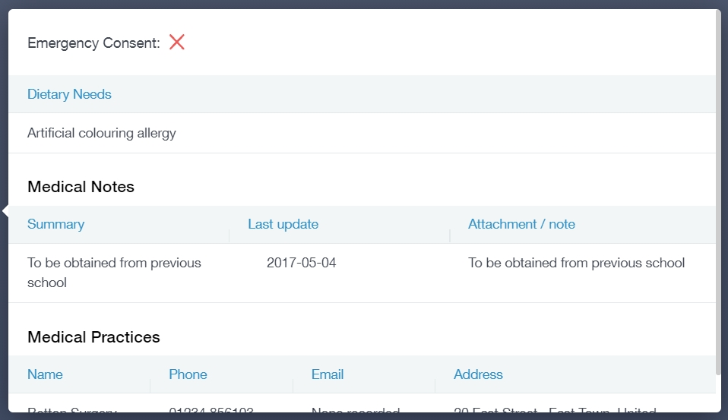

Update Information
This section shows you the basic information that the school has on record.
Here you can change your preferred name, e.g. instead of Samantha you put Sam. When updated information is submitted through Edulink One, this will be picked up by the designated personnel in school in charge of updating records. It will be checked by them and approved.
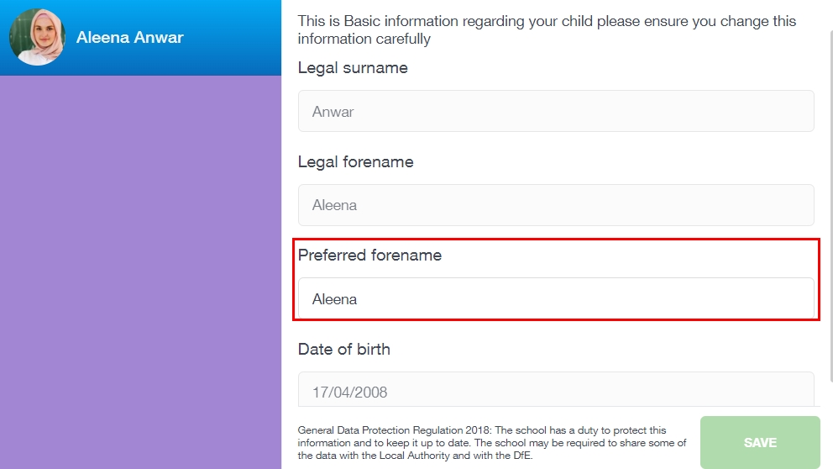

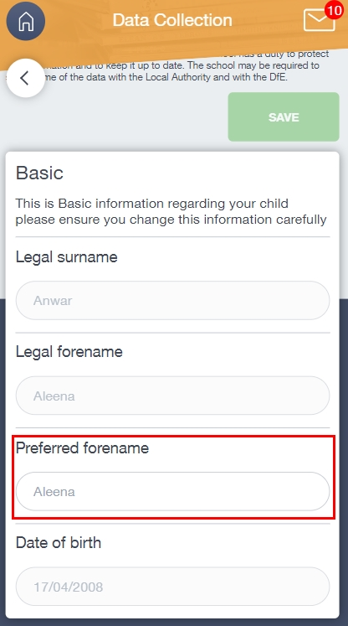
You may not have this option

Links
This section contains links to resources for students to use.
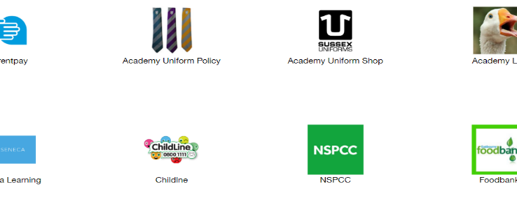

Exams
The exams section contains detailed information about your upcoming exams.
It includes the Exam Timetable along with the exam name and location. You may also see exam entries and a countdown clock if your school has chosen to enable this.
Once the exam results are in, your school has the option to post them in the Exam Results tab. As you own your results as a student, your school may decide not to display them to parents and only the students.

Exam Timetable

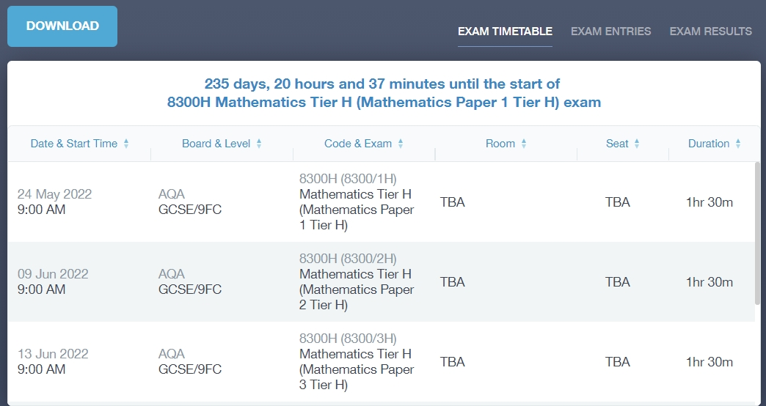

Exam Entries

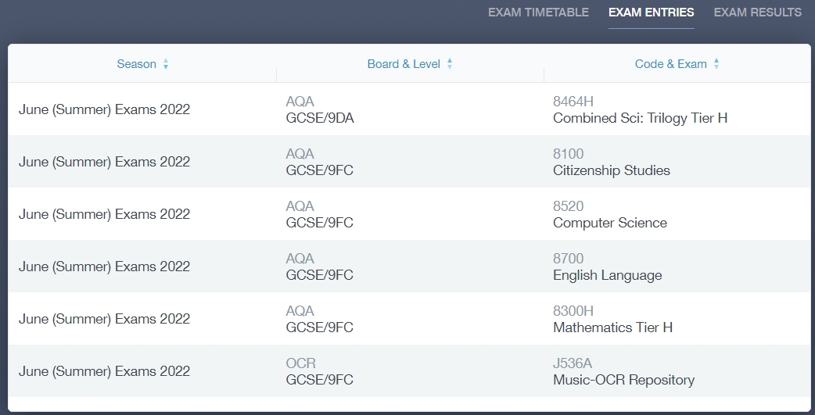

Timetable
This allows you to view your school timetable and shows you information on what lessons you have each day, including who the teachers are for those lessons.

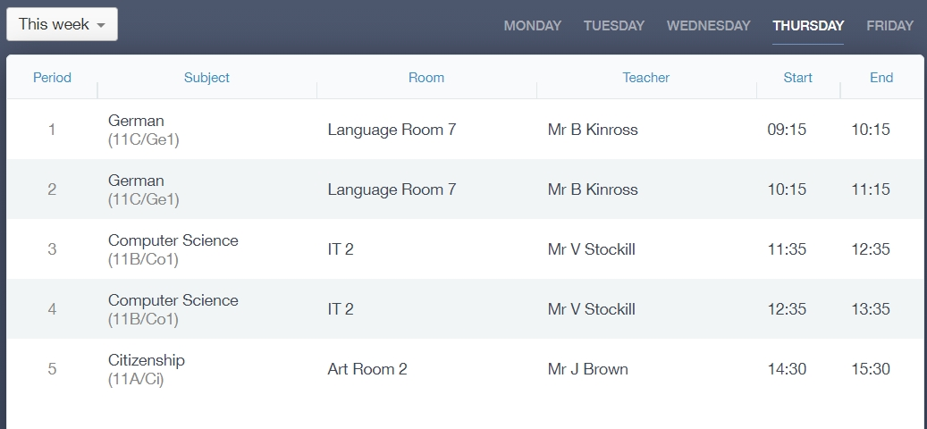

Account Info
Here you can view your current address details the school has on file. Other information about your year group, house, tutor, admission date and ULN number are also available.

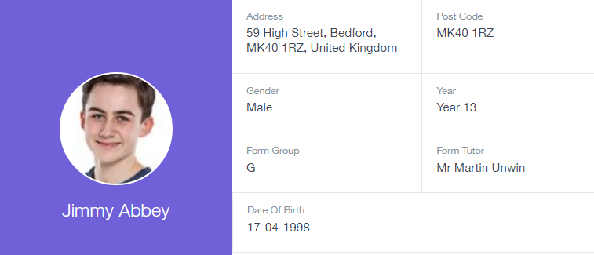

Messages
The message button can be found in the bottom right of the screen. Here you can read messages that have been sent through to you from staff at the school. You can reply to messages here, if allowed. You can also write and send messages to one or more teachers, if enabled.
In the example below, the received tab is where any messages sent to you from the school will be. You have the option to read and reply from here. The sent box will store messages you’ve sent through previously.
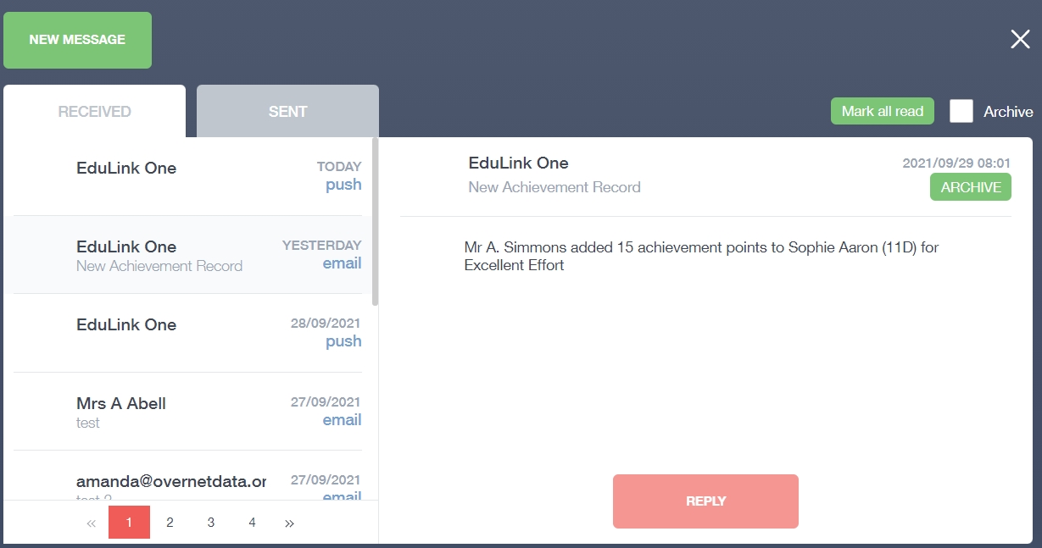

Sending a new message
To begin sending a new message you will need to click the green new message button. 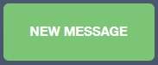
Next, choose the person to send your message to. As you can see in the example below it is broken down into teachers, form tutors, Head of Year and Head of House (this may differ between schools). Depending on who you want to send to, you can pick from the relevant boxes.
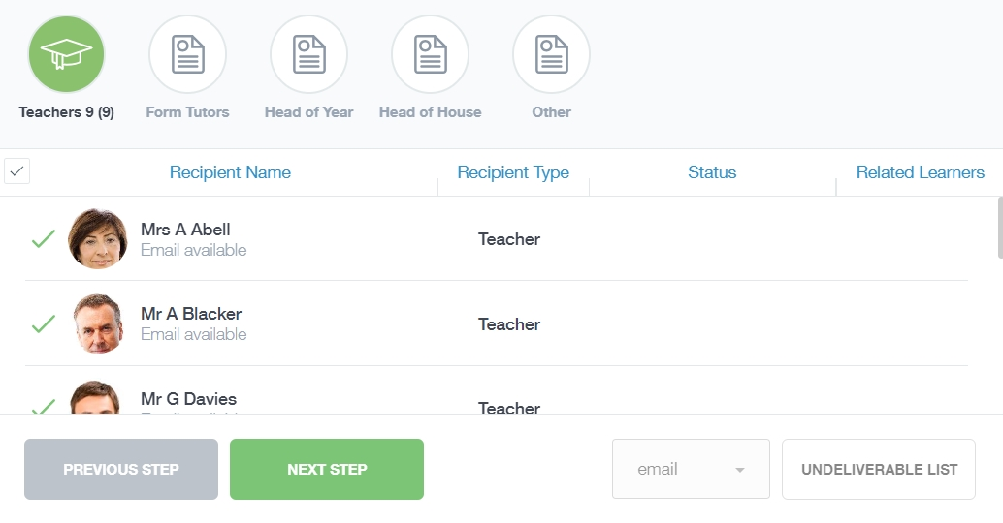
It will pre-select all teachers. You can see this below as each teacher has a green tick beside. This means if you send a message now, it would go to all the selected teachers. To deselect specific teachers, just click on the green tick or deselect all using the smaller black tick. Click Next when done.
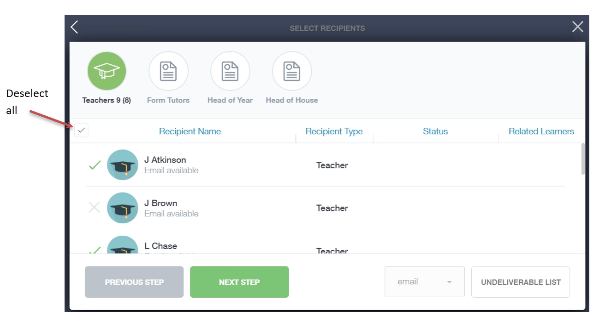

Type your message subject and text. You can customise your text using the toolbar at the top and you can add attachments using the paperclip icon at the bottom of the window. When you are finished, click the Send button.
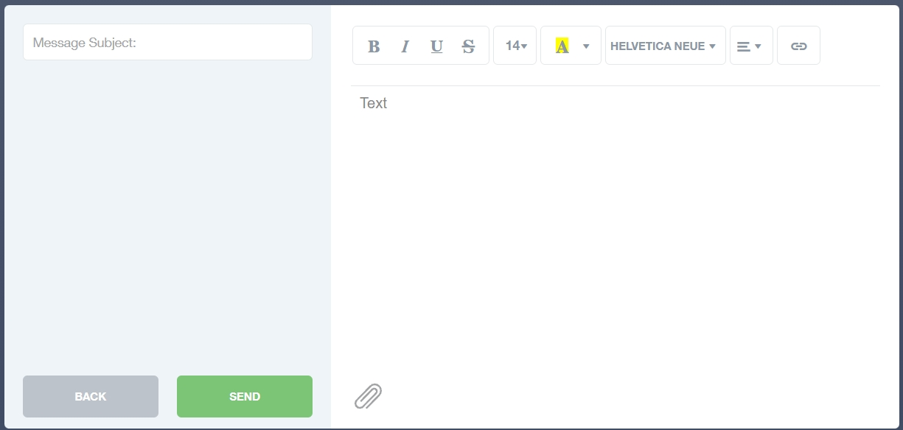

Homework
The homework section operates as a standalone homework system where teachers can set homework through Edulink One. Teachers have the ability to upload homework using Google Classroom or Microsoft if this has been enabled by their school. However, this is a visual of the homework only. You can see what homework has been set, when it is due and mark it as completed.
You will see the homework in a list format; this can be organised by clicking on the headings.
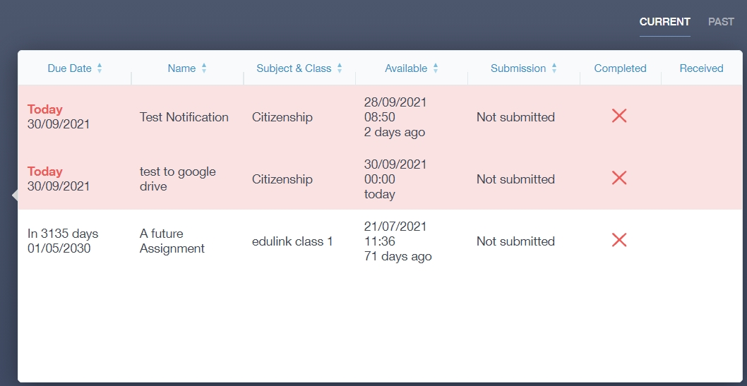
Click on the homework to read it and click on the X in the top right corner to close it.
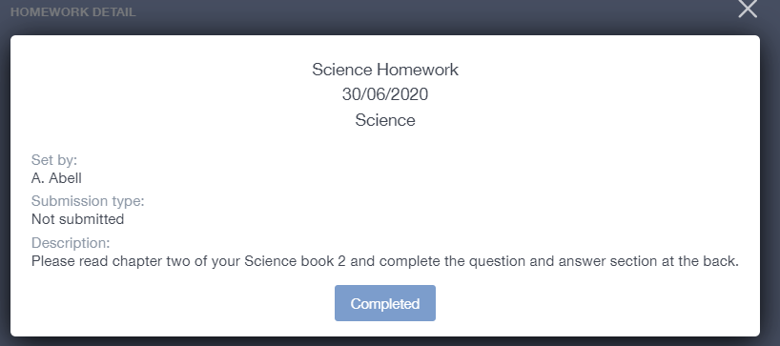
Once you have completed the homework assignment, click the Completed button to notify your teacher the work has been done. It is important to note that you can only view set homework.
For work that is to be handed in, the teacher may ask for the work to be emailed or sent to a Teams or Google Classroom location or any shared drive solution the school may use.
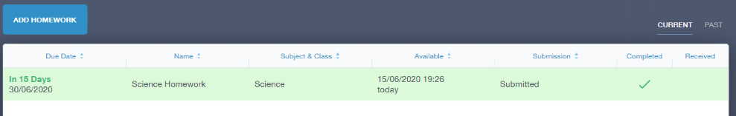
Once you have clicked completed, you will need to wait for your teacher to review the work.
If the teacher has an issue with the homework, then they will contact you and mark the work as received but not completed as per below.
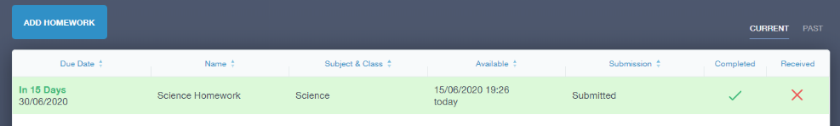
If the teacher is happy with the completed work, they will mark the work as completed and it will appear with a green check in the received column.
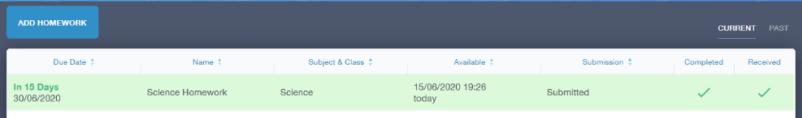
Please Note: You can add their own homework using the Add Homework option, if enabled. This will not be reviewed by the teacher but can be used to help you create a study plan, self-assessments, etc...
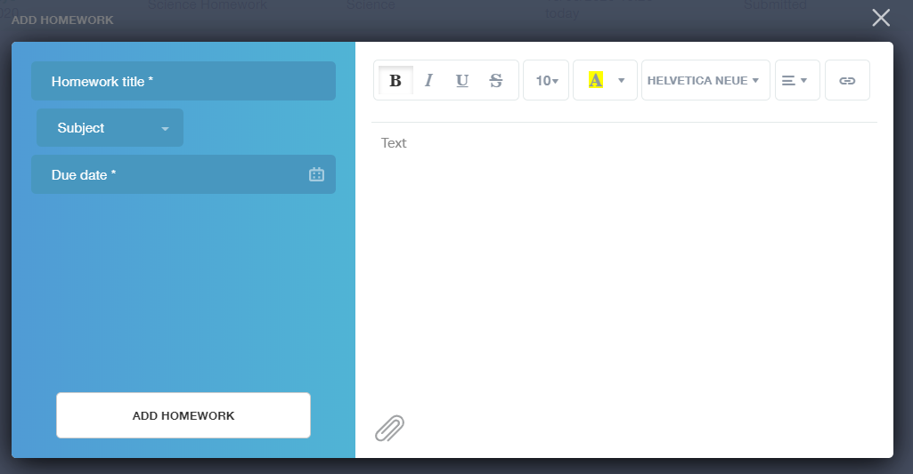
Provide a title, subject and due date and some text of what this activity is about. This could be used to show teachers extra work completed.
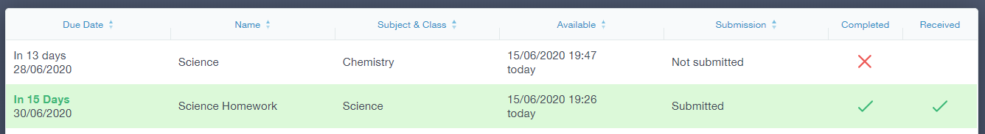

Forms
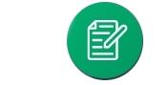
You can fill out a form sent by the school in the Forms icon. Schools will send out forms for many reasons: school trips, meal selection, permission forms etc...
The forms screen is created as a list, providing details about the due date and whether you have completed the form or not. You need to click on a form to fill it out.
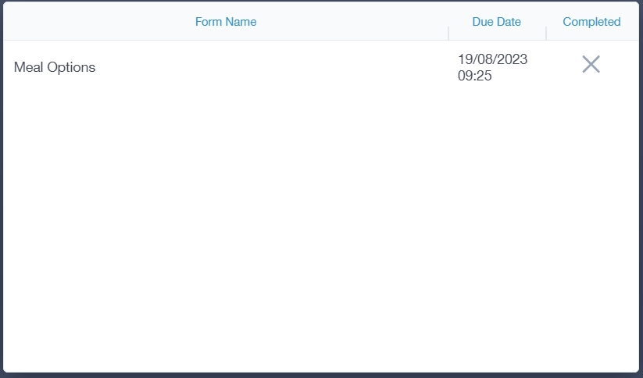
A new window opens where you can read the details regarding the form and make any necessary selections or comments.
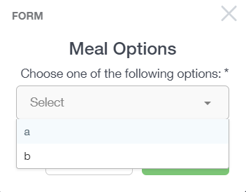
To fill in a form, select an answer from the dropdown list, e.g. A or B. Then press Submit.
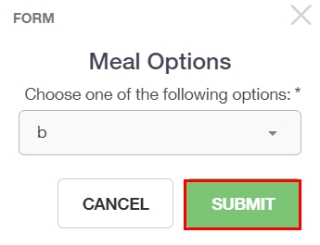
You might be asked to fill in other details depending on the form.

SEN
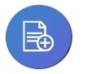
If you have a Special Educational Need or Disability, information on your SEN details can be found in the SEN icon.
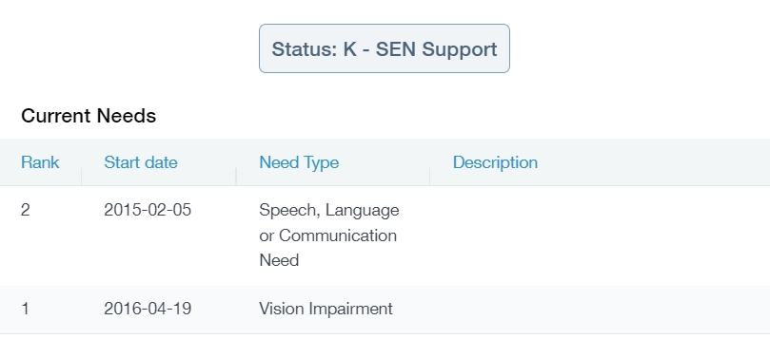
If your school has enabled the Strategies portion of the SEN screen, you can view the strategies the school uses to help you.

Attendance
The attendance area lets you see which lessons you have attended that day and whether you have been marked as present or absent. In the Attendance Today tab, you can see this for both statutory registration and lesson registration.
Below the statutory registration information is a list of your lessons for each period of the day.

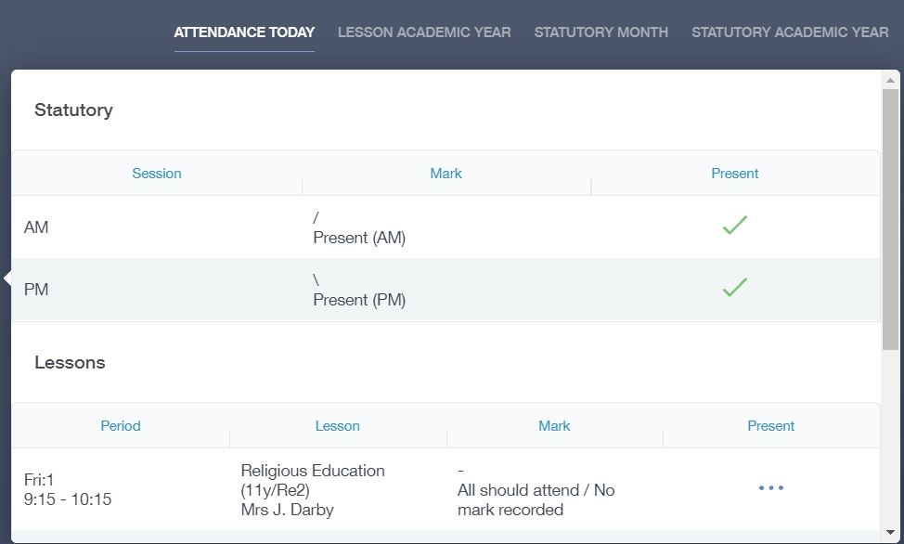
Additionally, the school has the option to allow you to see data regarding lesson attendance for the academic year, as well as statutory month data and statutory academic year data. The data in these sections appear as pie charts like the example below.
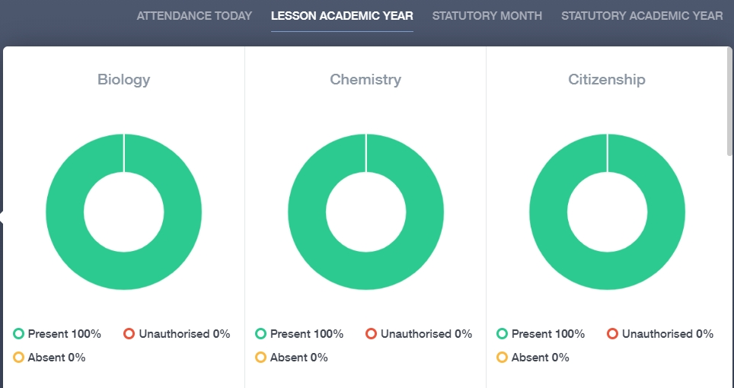

Assessment
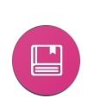
The assessment screen is customisable for every school, so most schools’ assessments will not look the same. If you are struggling to understand the assessment data, it is best you talk to your teachers so they can explain their assessment process.
You can see your grades, targets, attitude to learning and other aspects that the school wants you and your parents to see in Assessments. Some schools colour code data to tell you if you are working at the expected level. Many schools also provide a written explanation about the assessment, like what each effort grade means.
Also, you can view other assessments, including past assessments, and some schools may make KS2, KS3 or KS4 data available for parents to view.
Below is an example of what an assessment could look like in Edulink One.

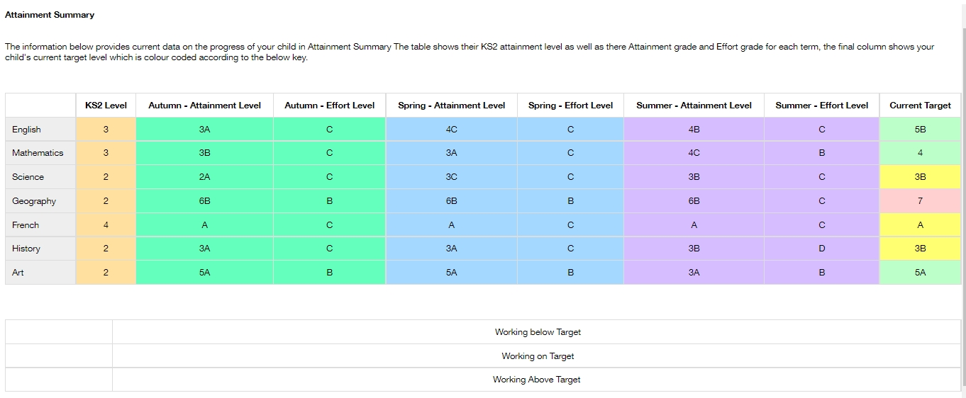

Noticeboard
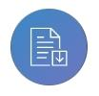
The noticeboard is where you can see news and upcoming announcements from the school. Schools can upload newsletters, documents and other useful information.
There is also a snippet section at the top that displays important announcements, like the date of the school panto.
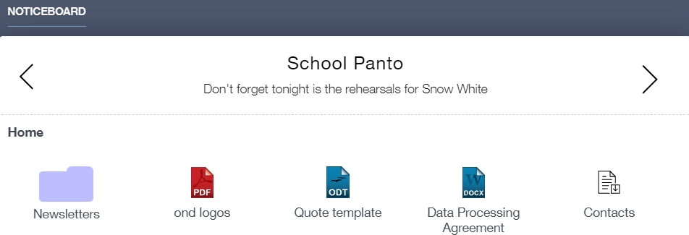

Calendar
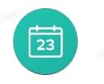
If your school has enabled the calendar in Edulink One, you can see the events that are going on at the school, such as term dates, staff training days, school events and more.
Homework can also be displayed, linking the calendar up with the homework area in Edulink One.
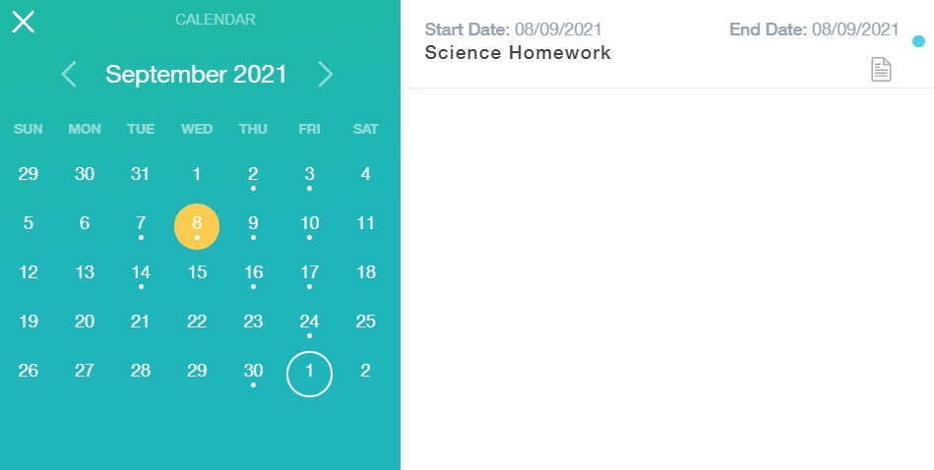

Manage Your Calendar
To manage your calendar, you need to go to the cog in the top left corner of the screen and click on it. Then, you need to click on Manage iCal.
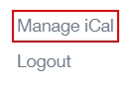
In Exports, you can export your Timetable and school Calendar. To do this, press on the ‘toggle’ to turn on the export and then copy the link to your personal calendar. 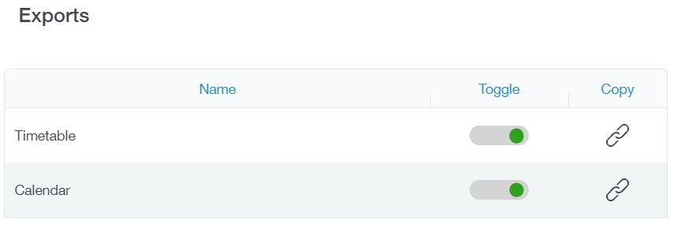
You may also be able to import your own calendar to Edulink One using Imports. Press the +Add button to add a calendar.
Import your personal calendar, such as Microsoft 365, by pasting a link to it in the URL field. Give the calendar a name and click the ‘Add’ button. 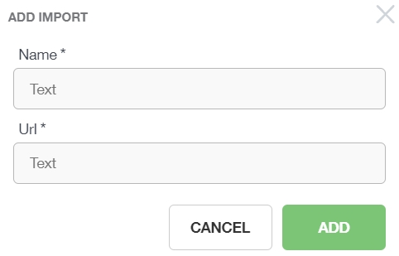

Clubs
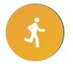
Clubs are a great way for you to get involved in extracurricular activities. You and your parents can use the Clubs area to sign up for open clubs the school is running. For any invitation only clubs, you will see these under the My Clubs tab.

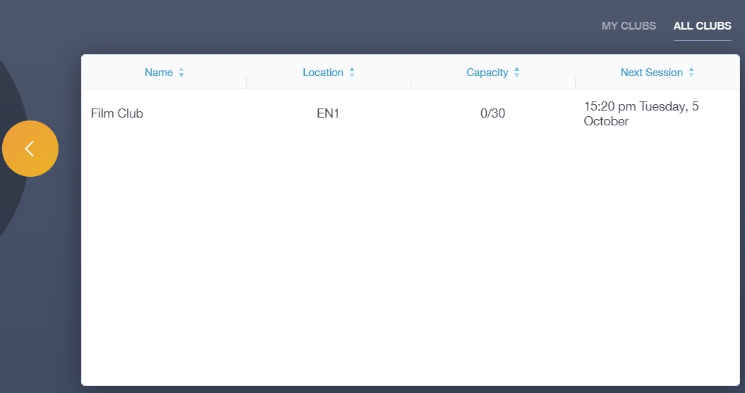
To join a club, click on the club in the All Clubs tab. 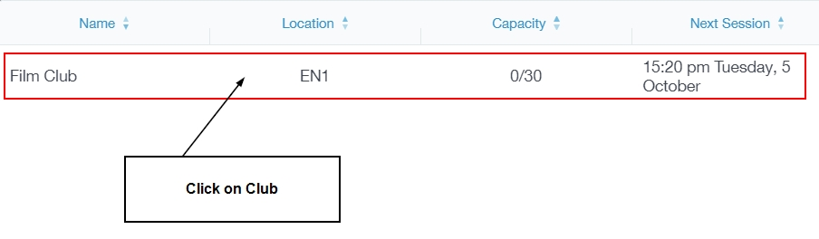
Once you have clicked on the club, a new window opens where you can read about the club and decide to join it.
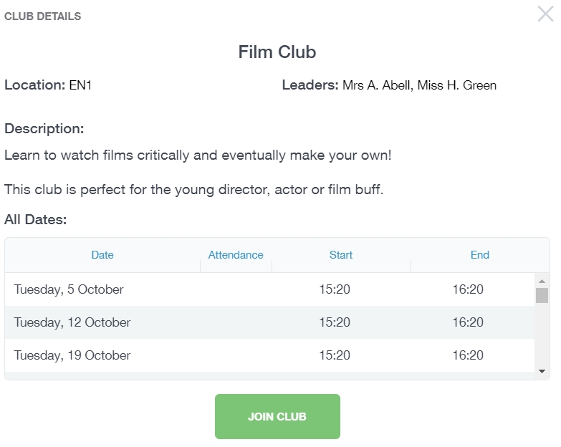
To join the club, click on the Join Club button. It will now appear in your My Clubs tab.
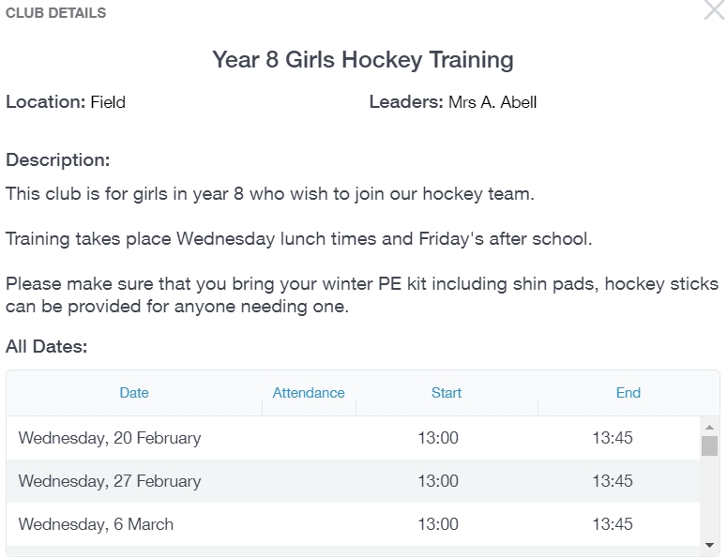
If you have not been joined to a club by a teacher (such as revision sessions), you can choose to unbook a club. If a teacher signed you up, you will need to attend the club and must ask the teacher to leave, e.g. your exam is now over so you no longer need to attend the revision sessions.
You can also view your attendance at a club. This appears after the fact and not during the session of the club.
