Parent Guide for [School Name]

A Parent's Guide to Getting Started with “Edulink One”
All schools have their own way of working with Edulink One. It is customisable, meaning each school can tailor the product to meet their individual needs. The features covered in this guide are subject to the options your school chooses to use and should be viewed with this in mind. We request that users contact their school directly with any questions they may have.
There are two ways to use Edulink One: through a web browser like Google Chrome or through an app you can download to use on your mobile device. The Edulink One app is available for iOS and Android devices.

Web Browser Instructions
This is your school’s individual login link if you use a browser to log in.
Start by going to https://www.edulinkone.com/#!/login?id=YYYY or if you are not using your school’s direct link, visit https://www.edulinkone.com/.
After clicking the link this will take you straight to the Edulink One login page for your school.
If you do not have a direct link, you will need to enter your School ID or Postcode and press Next. Your School ID will have been sent to you by the school. If you forget your username or password, please contact the school.
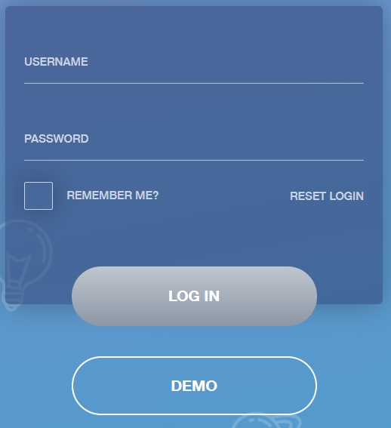
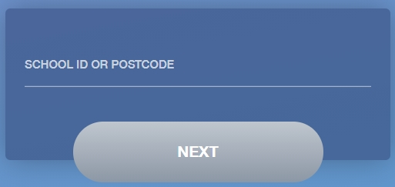
Enter your Username and Password that the school has sent to you.
If you have not received an email with your login details, please contact your school to resolve this issue.
Once you have filled in the username and password boxes with your login details, click LOG IN to get started.

Downloading and Using the App
The Edulink One app is available for iOS and Android devices. You can download from these links or search in the App or Play stores.
Apple App Store
https://itunes.apple.com/gb/app/edulink-one/id1188809029?mt=8&ign-mpt=uo%3D4
Android Google Play
https://play.google.com/store/apps/details?id=com.overnetdata.edulinkone&hl=en
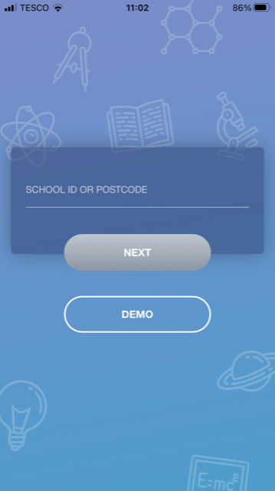
If you are using the mobile app you will see the screen to the left. You must input your School ID or Postcode and click the Next button to continue.
This is followed by the USERNAME and PASSWORD screen where you need to enter the login details your school has sent you.
Once you have filled in all three boxes with your login details, click LOG IN to get started.
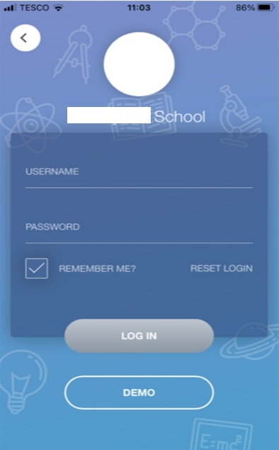
If you forget your username or password, please contact the school

Main Screen
Once logged in, you will see the main screen in Edulink One. The information held in your account relates to your child/children. You will be able to navigate through the different sections of Edulink One by clicking on the icons, e.g. to view your child’s attendance, click the Attendance icon.
Please see an example of the main screen below. The options may vary between schools as not all schools use all Edulink One’s functions.
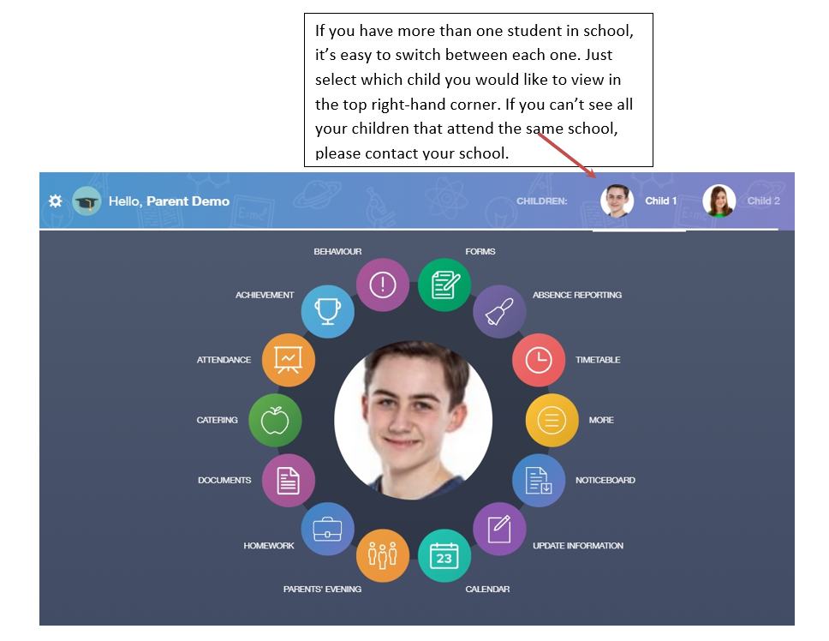
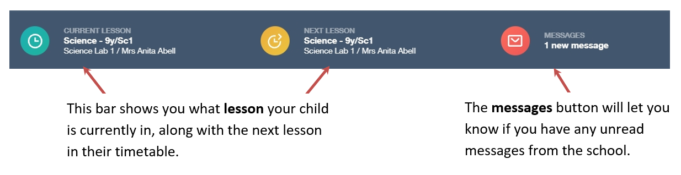

Behaviour
The behaviour button will give you access to view behaviour records, detentions and lesson behaviour, which have been assigned to your child. Information on detentions and graphs on lesson behaviour are also shown.

Behaviour Records Tab
This tab will show you detailed information about any behaviour incidents which have been logged on Edulink One by staff. As the example below shows, each behaviour incident that has been recorded will show you when the incident occurred and details about the incident such as the type, location and the action taken.
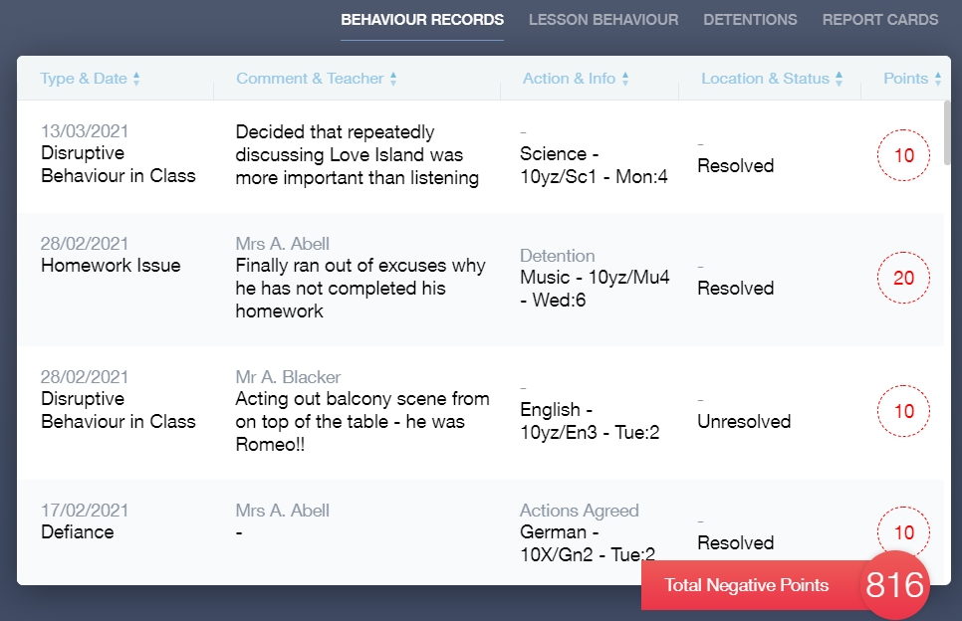
Detentions Tab
The detentions tab will show you any detentions which have been assigned to your child, including the date, start and finish times, the location and whether your child has attended. 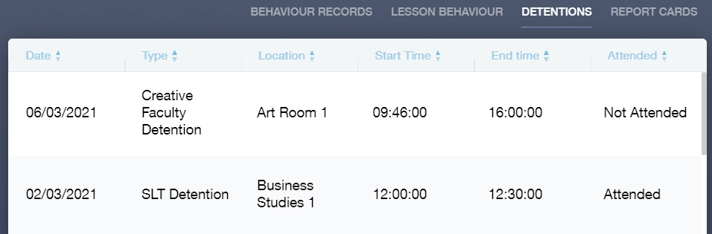

Achievement
This section is where you can view information on positive achievements that have been awarded to your child. Very similar to the behaviour section, you are able to see who awarded the points and the reason for the award.
See the example below.
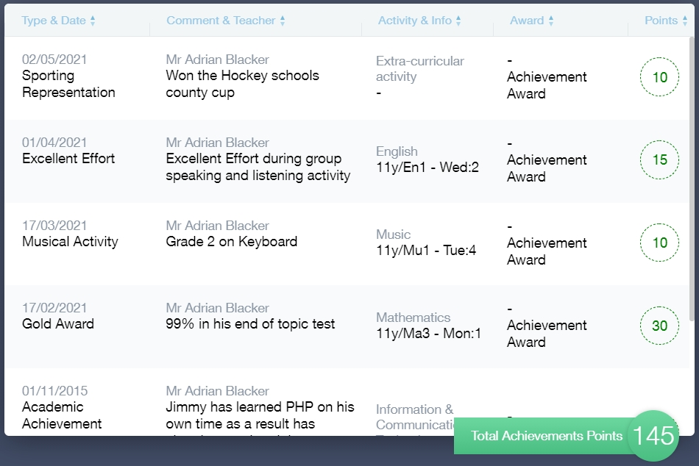

Catering
Here you can check the remaining balance of your child’s school cashless catering account. Details of purchased items from the canteen are also broken down into a list including dates and times so you can see what your child has purchased each day.
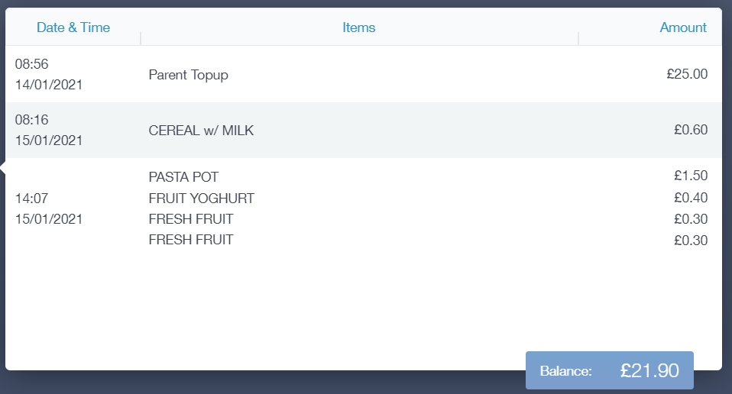

Documents
In this section you will find all the individual reports related to your child.
This includes profile reports and progress checks. Historical reports from previous years will be stored here and will be available for you to download in PDF format whenever you choose.

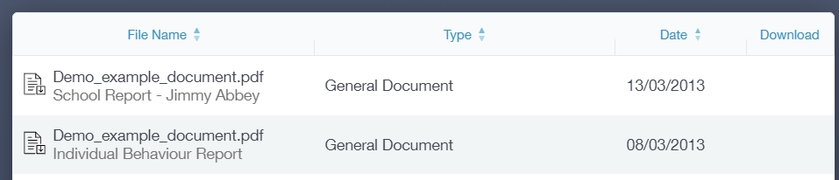

Medical Info
This section contains medical information that you have supplied to the school regarding your child. Details on medical conditions, medical notes, medical practices, and medical events such as appointments can all be viewed here. Allergy lists and other attachments can be downloaded in PDF format.
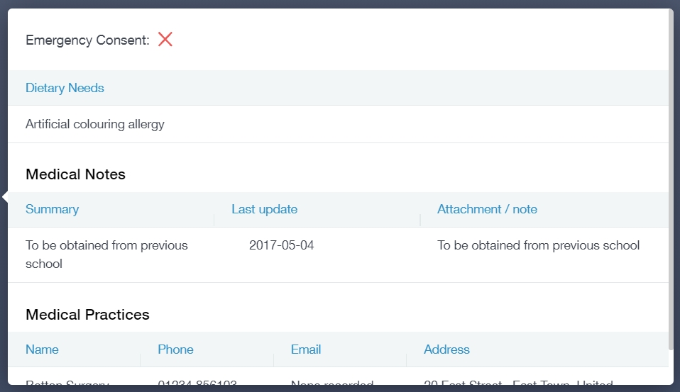

Update Information
This section shows you the contact information that the school has on record for yourself and your children.
Here you can review the contact information the school holds for you, but you will also be able to update this with any changes that may occur to this information. When updated information is submitted through Edulink One, this will be picked up by the designated personnel in school in charge of updating records. It will be checked by them and approved.
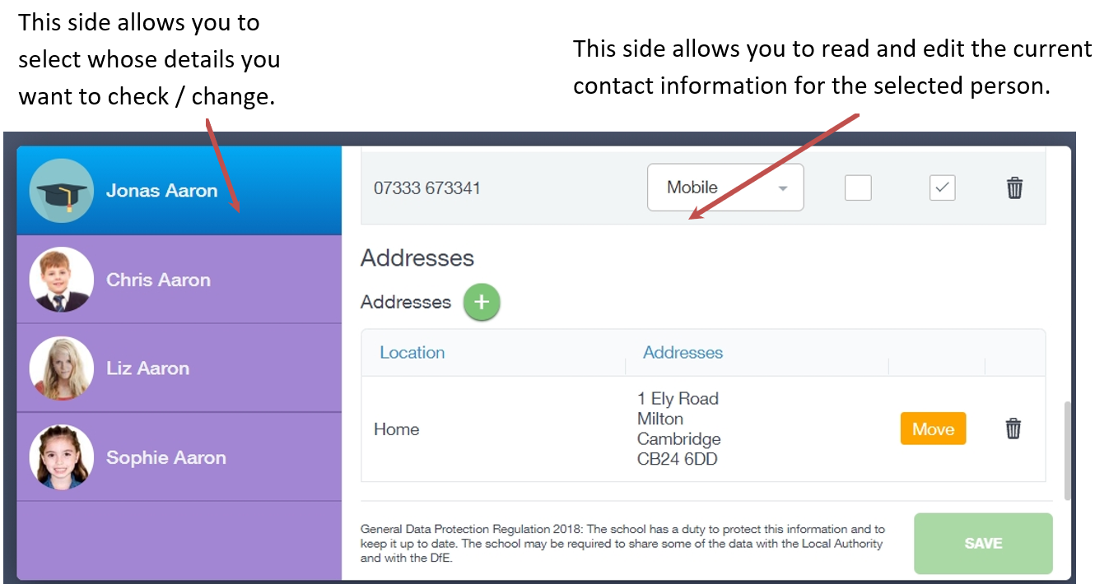
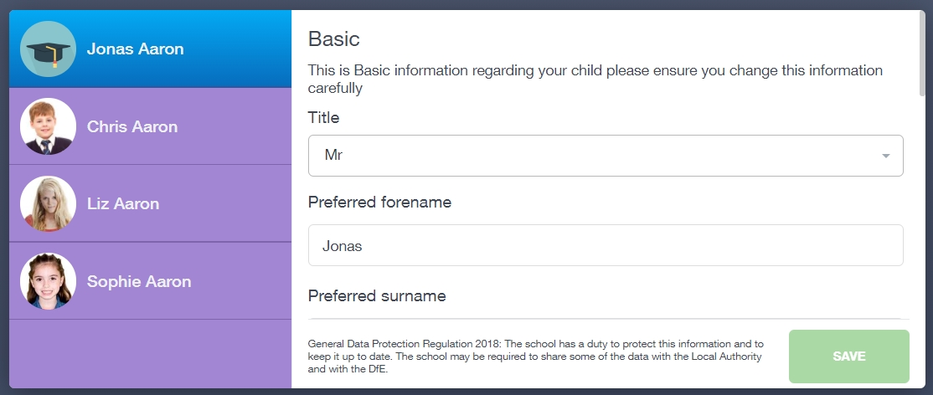
To update information using the Edulink One app on a mobile phone, click on the Data Collection/ Update Information icon and the screen will open.
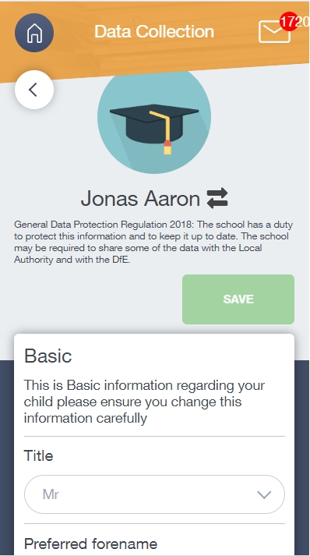

To update your own information, simply fill out the fields under your name. If you need to update information for a child, you need to click on the Switch Account arrows beside your name. Then, select the child you need to update the information for. Fill out the information in the fields as usual.
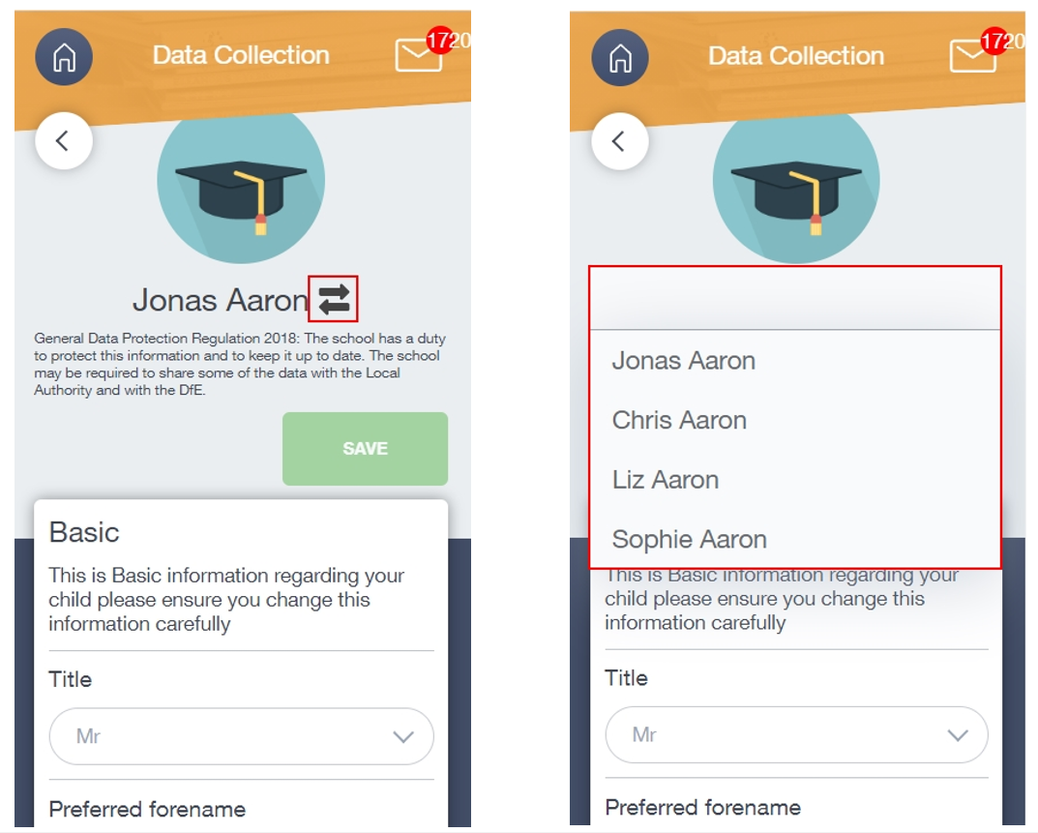

Absence Reporting
This feature allows you to send a direct message to the school’s attendance officer to notify the school of your child’s absence or upcoming absence.
The example below shows you how to select the time and date for the absence request and the reason for the absence.
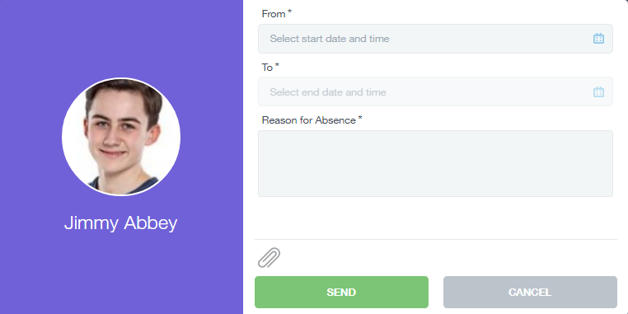

Links
This section contains links to resources for students to use.
There are also links specifically for parents.

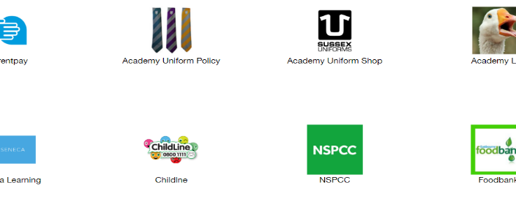

Exams
The exams section contains detailed information about upcoming exams that your child will be sitting.
It includes the Exam Timetable along with the exam name and location. Your child also has access to this so they can keep track of upcoming exams themselves.
Once the exam results are in, your school has the option to post them in the Exam Results tab. As the students own their results, the school may decide not to display them to parents and only the students.

Exam Timetable
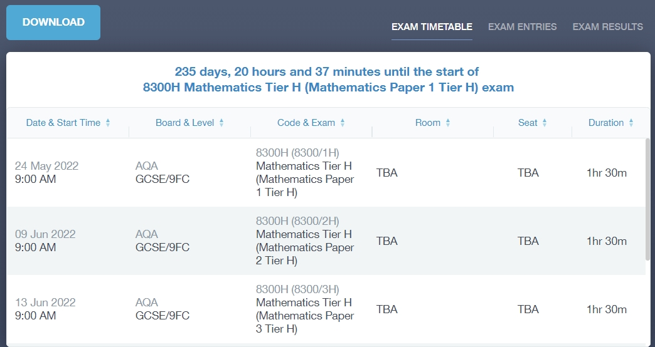

Exam Entries

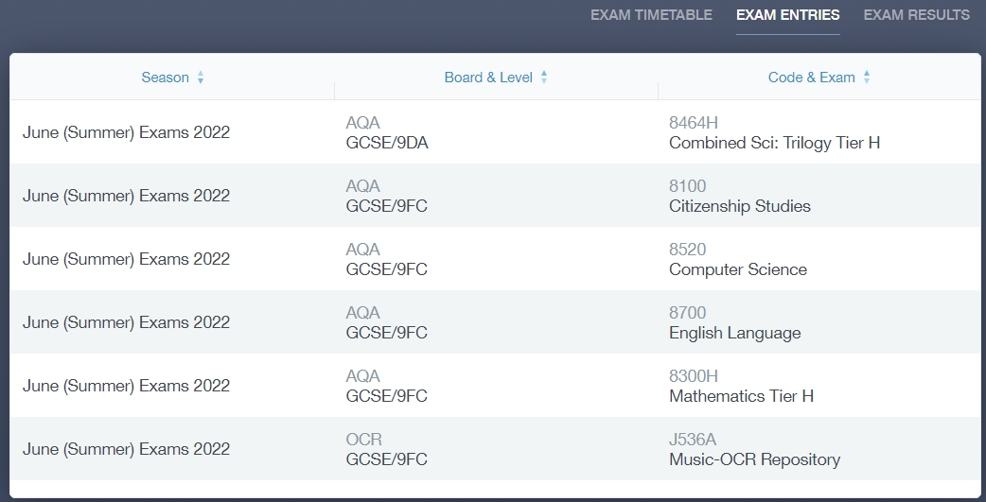

Timetable
Parents and students both have access to this section, which allows you to view your child’s school timetable. This shows you information on what lessons your child has each day and who the teachers are for those lessons.

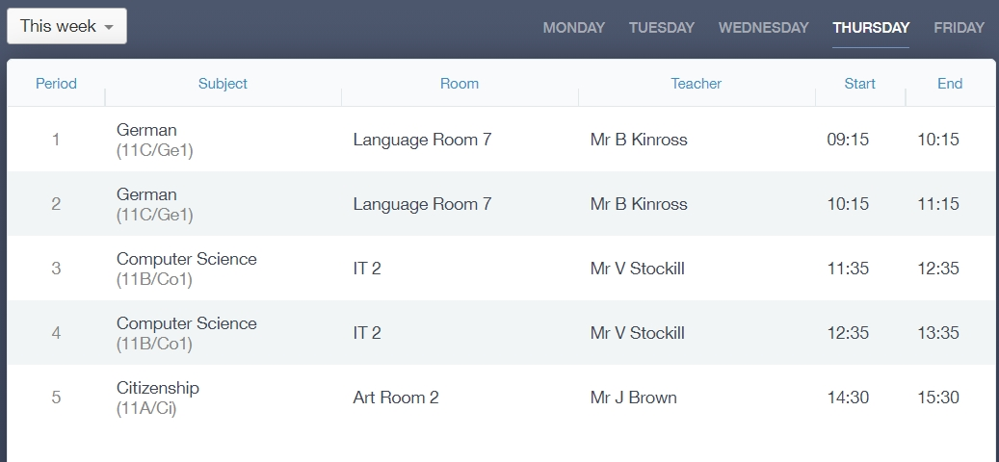

Account Info
Here you can view the current address details the school has on file for your child. Other information on your child’s year group, house and tutor are also available.

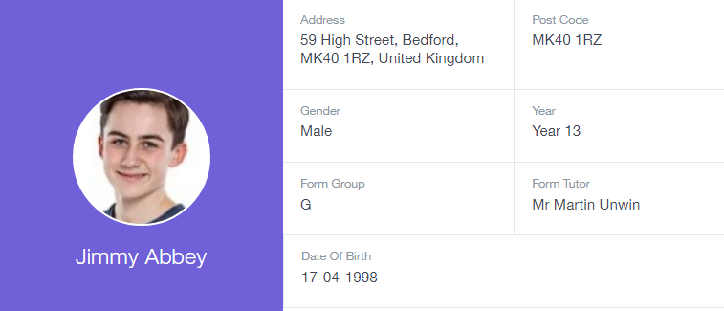

Messages
The message button can be found in the bottom right of the screen. Here you can read messages that have been sent through to you from staff at the school. You can reply to messages here. You can also write and send messages to one or more teachers and your child’s tutor. Most schools also send these to your registered email address.
In the example below, the received tab is where any messages sent to you from the school will be. You have the option to read and reply from here. The sent box will store messages you’ve sent through previously.
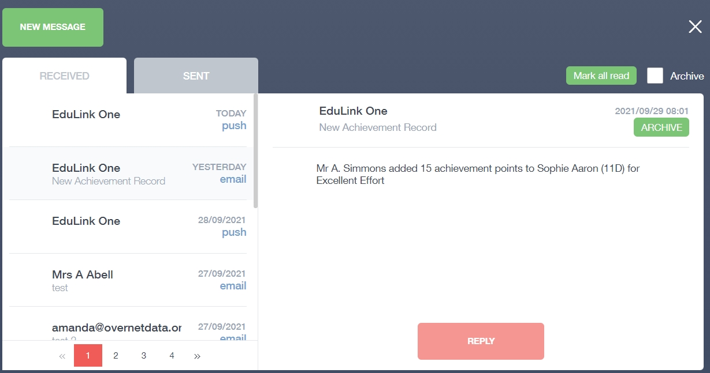

Sending a new message
To begin sending a new message you will need to click the green new message button. 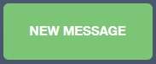
Next you will have to select your child/children. Once selected click the next step button.
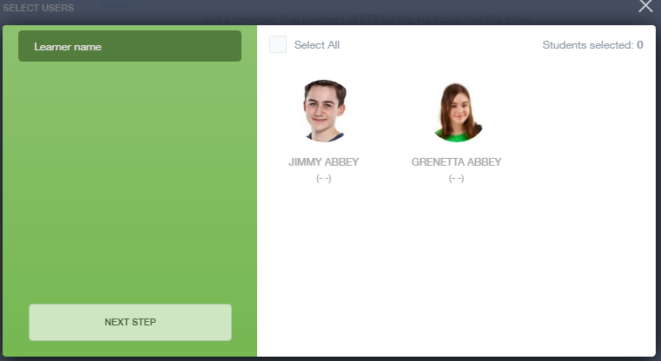
Next, choose the person to send your message to. As you can see in the example below it is broken down into teachers, form tutors, Head of Year and Head of House (this may differ between schools). Depending on who you want to send to, you can pick from the relevant boxes.
The default option is to pre-select all teachers. You can see this below as each teacher has a green tick beside. This means if you send a message now, it would go to all the selected teachers. To deselect specific teachers, just click on the green tick or deselect all using the smaller black tick. Click Next when done.
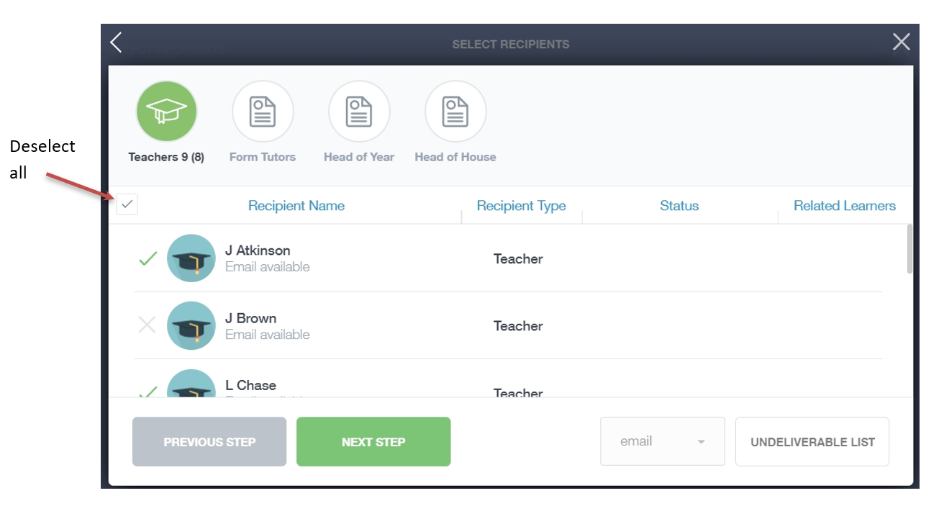

Type your message subject and text. You can customise your text using the toolbar at the top and you can add attachments using the paperclip icon at the bottom of the window. When you are finished, click the Send button.
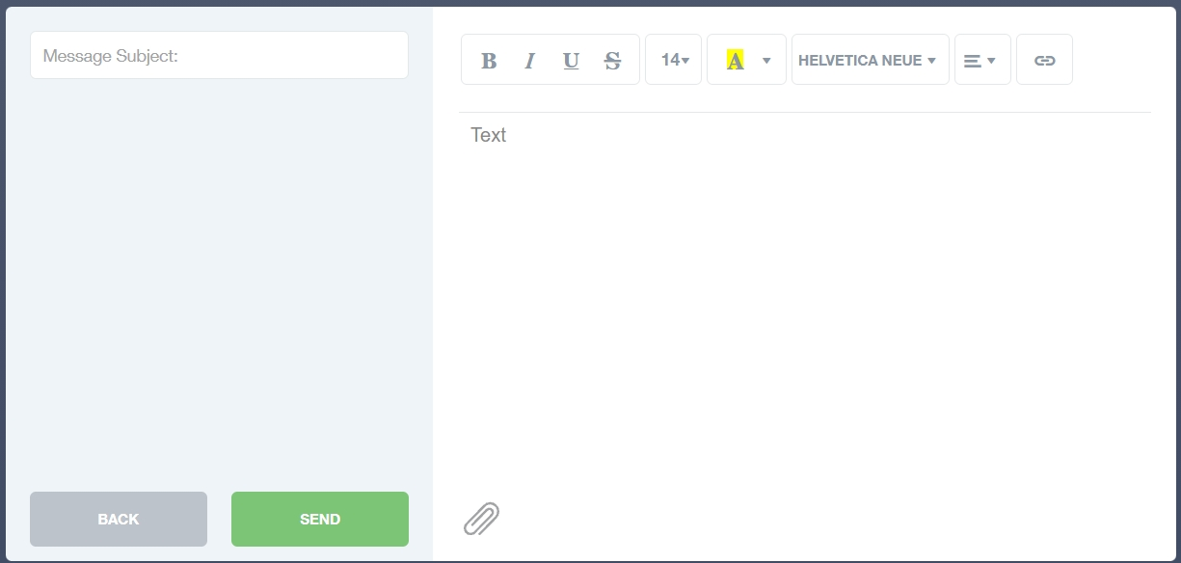

Homework
The homework section operates as a standalone homework system where teachers can set homework through Edulink One. Teachers have the ability to upload homework using Google Classroom if this has been enabled by their school. However, this is a visual of the homework only. Students can see what homework has been set when it is due and they can also mark it as completed.
The student and parent will see the homework in a list format; this can be organised by clicking on the headings.
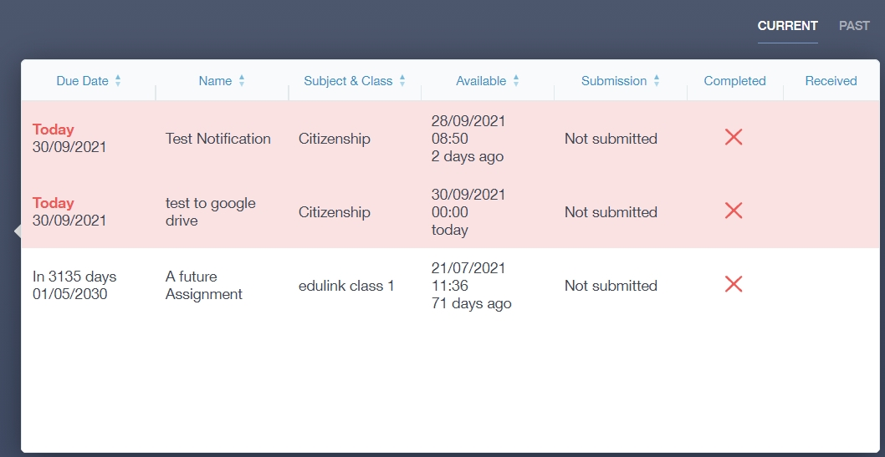
The student and parent can then click on the text of the homework to read the requirements. To exit this just click on the X in the top right corner.
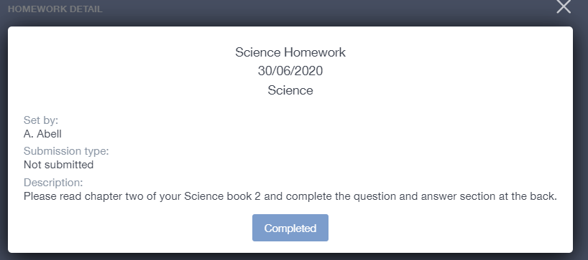
Once the student has completed the homework assignment, they should click the Completed button to notify their teacher the work has been done. It is important to note that parents can only view set homework.
For work that is to be handed in, the teacher may ask for the work to be emailed or sent to a Teams or Google Classroom location or any shared drive solution the school may use.
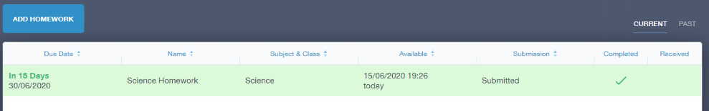
Once the student has clicked completed, they will need to wait for the teacher to review the work.
If the teacher has an issue with the homework, then they will contact the student and mark the work as received but not completed as per below.
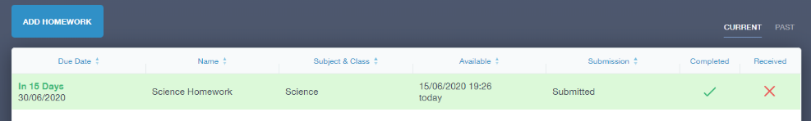
If the teacher is happy with the completed work, they will mark the work as completed and it will appear with a green check in the received column.
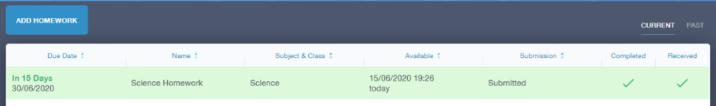
Please Note: Students can add their own homework using the Add Homework option. This will not be reviewed by the teacher but can be used to help students create a study plan, self-assessments, etc...
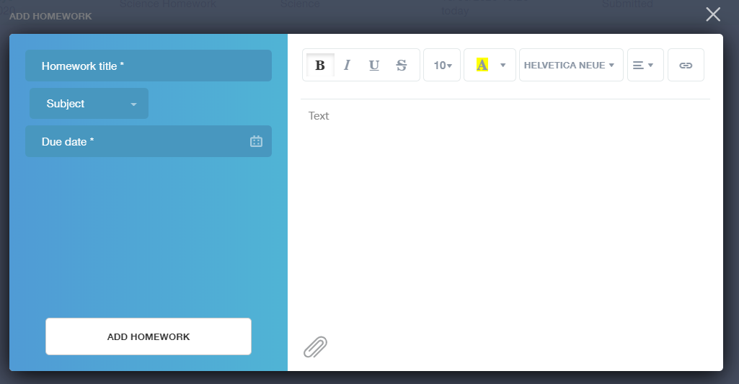
They would need to provide a title, subject and due date and some text of what this activity is about. This could be used to show teachers extra work completed.
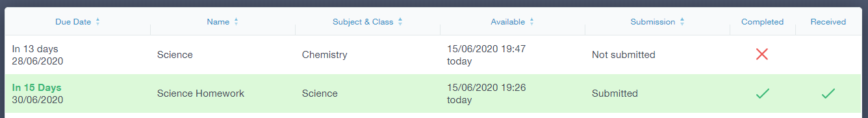

Forms
You can fill out a form sent by the school in the Forms icon. Schools will send out forms for many reasons: school trips, meal selection, permission forms etc...
The forms screen is created as a list, providing details about your child/children, the due date and whether you have completed the form or not. You need to click on a form to fill it out.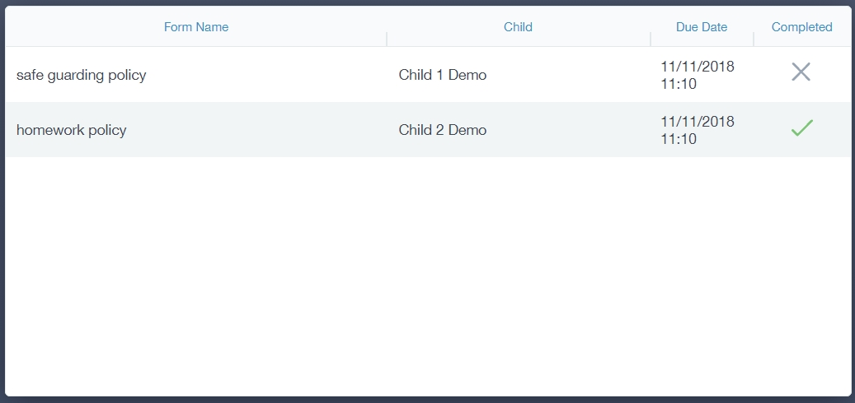
A new window opens where you can read the details regarding the form and make any necessary selections or comments. 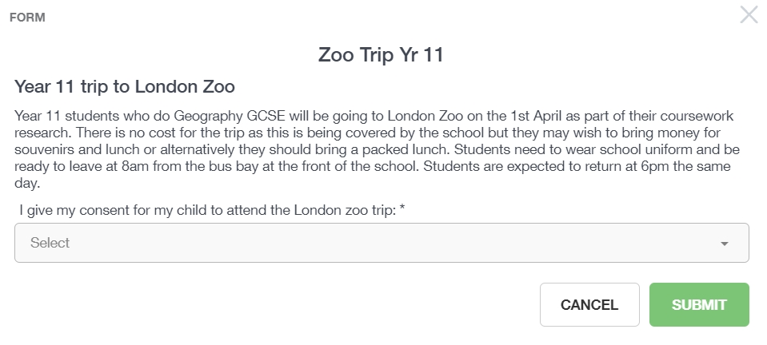
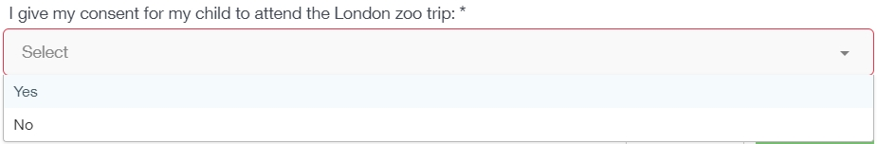
To fill in a form, select an answer from the dropdown list, e.g. yes or no. Then press Submit.

Contacts
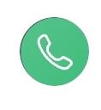
This section contains parent contact information. Details on telephone and mobile numbers, email, address, and parental responsibility can be viewed here.
If you notice any out-of-date details, you can update them in the Update Information area.
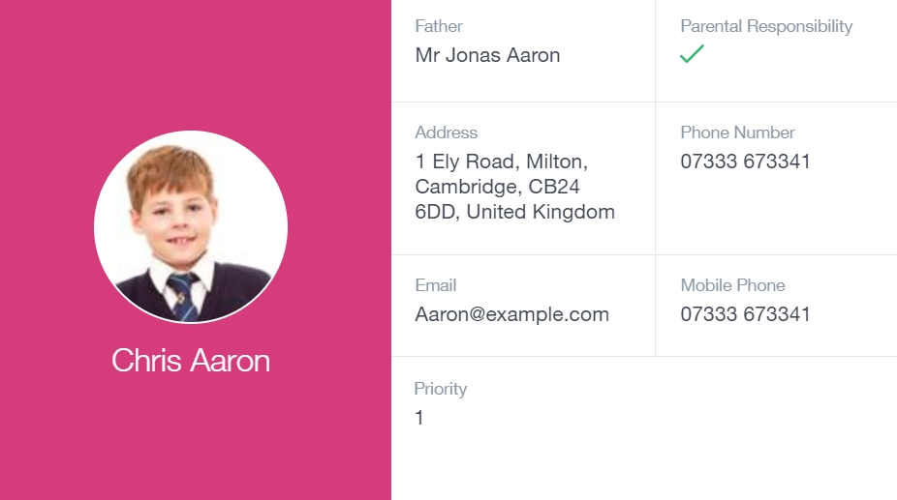

SEN
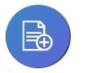
If your child has a Special Educational Need or Disability, information on their SEN details can be found in the SEN icon.
You can also see whether your child has an EHCP (Education, Health and Care Plan), though documents may or may not be visible depending on your school’s settings. 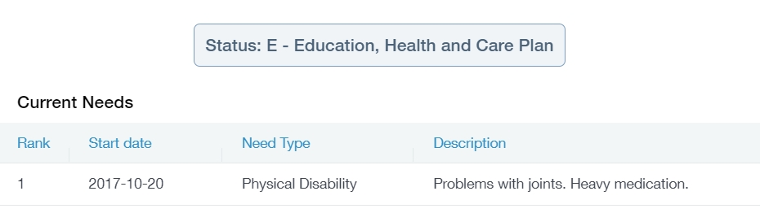
If your school has enabled the Strategies portion of the SEN screen, parents can view the strategies the school uses with their children to aid in their learning.

Attendance
The attendance area lets you see which lessons your child/children has that day and whether they have been marked as present or absent. In the Attendance Today tab, you can see this for both statutory registration and lesson registration.
Below the statutory registration information is a list of the child’s lessons for each period of the day.

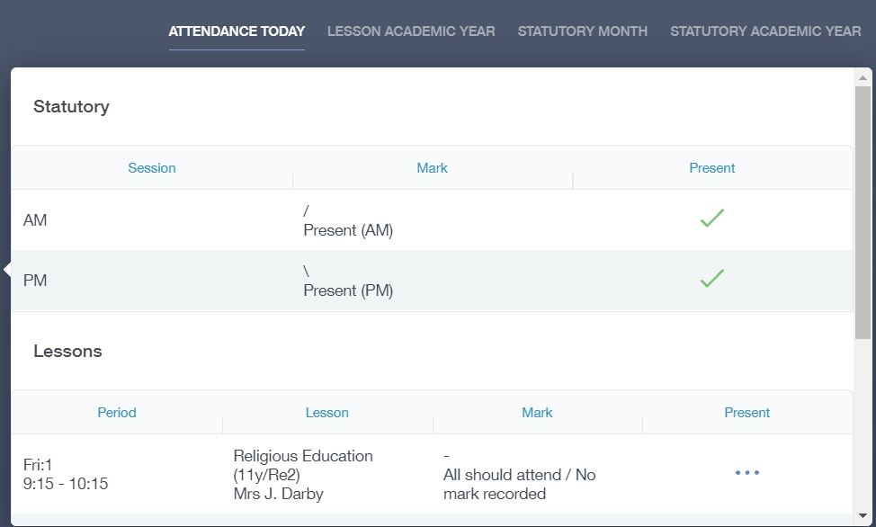
Additionally, the school has the option to allow you to see data regarding lesson attendance for the academic year, as well as statutory month data and statutory academic year data. The data in these sections appear as pie charts like the example below.
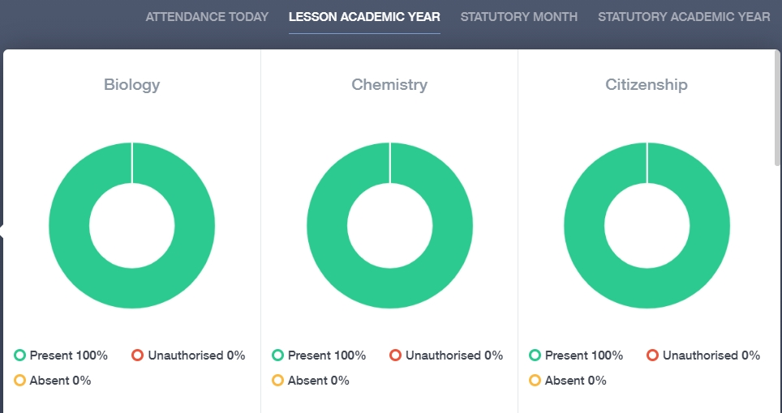

Assessment
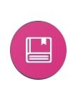
The assessment screen is customisable for every school, so most schools’ assessments will not look the same. If you are struggling to understand the assessment data, it is best you contact your school so they can explain their assessment process.
You can see your child’s/children’s grades, targets, attitude to learning and other aspects that the school wants parents to see in Assessments. Some schools colour code data to tell you if your child is working at the expected level. Many schools also provide a written explanation about the assessment, like what each effort grade means.
Also, you can view other assessments, including past assessments, and some schools may make KS2, KS3 or KS4 data available for parents to view.
Below is an example of what an assessment could look like in Edulink One.

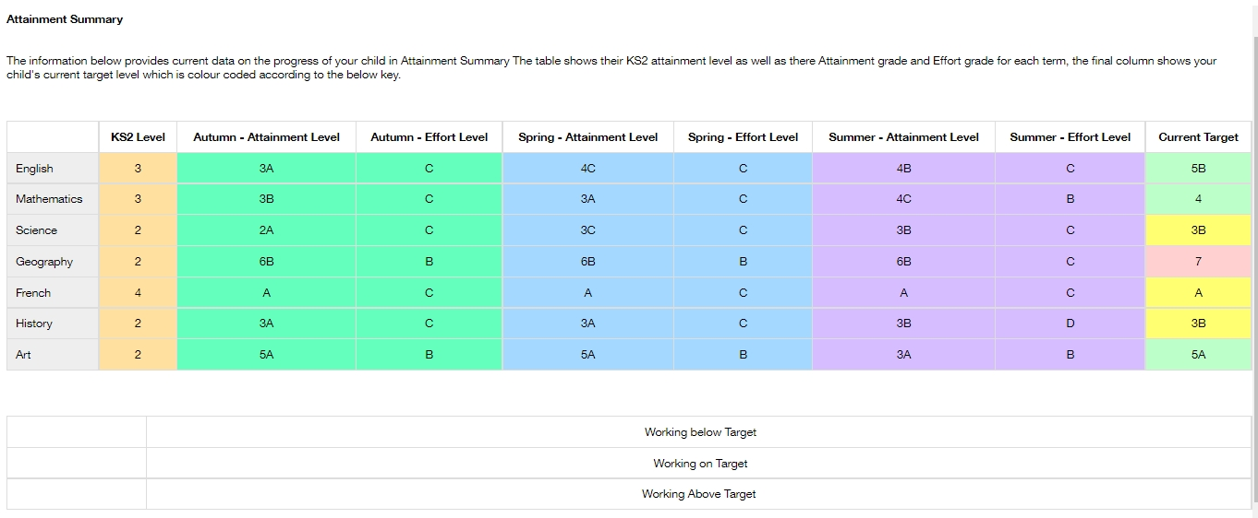

Noticeboard
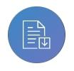
The noticeboard is where parents can see news and upcoming announcements from the school. Schools can upload newsletters, documents and other useful information.
There is also a snippet section at the top that displays important announcements, like the date of the school panto.
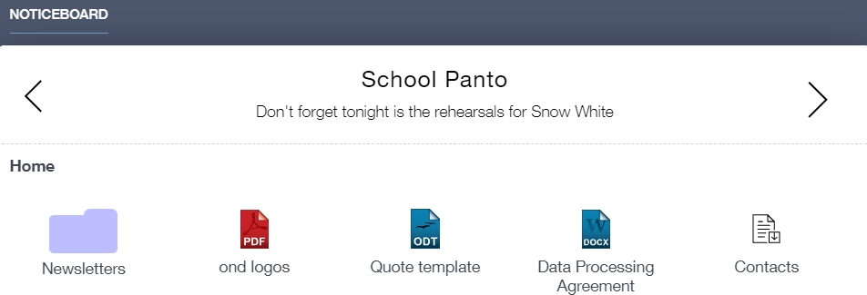

Calendar
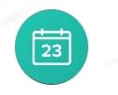
If your school has enabled the calendar in Edulink One, you can see the events that are going on at the school, such as term dates, staff training days, school events and more.
Homework can also be displayed for parents, linking the calendar up with the homework area in Edulink One.
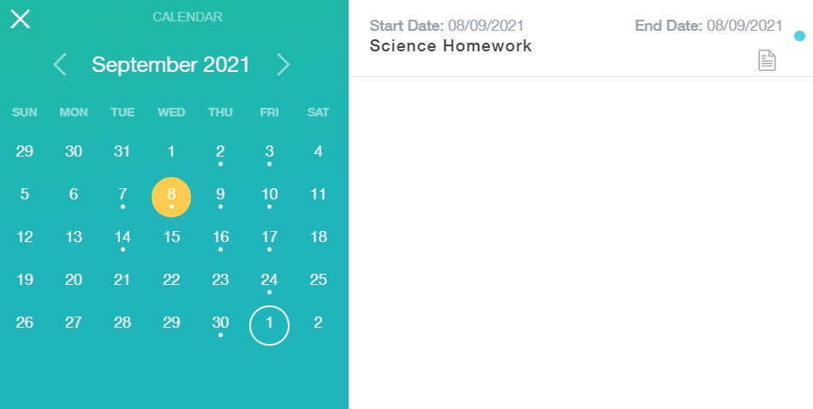

Manage Your Calendar
To manage your calendar, you need to go to the cog in the top left corner of the screen and click on it. Then, you need to click on Manage iCal.
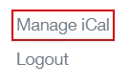
In Exports, you can export your child’s Timetable and school Calendar. To do this, press on the ‘toggle’ to turn on the export and then copy the link. 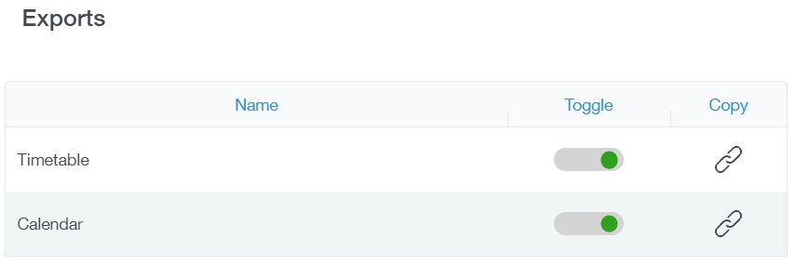
Afterwards, go to Imports and press the +Add button.
Import your child’s timetable and school calendar into your personal calendar, such as Microsoft 365, by pasting the link in the URL field. Give the calendar a name and click the Add button. 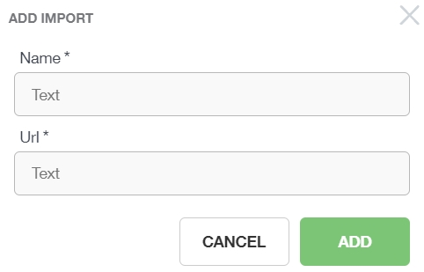

Clubs
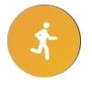
Clubs are a great way for your child to get involved in extracurricular activities. Parents can use the Clubs area to help their child sign up for open clubs the school is running. For any invitation only clubs, parents will see these under the My Clubs tab.

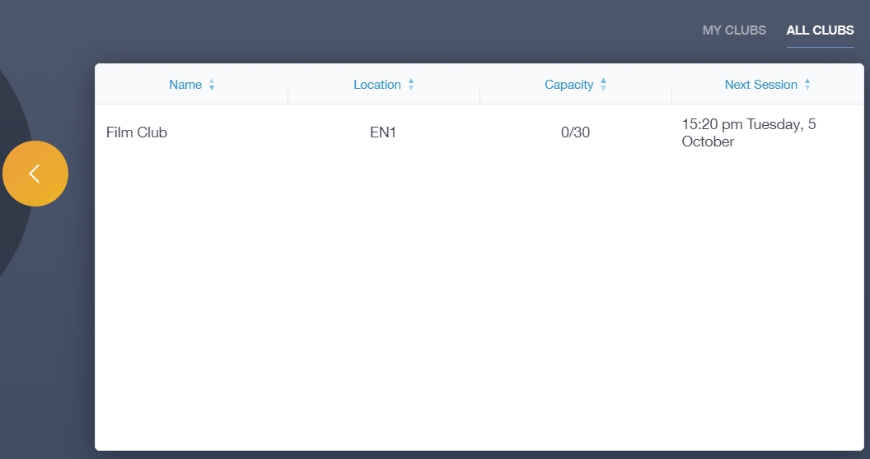
To help your child join a club, click on the club in the All Clubs tab. 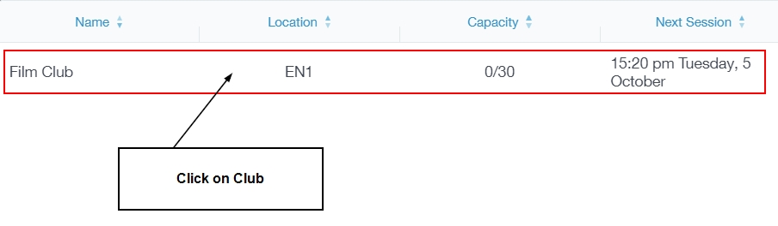
Once you have clicked on the club, a new window opens where you can read about the club and decide to join it.
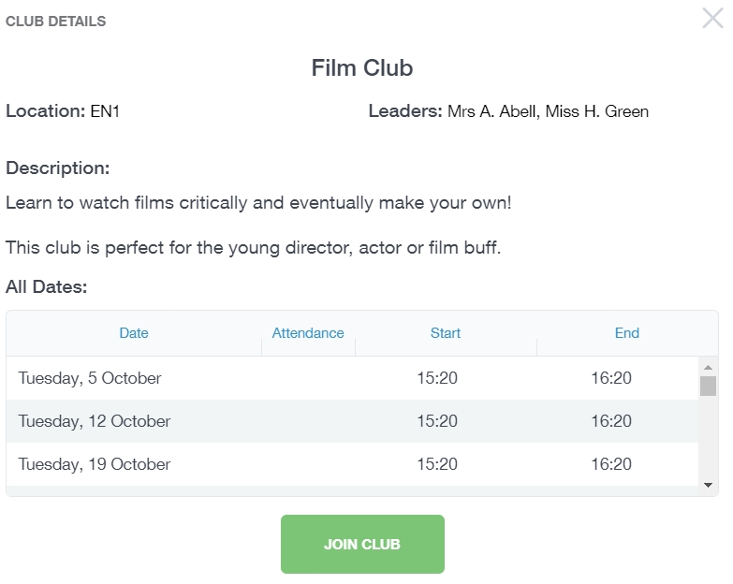

To join the club, parents should click on the Join Club button. It will now appear in your My Clubs tab. 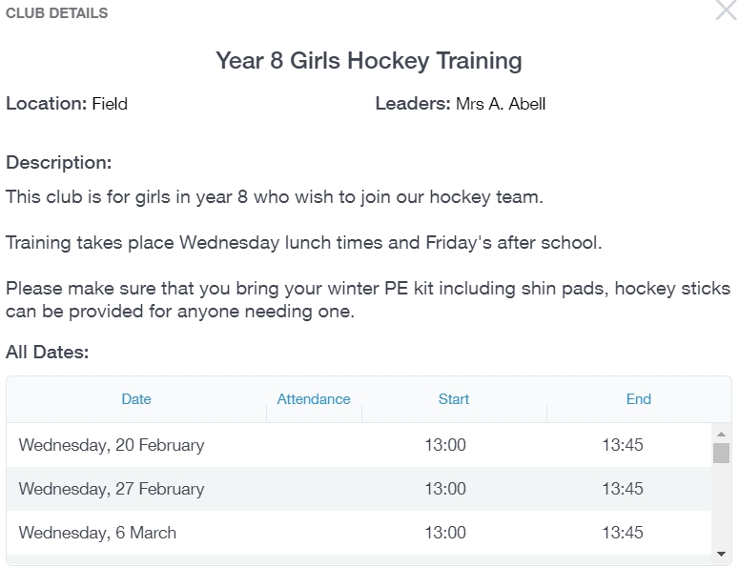
If your child has not been joined to a club by a teacher (such as revision sessions), you can choose to unbook a club. If the teacher signed your child up, your child will need to attend the club and must ask the teacher to leave, e.g. exam is now over so your child no longer needs to attend the revision session. You would need to contact your school’s teacher to leave a club the teacher has signed them up to.
Parents can also view a child’s attendance at a club. This appears after the fact and not during the session of the club. 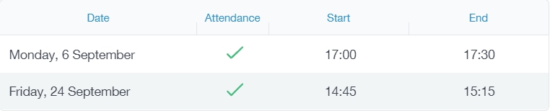

Parents’ Evening
*Please contact your school if there are Parents’ Evening issues.
The parents’ evening area in Edulink One allows parents to see the details about a parents’ evening and to book appointments.
To book your appointments, click anywhere on the parents’ evening event.
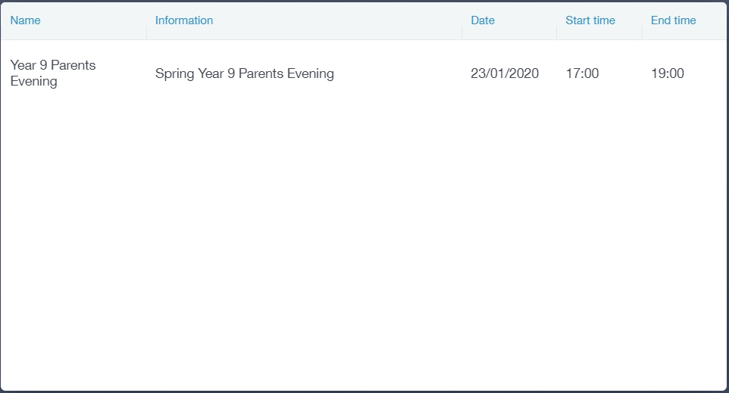
After clicking on the parents’ evening event, a new window will open where you can book appointments with all your child’s teachers. Free spaces appear as white, booked, or blocked spaces appear as grey with a red X, and spaces you have already booked appear in green.
To book an appointment, click on any free white space.
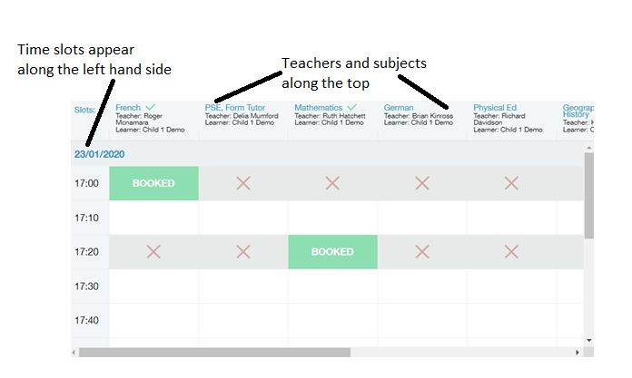

Once you have clicked on a free white space for the subject/ teacher column and the time slot column, then a new book slot window opens. It details the date and time of the booking slot, the subject you are booking for and the child you are booking for. At this time, you can also add a comment, for example, if there is something in particular you would like to discuss with the teacher.
Click on the green Book button to book. Your bookings will appear when you click on the event.
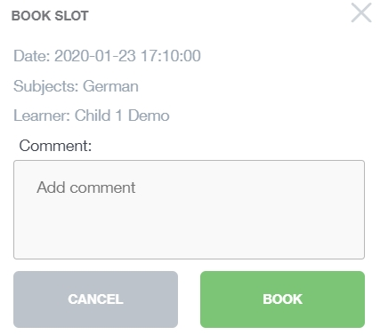
You can also print your bookings. Edulink One can also email (using the Email button) a copy of the Parents’ Evening bookings if your school has enabled these settings.
To print your bookings, click on the Print button at the top of your booking screen. A list of your appointments will be generated for you to print.

Attending a Virtual Parents’ Evening
Many schools have now included an option for virtual parents’ evenings. If your school is using virtual appointments, please open your parents’ evening area in Edulink One and click anywhere on your child’s parents’ evening event.
Once you have clicked on the parents’ evening event, you then need to click on the Start Appointments button. Note: This is only if your school is using video conferencing appointments; otherwise, appointments for parents’ evenings will still be in-person.
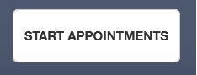
Your child’s teacher will start the appointments at the correct time and the appointments will happen automatically— parents just need to have the video conference open.
The next page shows you a view of what a video conference looks like. The teacher’s camera is larger in the middle and you will see your camera off to the right side.
Your next appointment is listed on the bottom. You do not need to do anything; the teacher will end the appointment when you are finished, or the appointment will cut off automatically at the end of the appointment time. This is highlighted by a red border 30 seconds before the appointment ends.
The teacher has no control over this cut off as it happens automatically to make sure all appointments run on time. If you need more information from a teacher, schedule a further meeting or telephone call with them.
