Staff Guide for [School Name]

There are two ways to use Edulink One: through a web browser like Google Chrome or through an app you can download to use on your mobile device. The Edulink One app is available for iOS and Android devices.
For more detailed instructions of all areas covered in this guide, please go to https://support.overnetdata.com/ to read articles on our Knowledge Hub. We have also published a helpful article for New/Trial schools to get you started https://support.overnetdata.com/knowledge-base/new-trial-school-setup-information/.

Web Browser Instructions
This is your school’s individual login link if you use a browser to log in.
Start by going to https://www.edulinkone.com/#!/login?id=YYYY or if you are not using your school’s direct link, visit https://www.edulinkone.com/.
After clicking the link this will take you straight to the Edulink One login page for your school.
If you do not have a direct link, you will need to enter your School ID or Postcode and press Next. Your School ID will have been sent to you by the school. In general, schools use network usernames and passwords. If you forget your username or password, please contact your IT department.
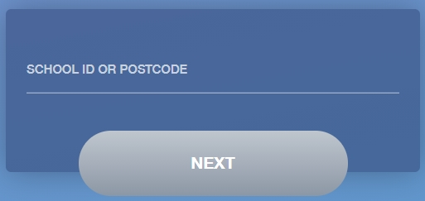

Enter your Username and Password.
Once you have filled in the username and password boxes with your login details, click LOG IN to get started.
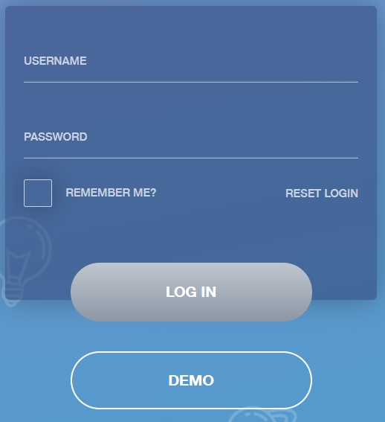
Downloading and Using the App

The Edulink One app is available for iOS and Android devices. You can download from these links or search in the App or Play stores.
Apple App Store
https://itunes.apple.com/gb/app/edulink-one/id1188809029?mt=8&ign-mpt=uo%3D4
Android Google Play
https://play.google.com/store/apps/details?id=com.overnetdata.edulinkone&hl=en
If you are using the mobile app you will see the screen to the left.
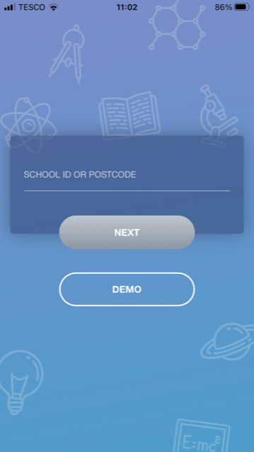
You must enter the SCHOOL ID or Postcode to continue.
Followed by your USERNAME & PASSWORD.
Once you have filled both boxes with your login details, click LOG IN to get started.
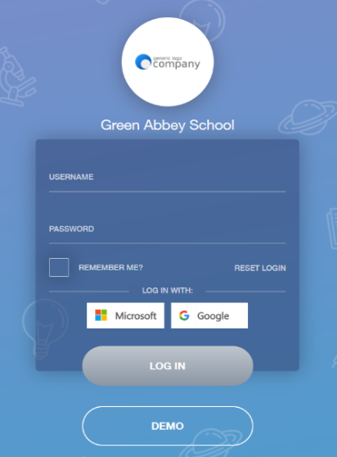
If you forget your username or password, please contact the school.

You will then be logged into EduLink One and see the main interface as below:
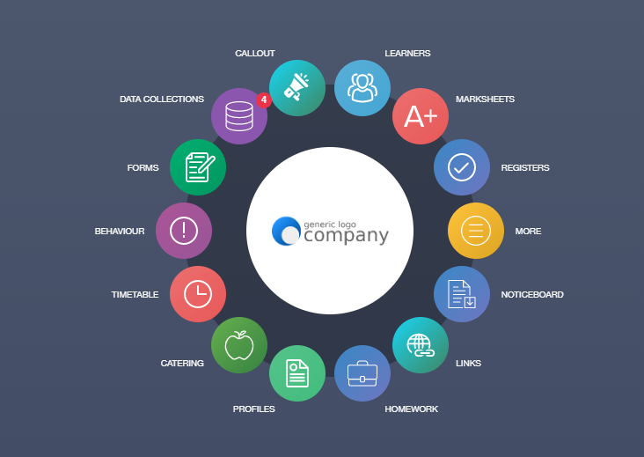

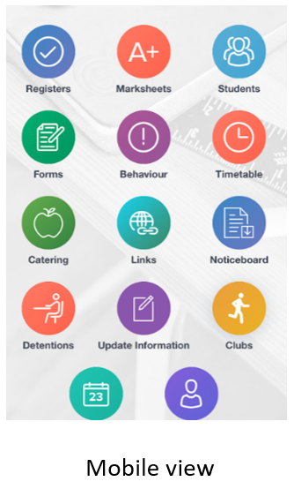

Messages
To send a message to a Year, Group, Form, Student etc., select the Messages icon at the bottom of your browser window or Mail icon at the top right on mobile.

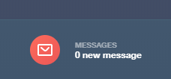

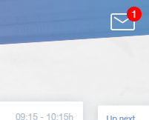

Click on the New Message button or select the new message icon on mobile at the top right.
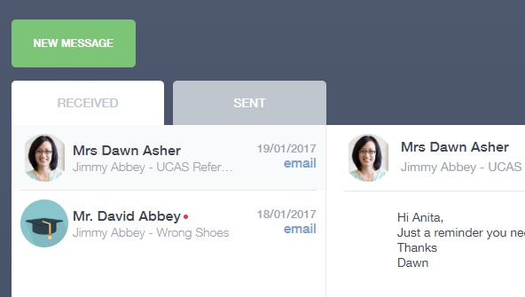

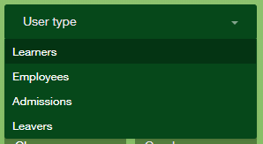
You can filter the message by user type. If you would like a message to be sent to Learners, for example, you can use additional filters such as Year, Form, Class, Gender etc., as pictured below.

Then, select the learners you would like to send the message to on the right-hand side. To do this, click on the image or the learners you would like to include and tick ‘Selected’ or tick the Select All box to select all learners in a class, year group, etc…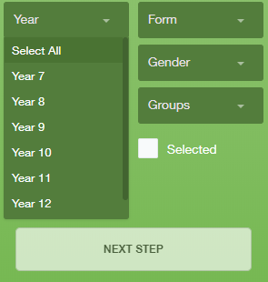

Next, you can see the list of recipients before sending the message:
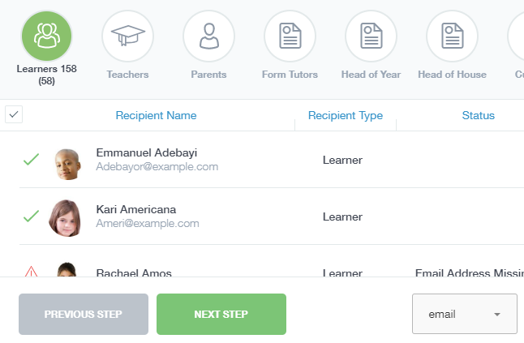

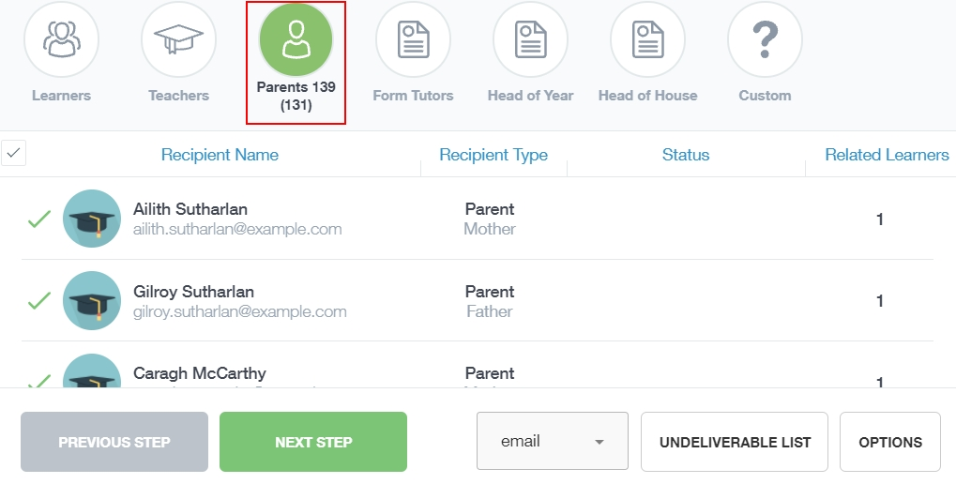
You have the option of messaging parents by selecting the Parents icon at the top.

If there are parents or learners that do not have email addresses in your system, you can export an undeliverable list by clicking the Undeliverable List button. You can then contact them in another way.
You can then compose your message and Send when complete:
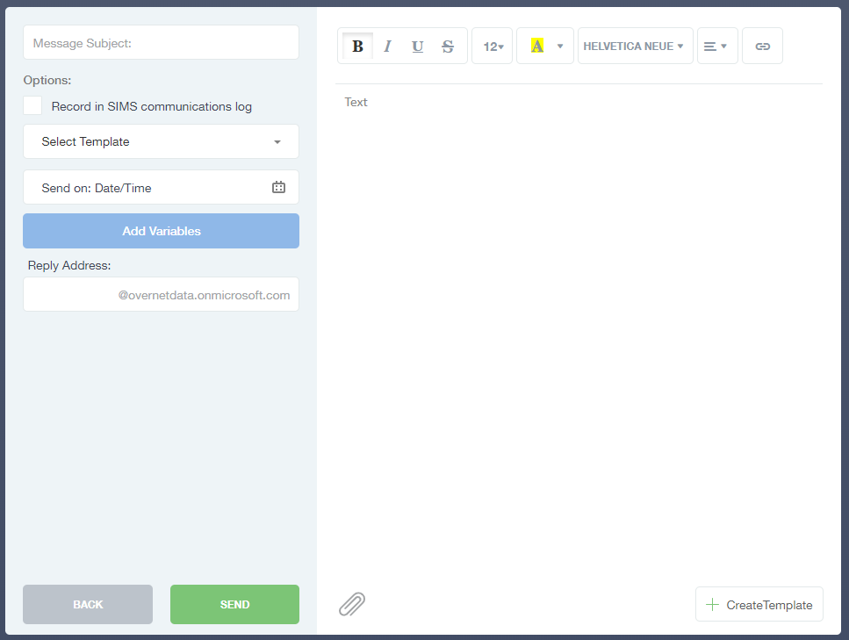
Once you click Send you will get the following confirmation, stating the number of messages to be sent.
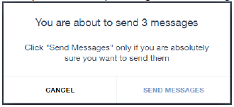

Timetable
Selecting Timetable will take you to your current timetable:
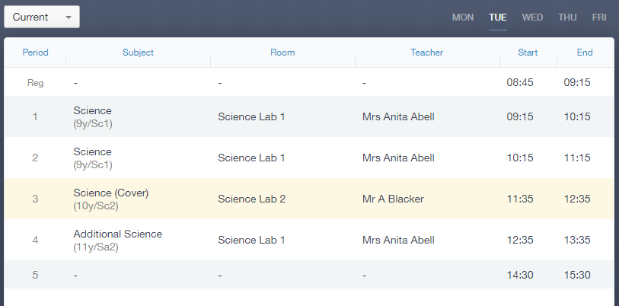
You can view other teaching timetables by selecting your name at the top right and searching for another member of staff.
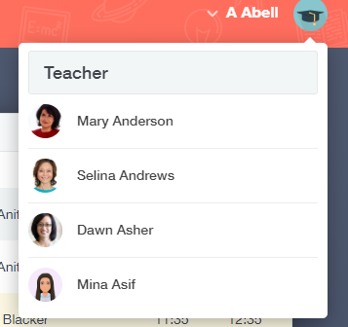

To view learners’ timetables, you need to select the Learners icon in Edulink One, search for the learner by typing in their name and then click the learner’s picture to enter their screen.
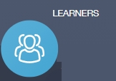

Behaviour
Selecting Behaviour allows Achievements and Behaviour to be added, either individually or in bulk. Select either the Add Behaviour or the Add Achievement button (to add bulk behaviour or bulk achievement select the buttons on the bottom left). This can also be added via the Register.
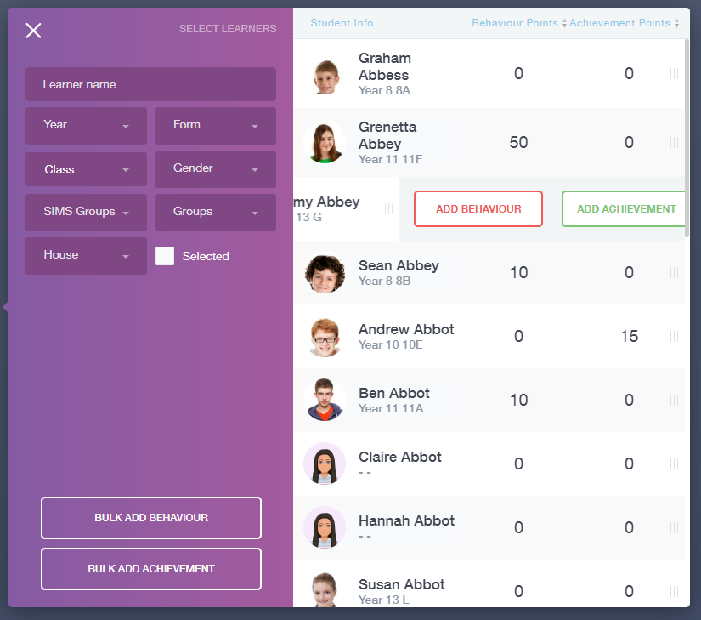
Mobile View
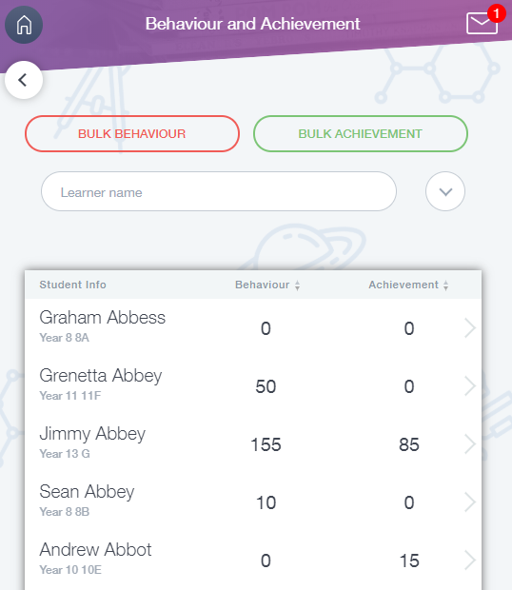
Select the behaviour type, activity, action taken, action taken date, status, detention and fill in a comment regarding the incident. Behaviour points are taken from SIMS.
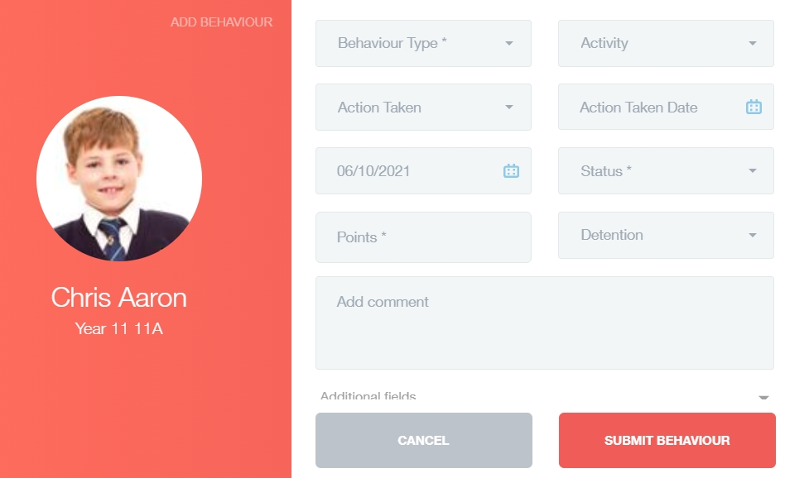

Staff can also fill out additional behaviour fields to add more behaviours by clicking the dropdown arrow.
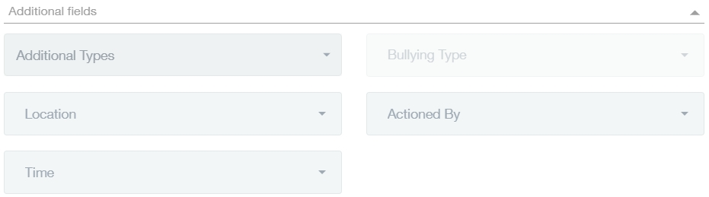

Learners
Selecting the Learners icon will display a list of all students on the right pane with filtering options available on the left:

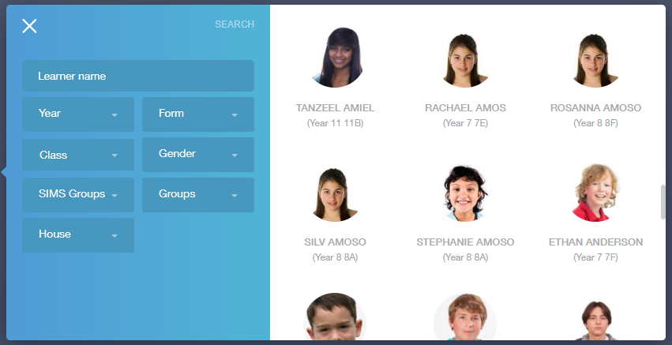

Selecting an individual student will bring up the available information for that student:

This is a quick method of viewing Behaviour, Achievement, Timetable and any Documents attached to a student’s profile.
Selecting Contacts, for example, will bring up all contact information available for this student.

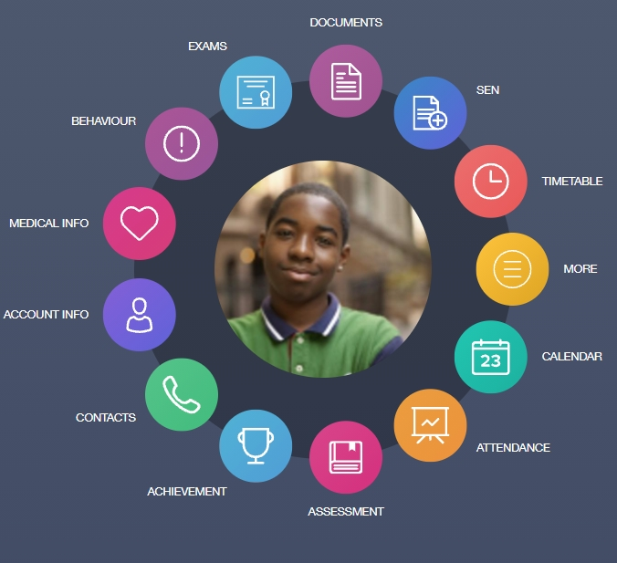

Selecting More will display additional menu options:

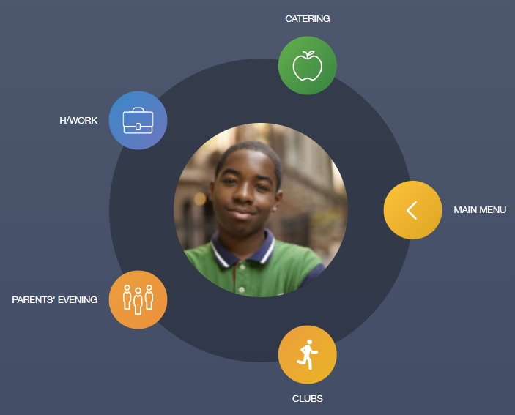

Additionally, you can check the seating plans for each learner’s classes in the Seating Plans icon within Learners.
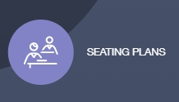

In the table, the Group Name, Teacher Name, Room Name and Seating Plans created in Edulink One are visible. This does not apply to seating plans created in other programmes.

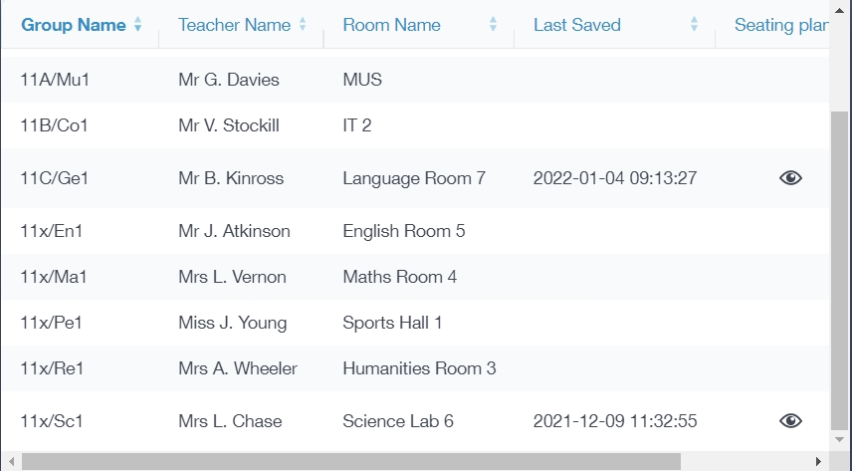

To view a class seating plan for the learner, click on the eye icon.

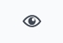

The seating plan will load and you can choose to download it to your computer where you will also be able to print it. Like the seating plans functionality in Registers, you can hide learner photos and show additional data if you choose.

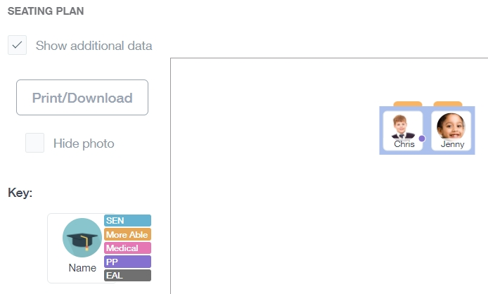

To return to your main menu, press the back arrow on the icon.

Registers
Selecting Registers will allow you to take a class register. Select a register from your class list to begin. Below is a view of the Register screen once it is opened.
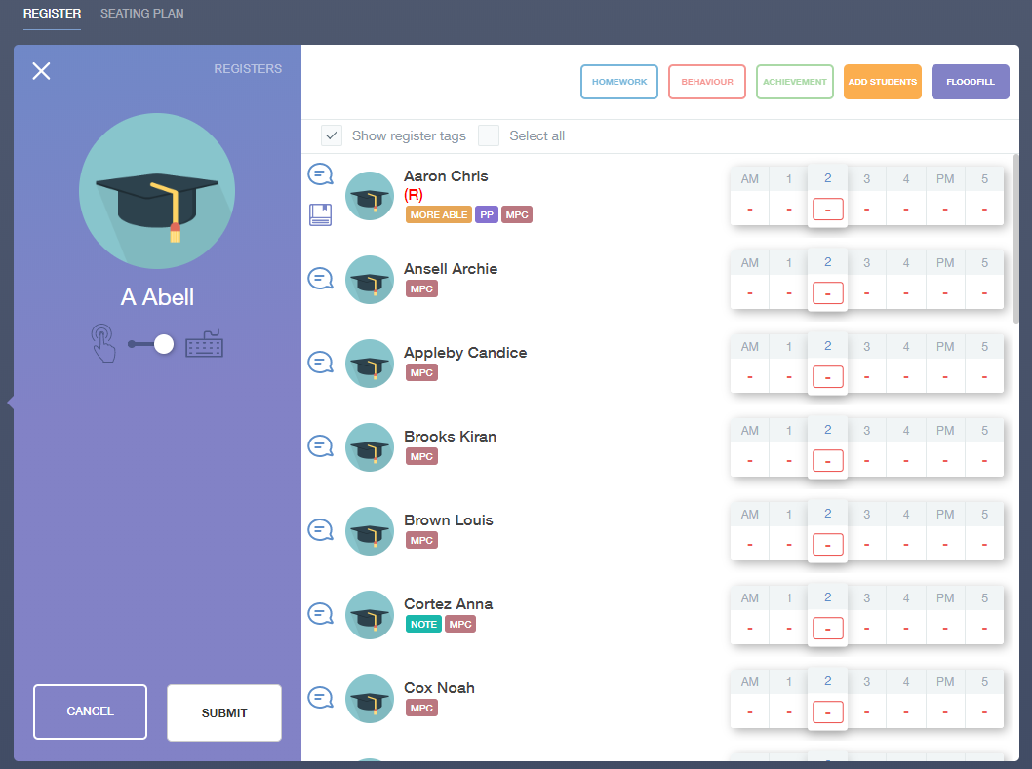

Toggling the slider under your staff picture and name will switch between touch interface and keyboard input, allowing you to choose how you want to take your registers. The register marks correspond to SIMS, e.g. /, N, L, M. You can also add comments if you press on the speech bubbles beside your learners.
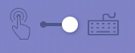
Additionally, there are options to add Homework, Behaviour, Achievement and to Floodfill marks. You can also add a learner to a lesson temporarily if required. You can also choose to select all learners, add tags, such as SEN, as well as meal options if enabled.

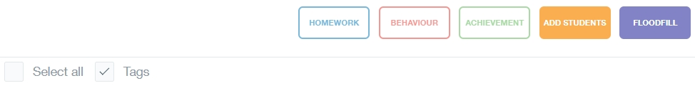How to Take a Register
To take a register, select whether you would like to fill in the register using a mouse or a keyboard (not all information about various mark codes is available in the keyboard option). The learners are listed on the left and the attendance marks on the right.
To mark a learner Present, select the checkmark which will turn green. To record an Absence, select the cross.
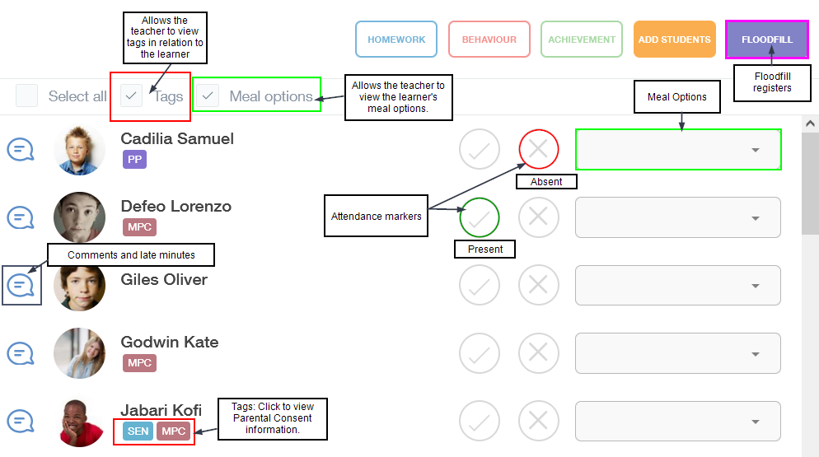
Select the appropriate mark code for the learner's absence and click it. The mark code will be recorded in red indicating the reason for the absence.
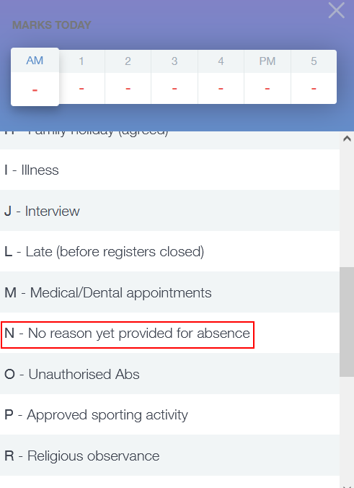
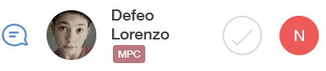
To override a mark you have submitted, select a new mark code from the Absence (X) column. Alternatively, you can override an absence code and mark a pupil present if an error was made.
Certain mark codes may generate a confirmation message if you attempt to change them. This may be because the attendance officer has filled these in before the start of lessons. Consider carefully before changing these codes.
Tags: Learner tags, including SEN, PP, Medical, Gifted and Talented, etc., will be visible to the teacher when the Tags box is ticked— this includes information regarding Parental Consent. To view the parental consents, click on the learner.
Tags contain potentially sensitive data. Therefore, it is important to consider whether the tags are on before projecting a register.
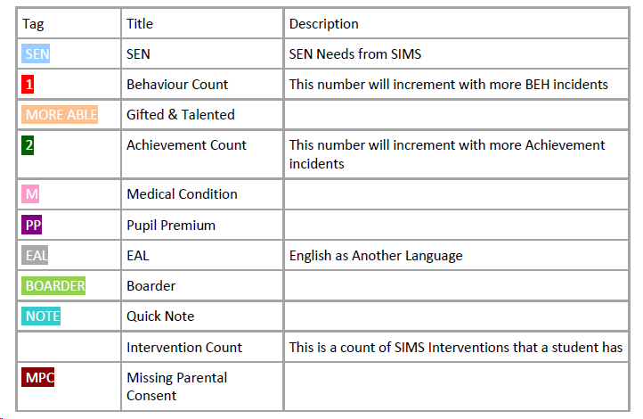
Meal Options: Tick the Meal Options box to fill in what meal the learner is ordering/has for that day. Teachers can select which meal option each student has from the dropdown menu beside the AM or PM marks.
Teachers can select from Cash Cafeteria, Home, Other School (in the event the learner attends more than one school), Packed Lunch and School Meal. Furthermore, if a learner is absent, teachers can select 'Absent' from the dropdown menu options.
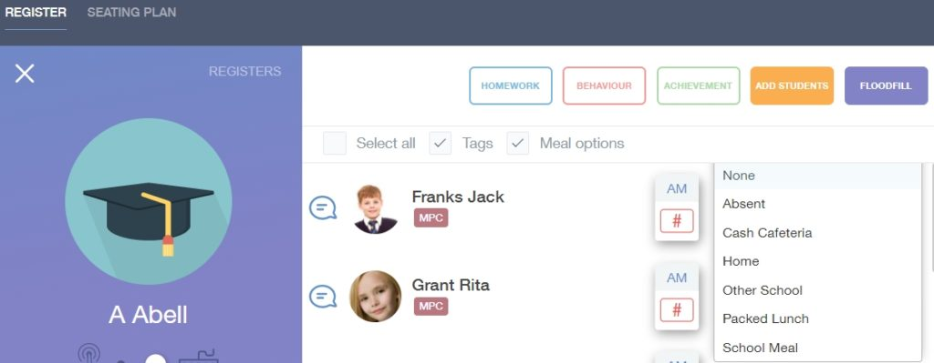
Lateness: To add late marks to your register, click on the Absence X icon. Select Late (L) before registers close to record a late pupil that arrives before registration. This will appear as a green L in the Present checkmark column. However, if a learner arrives late after registration is complete, select Late (U) after registers close which will appear as a red U in the absence column.
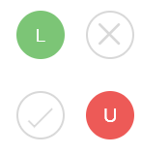
Late Minutes: To add late minutes to a learner, select the Comment bubble beside the learner's image. You can include comments regarding the learner here and submit late minutes.
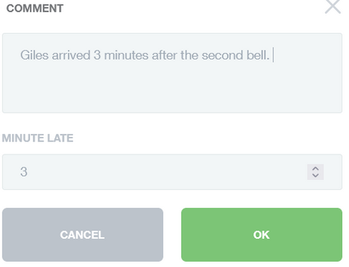
Floodfill: In the event you would like to flood fill a register, select the Floodfill button in the top right-hand corner. Then, select which mark code you would like to input and click it.
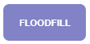
The register will flood fill with the chosen mark code.
When you have finished your register, click on ‘Submit’.
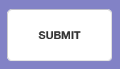

Seating Plans in Registers

An Introduction to Seating Plans
To determine what seating plan to create, Edulink One selects the first scenario that matches and will use that scenario to determine what is displayed to the teacher or member of staff; for instance, if someone has already created a seating plan for that room. Moreover, the teacher is the teacher assigned to the register on SIMS.net, not the end-user, e.g. cover supervisors.
The order of checking for the existence of Seating Plans is:
- Edulink One first looks to see if there is a plan for this teacher and this
teaching group in this room. If there is, it displays it.
- If there isn’t, it checks to see if there is a plan for the same teaching
group in this room (different teacher). If there is, it will display the plan
to include the furniture and the students which can be altered to your
liking.
- If it can’t find either of the above it checks to see if any teacher has a
plan in this room with any teaching group. If they do it will display the
table layout only (because there’s not one with this group of students).
- If none of these criteria is met, Edulink One checks to see if there is a table
layout. If there is, it displays it.
- If there isn’t any of the above, Edulink One displays an empty room.

Getting Started
The first thing to do at the beginning of the school year is to create a table layout in Seating Plans as the first table layout created for your room is saved for anyone using it. It’s a good plan to do this as the layout will remain for anyone in the room, just be aware that the seating plan you create for a room can impact other teachers.
Furthermore, if there are teachers that teach the same class in the same room, it’s worth saving the entire seating plan with the students added so they benefit from the students being seated. They would be able to amend it and not affect the original plan, as any amendments you make to your seating plan after a ‘save’ will not be reflected anywhere else except for the same class/room.
Log in to Edulink One using the app or website, and locate the Registers icon on the homepage.
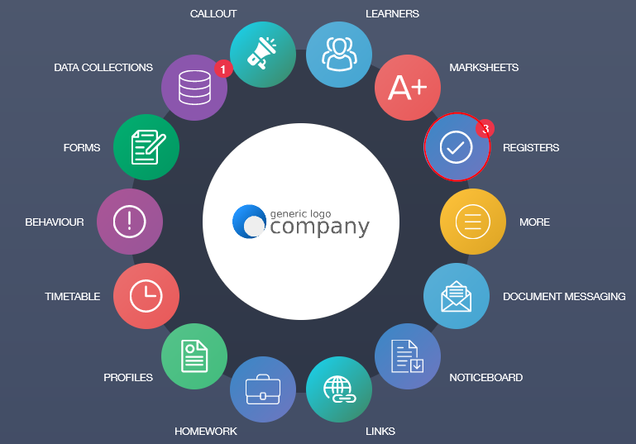
In the register, select the class you would like to create a seating plan for and click on it.
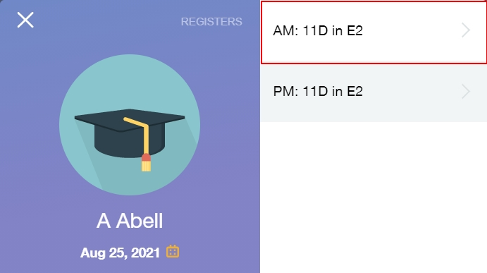
Once the register window opens, select the Seating Plan tab in the top left corner of the pane.
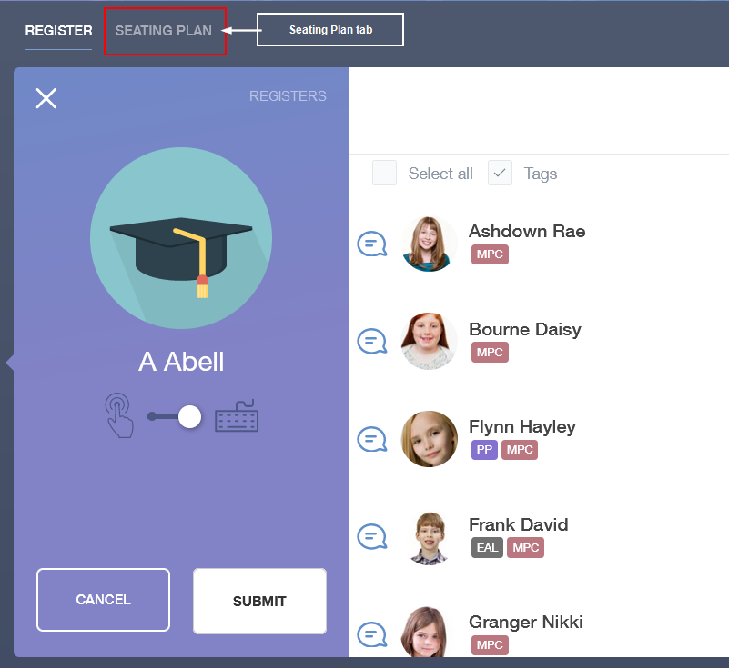

Adding Furniture
Firstly, begin with Room. Enter the dimensions of your room (meters), if you don't know the dimensions, you may be able to ask your site team or you can estimate the measurements.
Next, drag and drop the board into the white box to the right, positioning it to where it is located in the room. Then, drag and drop the table type you would like to use into the box, mirroring the layout of the room you have set up.
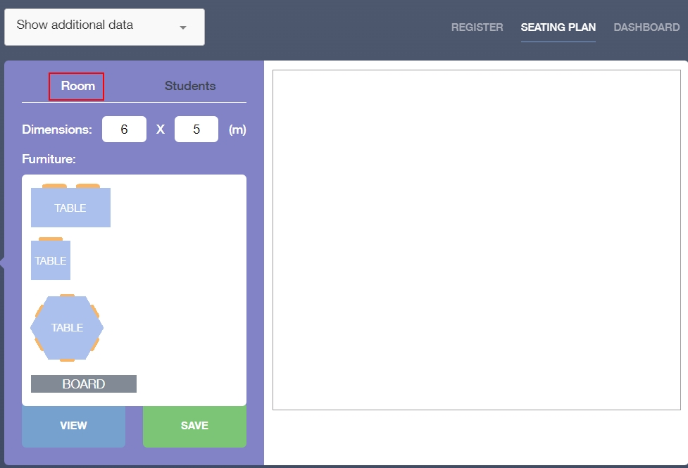
Room Set Up
If you need to turn the desks, e.g. to create group layouts or E/L shapes, use the rotate icon in the middle of each table. Click on the rotate icon to rotate the table into the correct position.
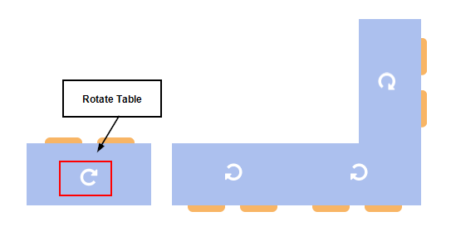Rotate Table
It is important to note, any changes you make to a room layout after setting it up at the beginning of the year mean you will have to change each seating plan individually. Edulink One only 'copies' the original seating plan for your room the first time you create it; otherwise, you need to change each seating plan every time you make a change to furniture layout— this is the same for any other employee that uses that room.

Adding Learners
Add learners to your room once the furniture layout is complete. Click on the Students tab to add your learners to your room.
If you would like to see additional information about your learners, select the Additional Data dropdown menu at the top of the seating plan screen. You can choose from three areas: Assessment Areas, Behaviour and Achievement and Tags, which could include SEN, PP and EAL data.
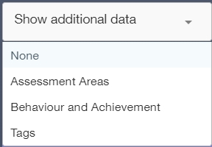
Additionally, a feature of the student list is the latest grade (TAG, SAG or similar). You can search grades based on the latest data entry, autumn data or spring data. Use the up and down arrows to change the order of the list from low to high.
The data in the seating plan is customisable in the Seating Plans tab in the Administration Settings. However, this is limited to three sets of data due to user interface restrictions.
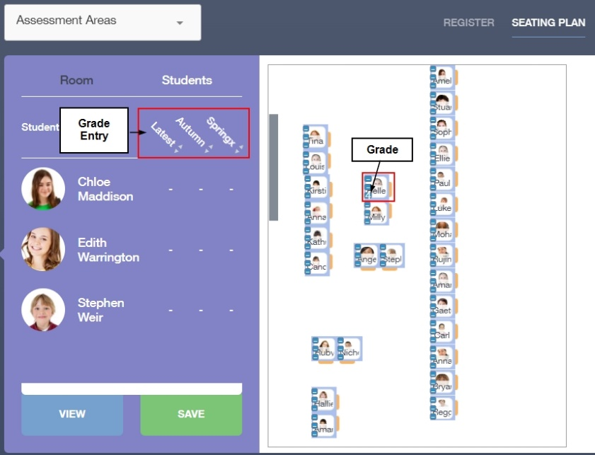
Following this, drag and drop the learners into the seating arrangement. Data regarding learners' grades and additional data (SEN, PP, G&T, etc...) will appear in the seating plan.

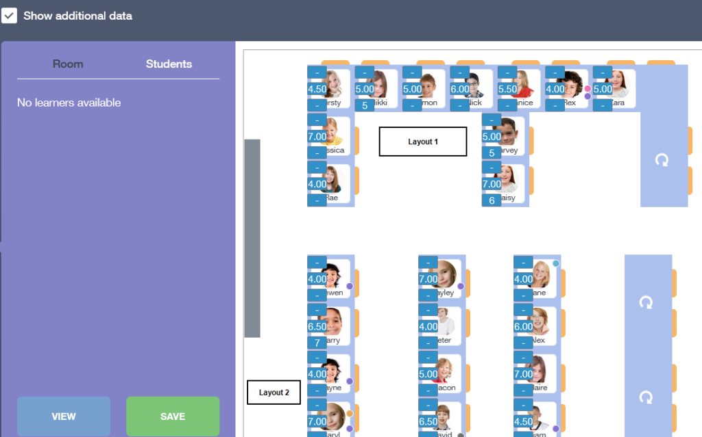
Click Save when you have completed your seating plan or to save the seating plan to return to it later.

Viewing, Printing and Downloading Seating Plans
To view your seating plan and to print it, click on the View Button.
Show Additional Data: Tick the Show Additional Data box to show the data on the printable/downloadable version of the seating plan.
Key: The key explains the meaning of the colour coded data circles, for instance, Pupil Premium (PP) students appear in purple.
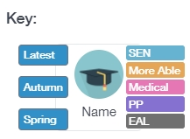
Hide Photo: Select Hide Photo if you do not want the photo of the student to be visible on a printed or downloaded version of the seating plan. Additionally, hiding a photo will make the learner's full name visible.
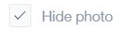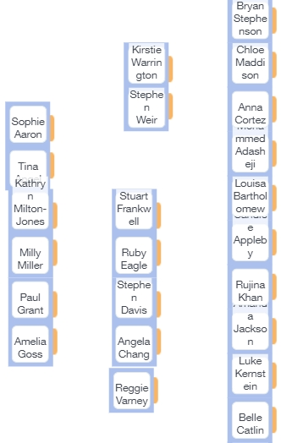
Consider whether this data would be a breach of GDPR if planning to use it in an unsecured location.
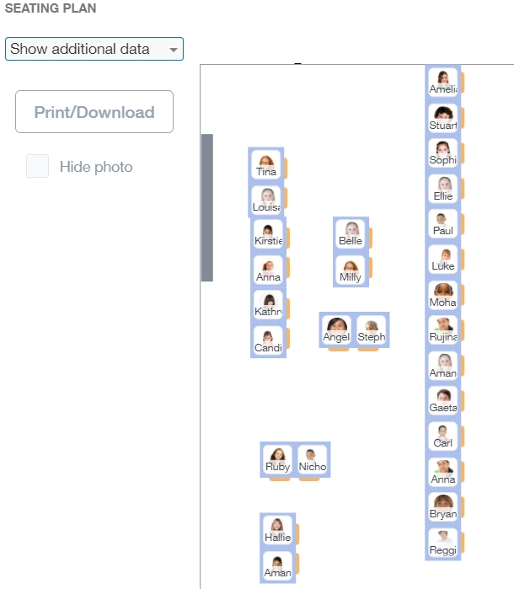
Lastly, click the Print/Download button to print or download a file of the seating plan.

Downloading Seating Plans
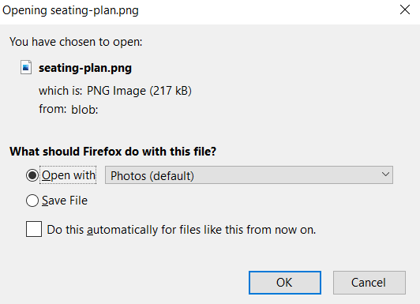
To begin with, choose to open the file by selecting Open With or save the file by selecting Save File. Depending on what application you choose to open your seating plan with, you can save or print the file in that application (e.g. Photos).
If you save your file, it will be available in Downloads.
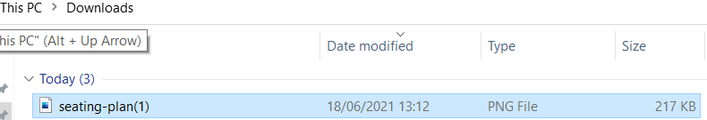
To return to the main register, click the X in the top right-hand corner. Check to see if your seating plan has been saved by entering the Seating Plans tab. Your seating plan will be located in the white box and will be configured to the specifications you entered.

Class Dashboard in Registers
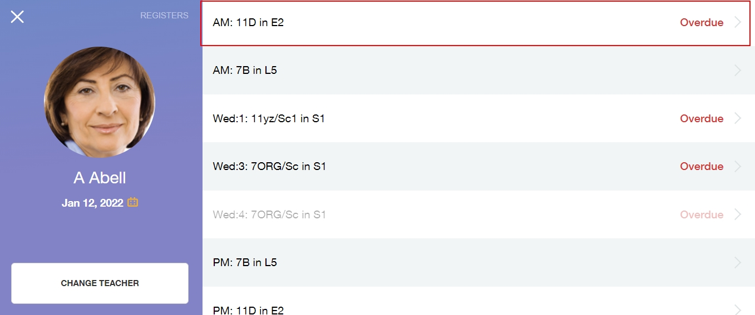
Class dashboard allows teachers to view learner data for all pupils in a class. To begin, click on the Registers icon and select the class that you wish to view.

Select the Dashboard tab to view the data.
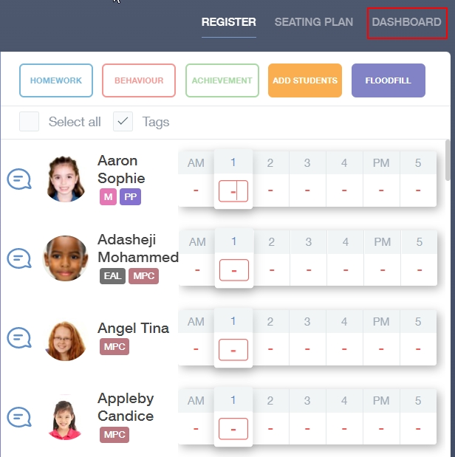
The class dashboard outlines the details for your learners. The example below is a Year 11 form group and it contains the information your administrator has enabled. It is important to note that every school is different and not all of the fields will be visible if your Edulink One administrator has not enabled them.
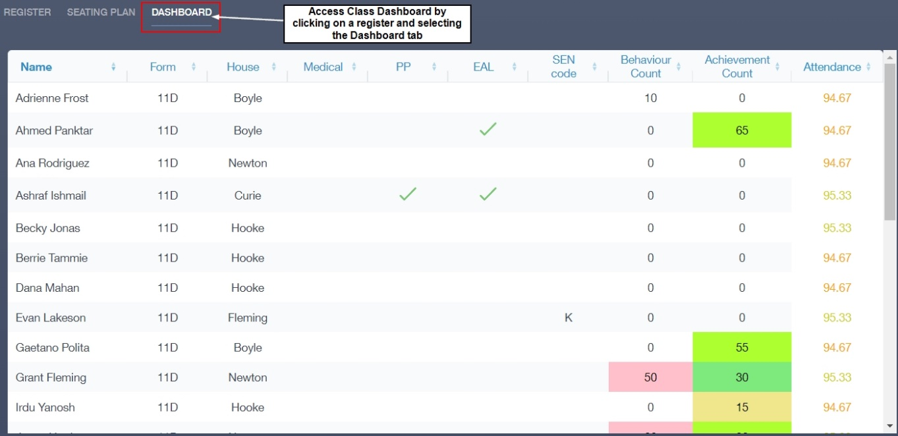
The class dashboard covers the following areas but not all may be visible: learner name, form group, house, medical information, pupil premium, EAL, SEN code, behaviour points count, achievement points count, attendance data and assessment data.
If included, assessment data aspects can be colour coded by the administrator using conditional formatting.

Clubs
Clubs can be used to register membership and record attendance for any school club. This is typically used for (but not restricted to) before and after school clubs.

Employees can set up clubs, with optional capacity limits. They can either manage the membership of the club themselves or allow for learners (or parents) to register for the club.

The club leaders can then take registers for each session to record the attendance. These registers are not written back to SIMS, so they will not affect your school attendance data.

Selecting My Clubs will show the list of your clubs. You can view all clubs by selecting the All Clubs option on the top right hand side:
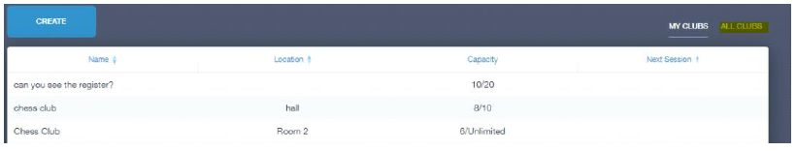
Click Create for a new club:

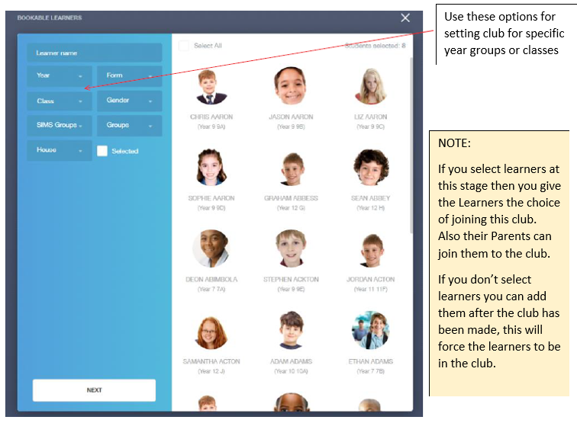
Add the Name of Club
The Capacity is where you put the maximum number of members of the club
Location is where the club is going to be held

Once you click Next you will see the Club window where you can name your club, provide a description, and set the capacity and location of the club.
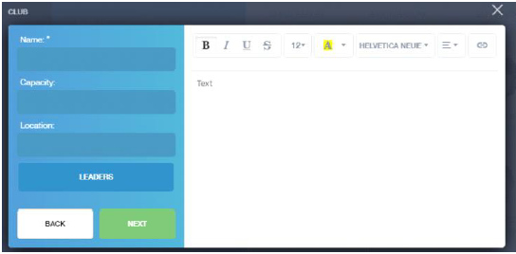

At this point the Leaders button will automatically set you (the creator) as the leader. You can add other Leaders if you choose. Leaders act as administrators of the club.

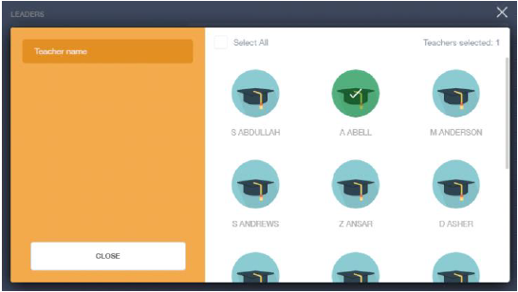
Once you click Next you will see:
The Start date is the date the club runs from.
The Start time and End time is the time of the club.
Weeks is the number of weeks the club is running for.
When you click Add Session it will create the club for the weeks it is available (you will see this in the area marked by the arrow).

Click Done when you are happy with the settings and the club will be created.

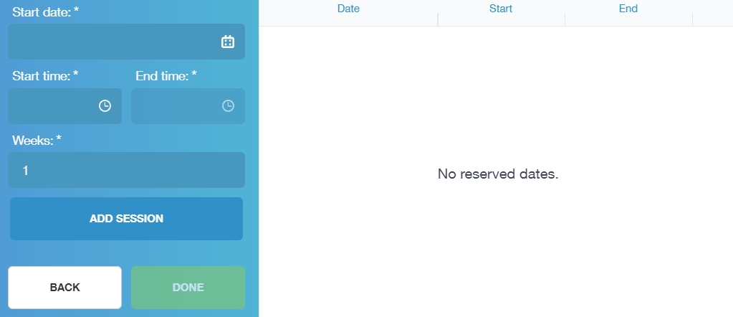

To Modify a Club
Click the club you wish to modify.
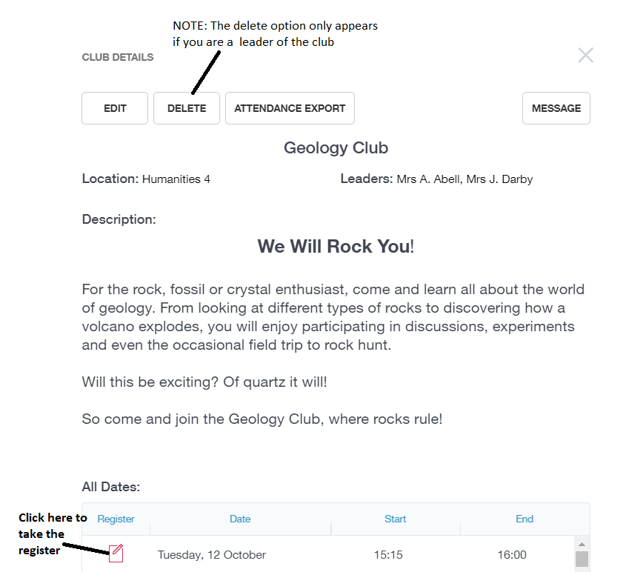

Marksheets
Selecting Marksheets will bring up your available marksheets in a list to the right.
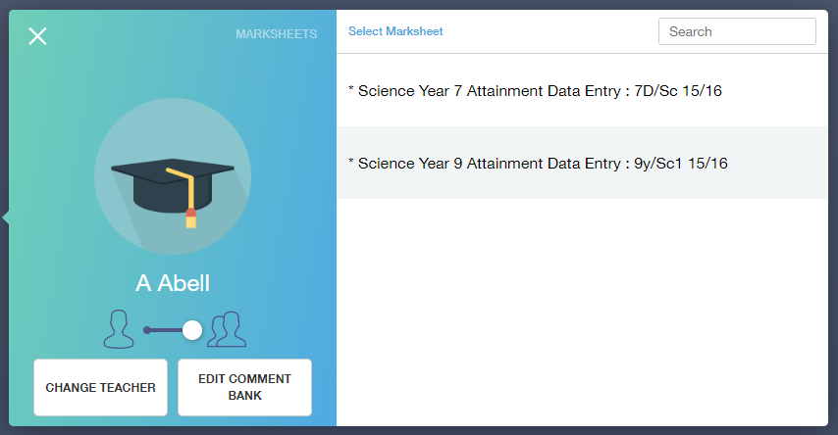
Selecting a marksheet will allow editing, saving, marking as complete or export options.

NOTE: If the marksheet is ticked completed, you will not be able to adjust marks until you untick Marksheet Completed.
Selecting Change Teacher will present a list of staff as below.
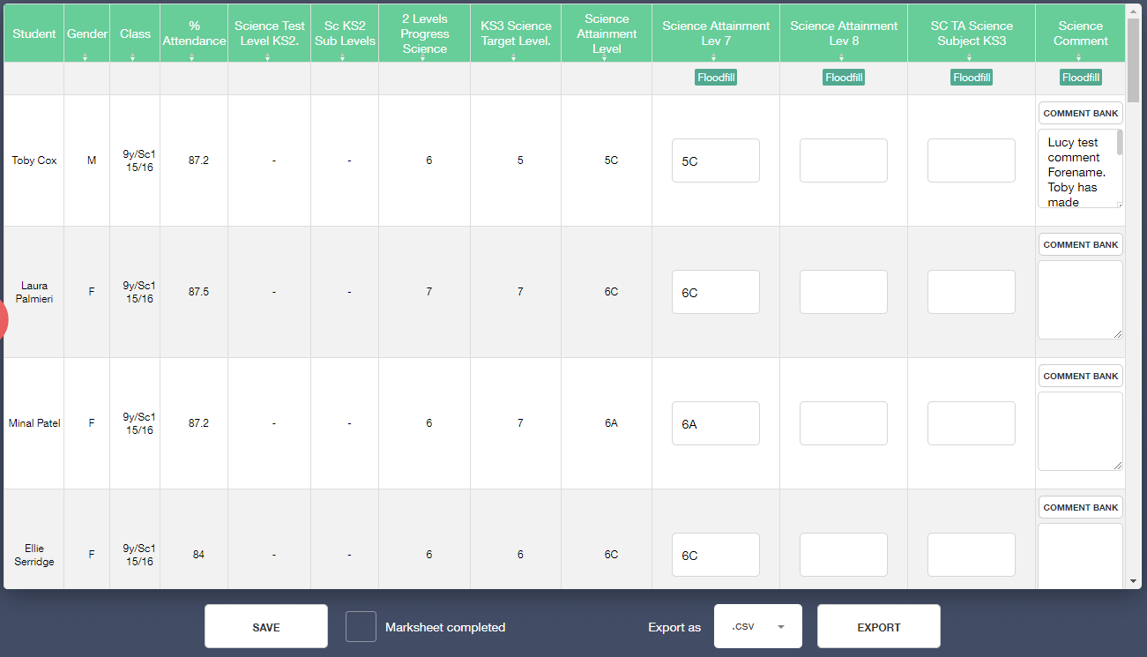
Selecting a member of staff will display their marksheets.
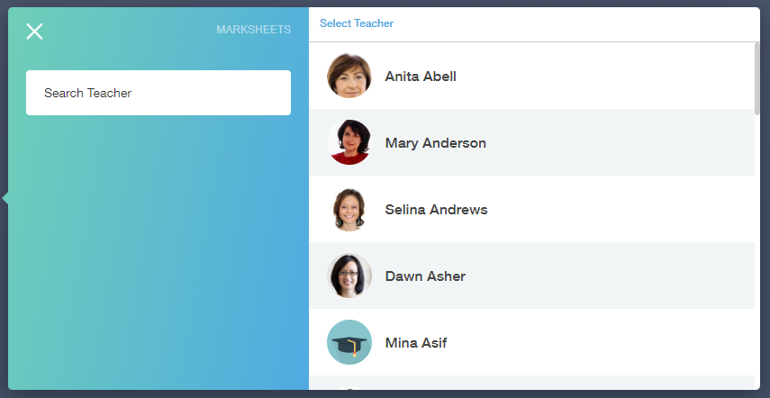
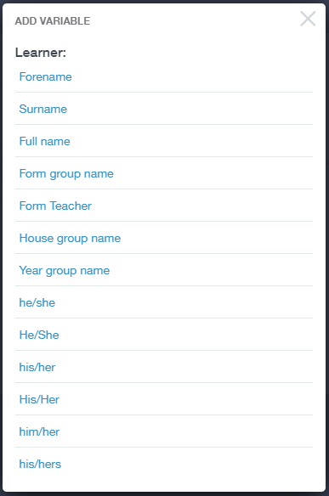
Selecting Comment Bank and filtering by Year and Subject at the top will allow editing and adding to the Comments available, like in the example below.
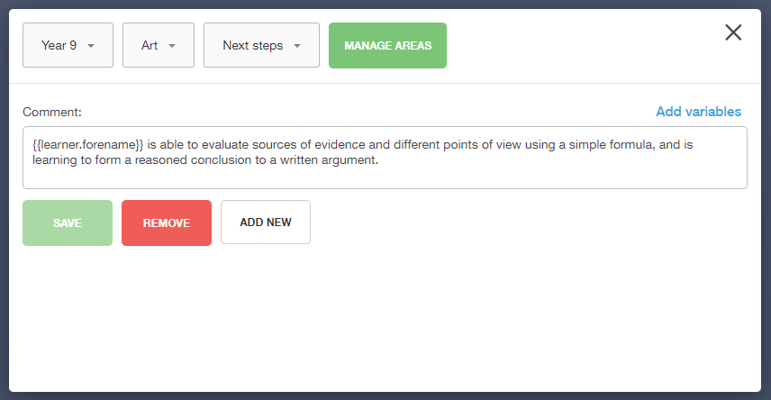

Variables can be inserted into the comment text
via the Add variables link.

Forms
Forms can be used for a range of multiple choice type responses that you need from parents. You can use them for something as simple as selecting a meal option, or you can use them for permission slips to attend a trip. The uses are endless.

Select the Forms icon to create a quick feedback form. To create a new form click New.

Fill in the Name of the Form, Due date and Available Date in the highlighted areas
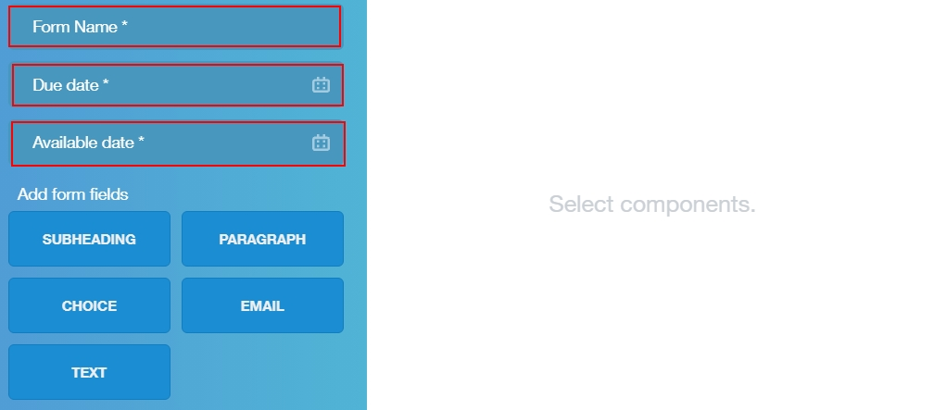
NOTE: Once the due date passes the form will disappear from all recipients’ screens. The form creator will still see the form.
Next click PARAGRAPH as this allows you to add text to explain what the form is about. You could also include subheadings to further break up your text.
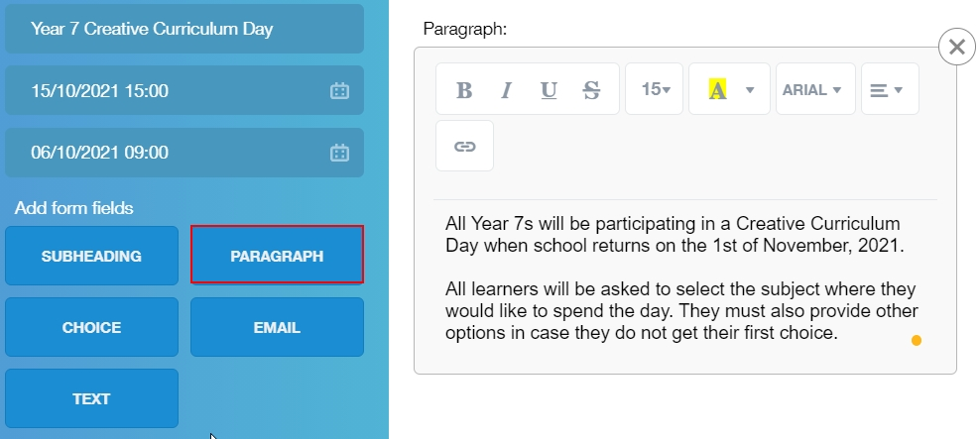

Next if you click CHOICE this allows you to create a multiple choice question.
In the Label box, type your question e.g. What is Your Choice for Creative Curriculum Day?
In the Option box, type your option and click ADD then type the next option and click ADD. Continue until you have included all the options you want to provide. This can be Yes or No type questions as well.
If you require an answer, click the Required Box.

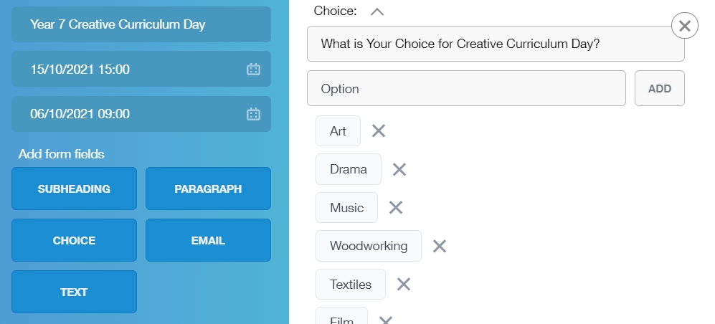

You can also choose to make the respondent include their email address or provide text. For example, providing second or third choices. You must include a label, generally a question the recipient must answer and a placeholder which appears in the text box, e.g. ‘My other choices are’.

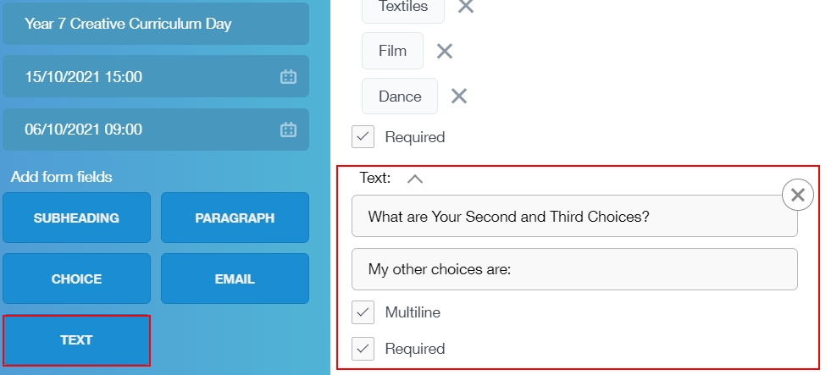

You can also tick whether a multiline answer is necessary and whether a response is required.

Once the form is laid out how you would like click RESPONDENTS button
The screen will change to the Respondents window.

Select the type of respondent you would like, parents, employees or learners. You then can filter by any of the options listed below the respondent type. For example, select the Year to limit a form to a specific Year group, e.g. Year 7. You can then tick the Select All option above learners’ images or manually select the pupils.

Once you are ready to send select DONE.

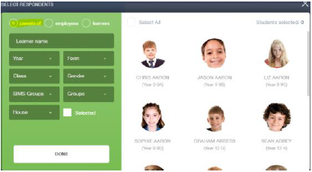

The forms will be sent to your respondents and the form will appear in your forms table.

When the respondents reply, you will be able to see their replies by going back into forms and clicking the orange View button on the relevant form. When selected, you can export all responses.
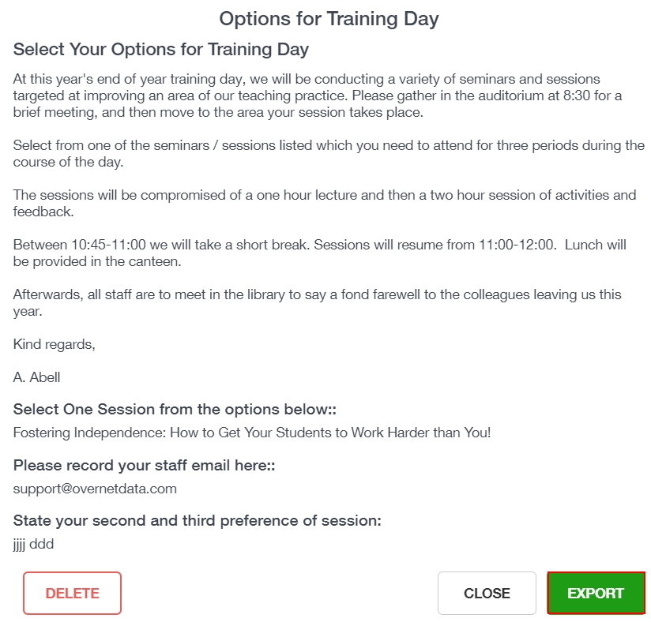

Catering
Here you can check the remaining balance of your school cashless catering account. Details of purchased items from the canteen are also broken down into a list including dates and times so you can see what you have purchased each day.
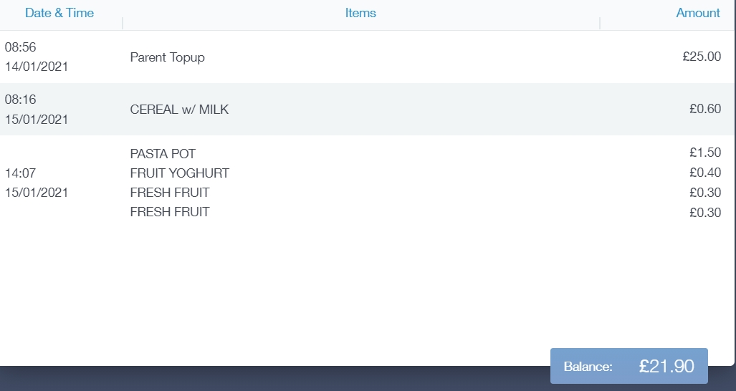

Links

This section contains links to resources for students to use.
There are also links specifically for employees.
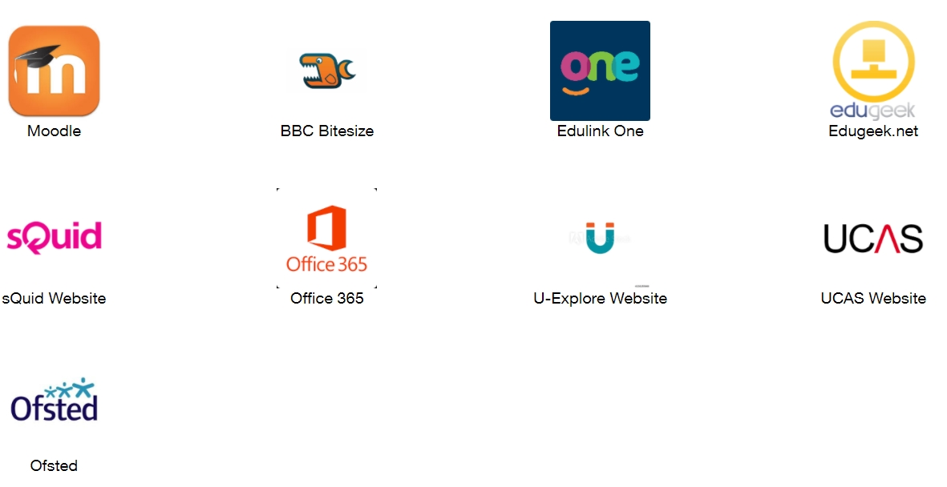

Account Info
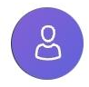
Here you can view the current details the school has on file for you.
In the case of staff members, the address, postcode, gender, phone number and email are kept on file.
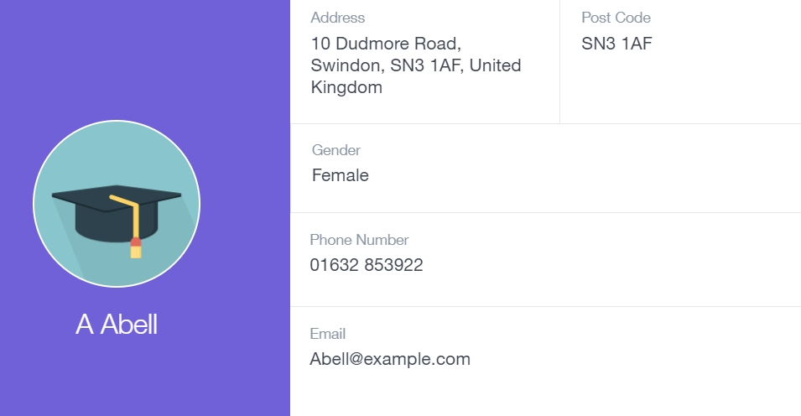

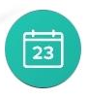
Calendar
If your school has enabled the calendar in Edulink One, you can see the events that are going on at the school, such as term dates, staff training days, school events and more.
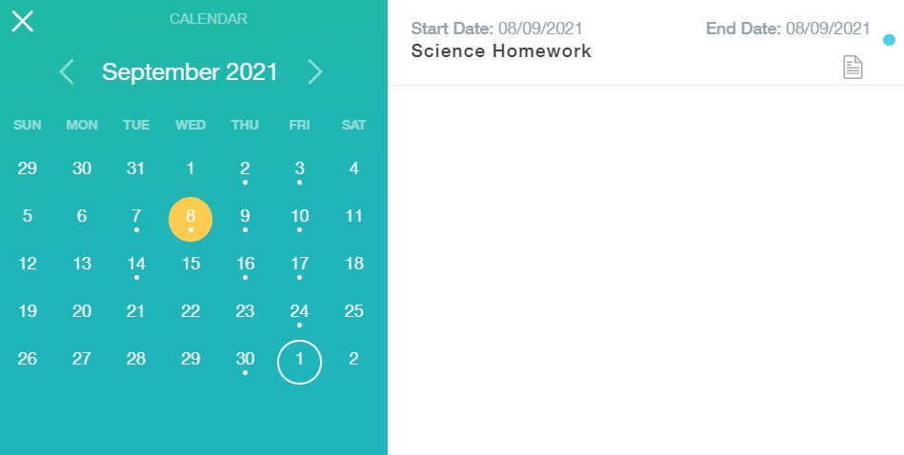
Homework can also be displayed for parents, linking the calendar up with the homework area in Edulink One.

Manage Your Calendar

To manage your calendar, you need to go to the cog in the top left corner of the screen and click on it. Then, you need to click on Manage iCal.
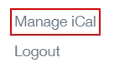
In Exports, you can export your timetable and school calendar. To do this, press on the ‘toggle’ to turn on the export and then copy the link.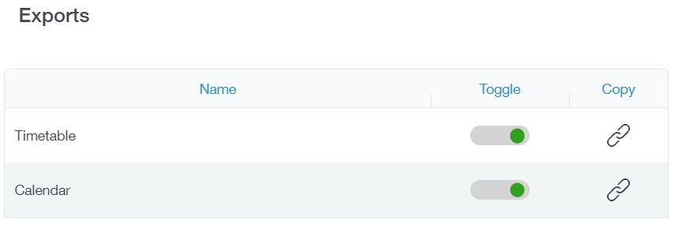
Afterwards, go to Imports and press the +Add button.
Import the timetable and school calendar into your calendar, such as Microsoft 365, by pasting the link in the URL field. Give the calendar a name and click the Add button. 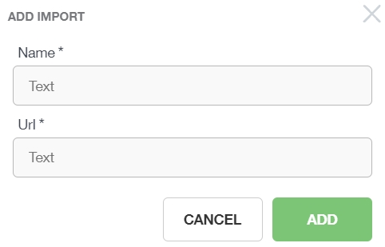

Noticeboard
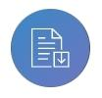
The noticeboard is where parents and staff can see news and upcoming announcements from the school. Schools can upload newsletters, documents and other useful information.

There is also a snippet section at the top that displays important announcements, like the date of the school panto. 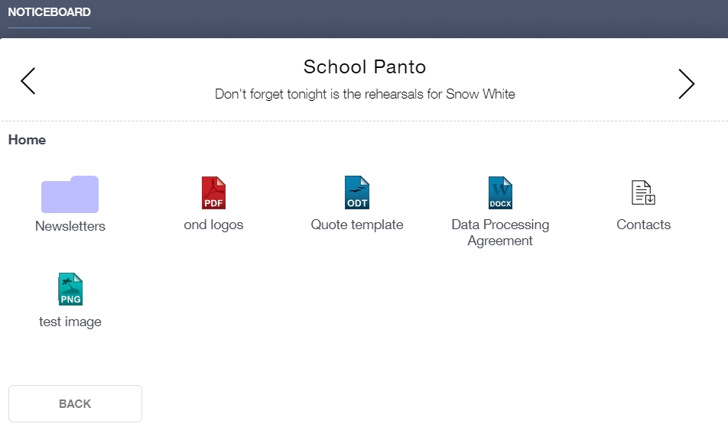

Update Information
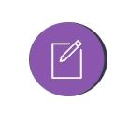
This section shows you the contact information that the school has on record for you.
Here you can review the contact information the school holds for you, but you will also be able to update this with any changes that may occur to this information. When updated information is submitted through Edulink One, this will be picked up by the designated personnel in school in charge of updating records. It will be checked by them and approved.
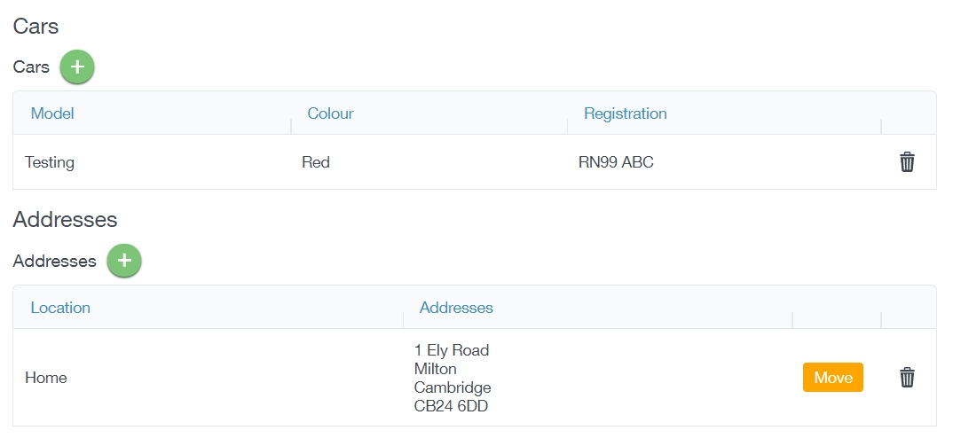

Callout
Click the Callout Icon to request urgent assistance.
Then, click on the New button to generate a callout.
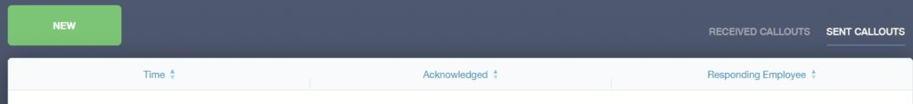

A new callout will be generated with the details of the class and the teacher requesting assistance. Finally, click New Callout.
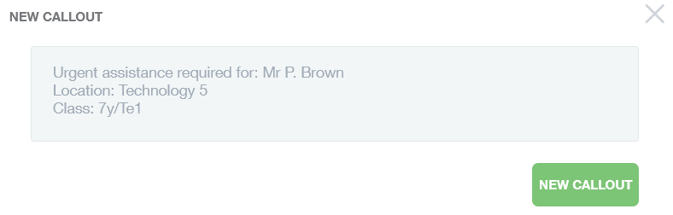
The Time of callout, Acknowledgement of the callout and the Responding Employee is visible in the table below the New button, once a new callout has been generated.
New Callout
The responding employee receives an alert and will respond accordingly.

Child Protection
All employees can refer child protection incidents to the Child Protection Team
To make a child protection referral, employees must click on the Child Protection icon.
To create a new referral, click the New Referral button.
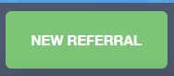
Select the learner you would like to refer to the Child Protection Team. You can select a learner by typing their name in the Learner Name search, or you can use the filters to narrow down the pupil you are referring to.
Click on the picture of the learner and it will open the Add Referral window.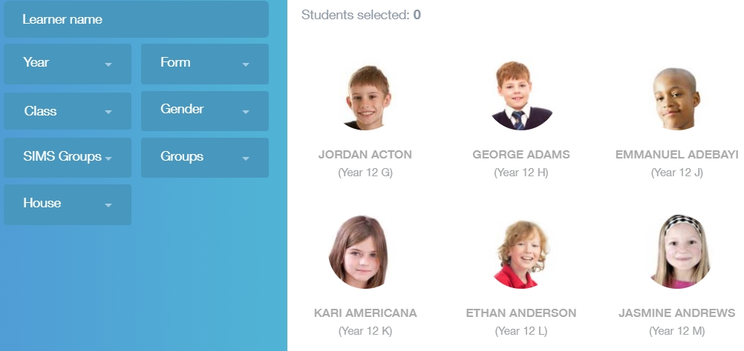
The learner's name appears in the Referral For field.
Staff name: The staff name is automatically populated with the name of the teacher/staff member writing the referral. However, you can switch to a different employee if you are helping to write a referral on their behalf.
Date/Time: Select the date and time of the referral from the calendar.
Referral to: Select whom the referral is being sent to; the authorised manager will be here.
Details: Provide details of the Child Protection concern, e.g. 'Overheard George saying to a classmate that he was not living at home'.
Disclosure: Any disclosure made to you by a learner, e.g. 'George then told me that his dad kicked him out of the house this weekend. He said he was trying to find friends who would let him stay with them'.
When did it happen: When exactly the incident occurred.
Where did it happen: The location of the child protection incident.
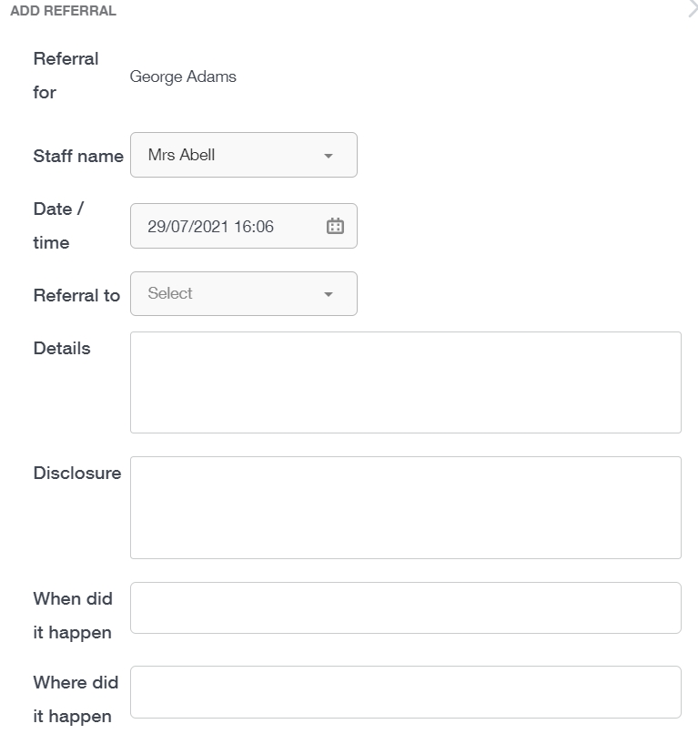
Action Taken: Describe the action that you have taken, e.g. 'Referral made to the Child Protection Team'.
Press the Save button to send your referral.
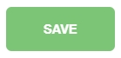
New referrals should appear in the My Referrals table. When the referral has been acknowledged by the Child Protection Manager and Team, a green check will appear to show that the referral is being managed.

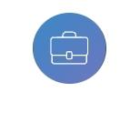
Homework

To view and add homework in Edulink One you need to click on your Homework icon to get started.
The Homework window opens to a table with tabs outlining Current (homework), Past (homework) and (homework) Report.

The Current tab displays the homework that is set in the present. The columns state the Due Date, Name of homework, Subject and Class, Set date, Learners button and also provides facilities to Edit, Remove or Clone homework.
To view a piece of homework, click anywhere on the first four columns to view the task set.
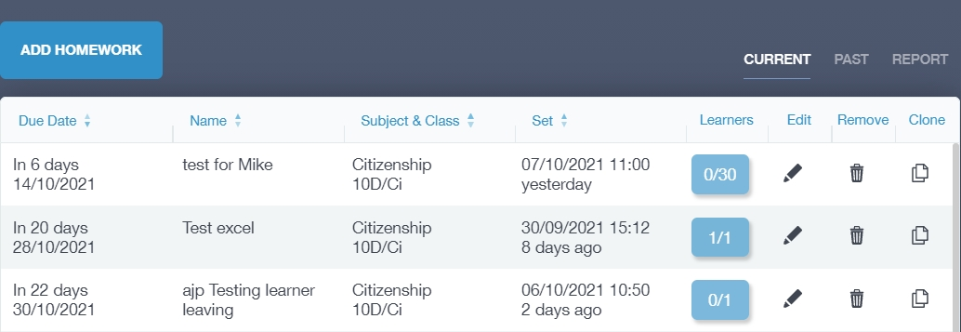
Another window opens, providing details of the homework set, including the teacher, submission type (if online or not), a description of the task, grade and feedback for the task.
To close the window, click the X in the top right corner.
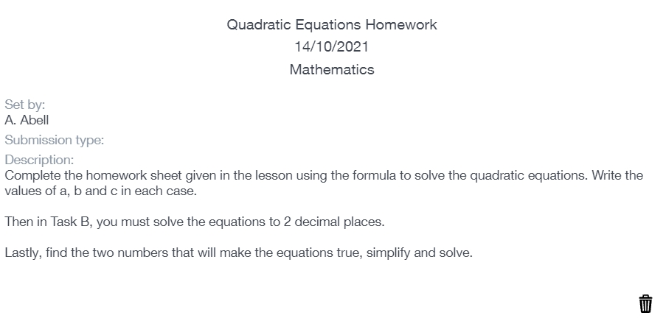
The learners column and button within the Current homework table, allows you to view whether the learners have completed the homework or not. Click on the learner button to view the learners.
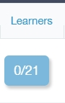

The table in the window contains the learners in the class and whether or not they have completed the homework (green check for yes and red X for no). There is also a column where the teacher can select whether they received the homework and if there is an issue, such as an incomplete piece of work.
If you click on the issue icon (exclamation point), a green 'Success' message appears (if your Edulink Admin has enabled this function). 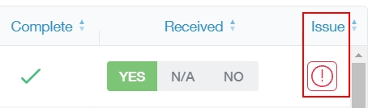
When the teacher has finished recording the homework, they should press OK to return to the Homework page.
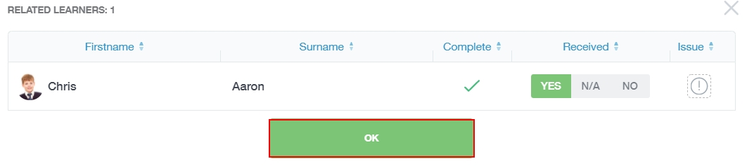
You can also edit a piece of homework by clicking the pen icon, remove homework by clicking the bin icon and can clone homework by clicking on the clone icon.
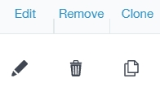

Cloning Homework
Cloning is an extremely useful tool if you would like to set similar homework if you teach classes in the same subject and Year Group, or if you would like to reuse a past assignment (available in Past tab).
You should press the Clone icon to begin.
A new window opens where you can edit the cloned work, modifying details for the new group.
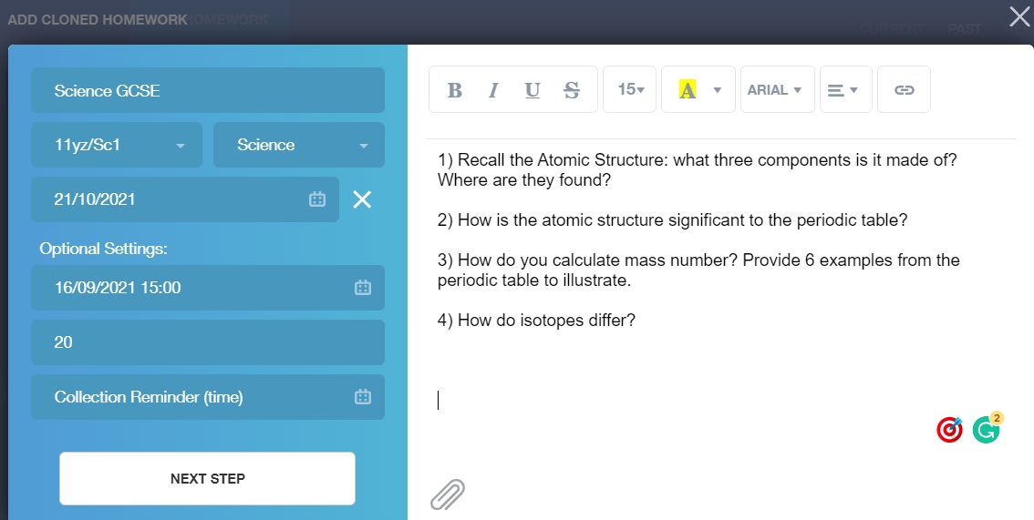
If you select the class here, you will still need to select the class and learners on the next screen.
Once the modifications are ready, teachers must press Next Step to open a new window where you can select the learners you are assigning the homework to. You can filter by Name, Year, Class, Gender, SIMS Groups, Groups, House
If you are planning to select all the learners in your class, tick the Select All box above the learner images or click the images of those learners you are assigning the homework to, for example, extension tasks, and tick the Selected box in the left pane. The images of the learners appear green with a checkmark if selected.
Press the Add Homework button when complete.
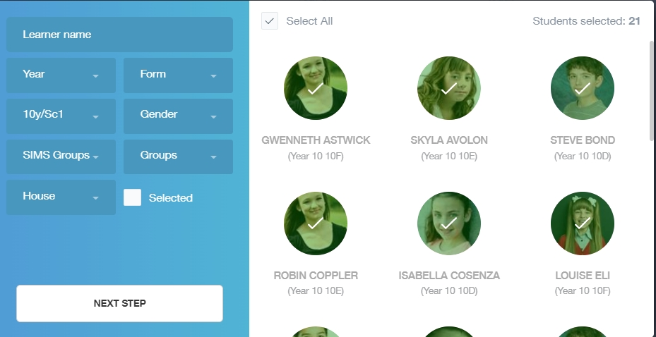

Past Homework
When a homework task passes its due date, the homework moves into the Past tab in the Homework screen. Past homework works the same as Current homework.
Identically, the past table's columns have the due date, name, subject and class and set date; it also has the learners window and the edit, remove and clone functionality.
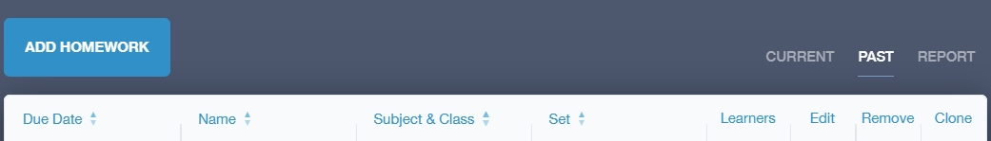

Report Tab
The report tab generates a report of homework completion for every class you teach and for each learner in the class, e.g. Simon from 11y/Sc1 has completed his homework 100% of the time this year, whereas Agata from the same class has only completed her work 68% of the time.
You must click on the class to view a report.
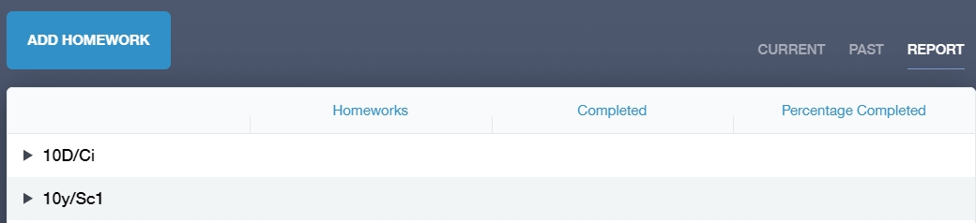

The report gives a breakdown of the homework assigned, the homework completed and the percentage completed by each learner.
﻿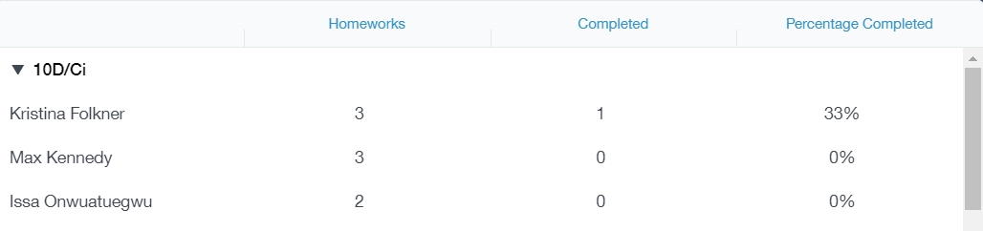

Add Homework
To add homework to Edulink One, you must click the Add Homework button. You can also add homework in the Register.
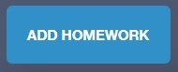
If you are using Google Classroom and are importing your homework from there, it is important to be aware that the homework will be visible, but you can't manage your work etc. in Edulink One.
Select the learners that you are adding homework for. You can filter the learners using their Name, Year, Form, Class, Gender, SIMS Groups, Groups and House. Tick the Select All box to choose all learners from your class or click on the images of the pupils you would like to assign homework and tick the Selected box in the left pane.
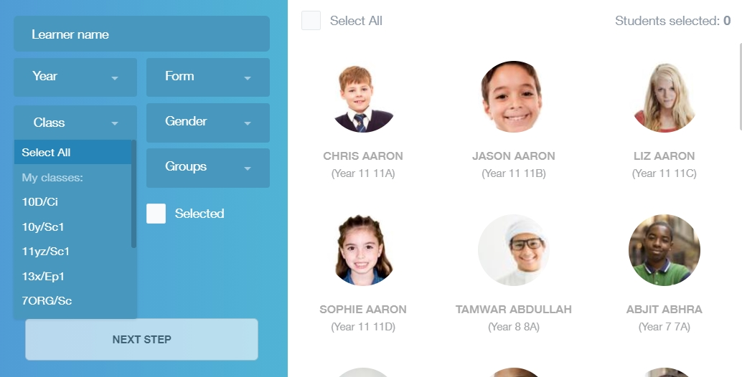
Click the Next Step button to proceed to Add Homework.

In the Add Homework window, teachers should type a description of the task and include any links or attachments relevant to the homework. These fields are compulsory.
Homework title: Provide the homework with a title.
Class: Select the class the homework is for. You must select the learners this is for in the previous window and you need to select the class here again. This is to ensure you can set homework for a whole class or a small group of learners.
Subject: Choose the subject the homework is for.
Due Date: Select the due date of the homework.
Also, there are optional settings below the compulsory fields above.
Available On date/ time: The date the homework is available from.
Expected Duration (mins): The length of time it takes to complete the homework.
Collection Reminder (time): A reminder for the teacher to collect in the homework. The reminder will be issued at the time set and will appear in your messages. 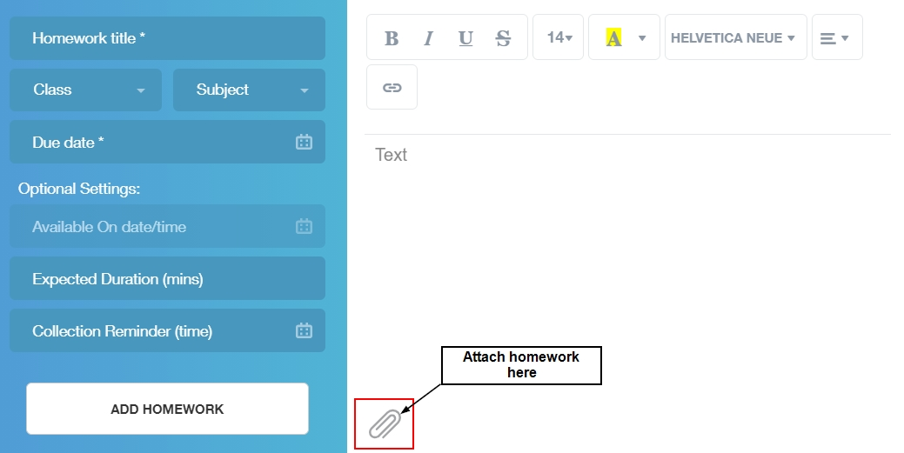
Once the description of the homework is complete, and the attachments or links added, press the Add Homework button.
The homework will appear in your Current tab.

*Administrators can switch teachers to assign work on behalf of teachers who might not be in school. They also have the ability to clone another teachers’ homework.

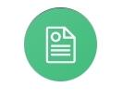
Profiles
If your school is using the Profiles reporting module in SIMS, log in to Edulink One to and click on your Profiles icon.
In the profiles window is a list of all of your individual profiles. There is also an option to change teacher, if you need to complete reports for another teacher.
Click on the profile to access your classes.
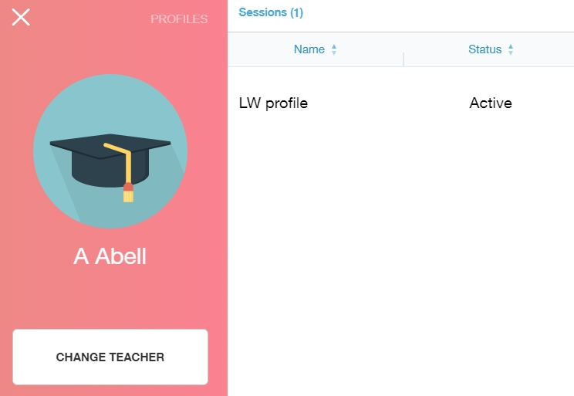
Then, click on the class you are writing profiles for to access the learners list.
Next, select a learner that you need to write a report for.
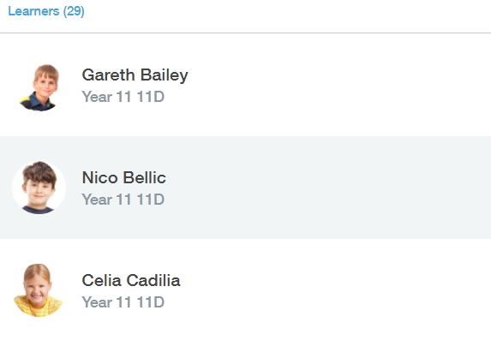
In the Profiles Session Entry window, you can either write a report using the text box provided or use a comment bank to help fill in your report.
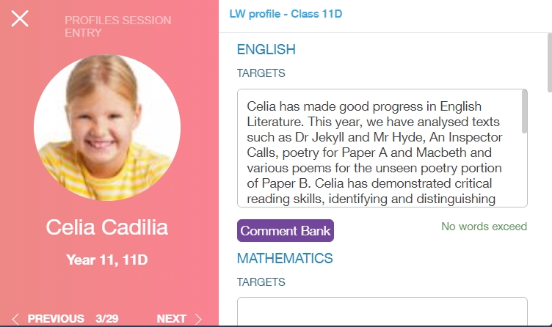
Comment banks are written in SIMS and Edulink One pulls the information through for use in Profiles. Click the comments that are applicable to the learner and press Confirm to add the comment(s).
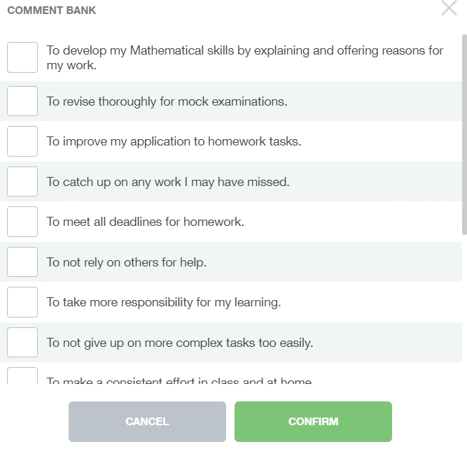
To the left, you can see the learner and arrows at the bottom of the window to navigate through your list of learners. Click the arrows to move between learners.
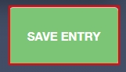
Save your profile entry when you have completed your reports.

Resource Booking
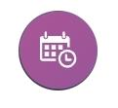
Click on Resource Booking to open the resource booking window. At the top of the window are two tabs, one for bookings and one for changes. Teachers can book out rooms and resources in the Bookings tab, which opens automatically, and they can view room/ resources changes and closures in the Changes tab.
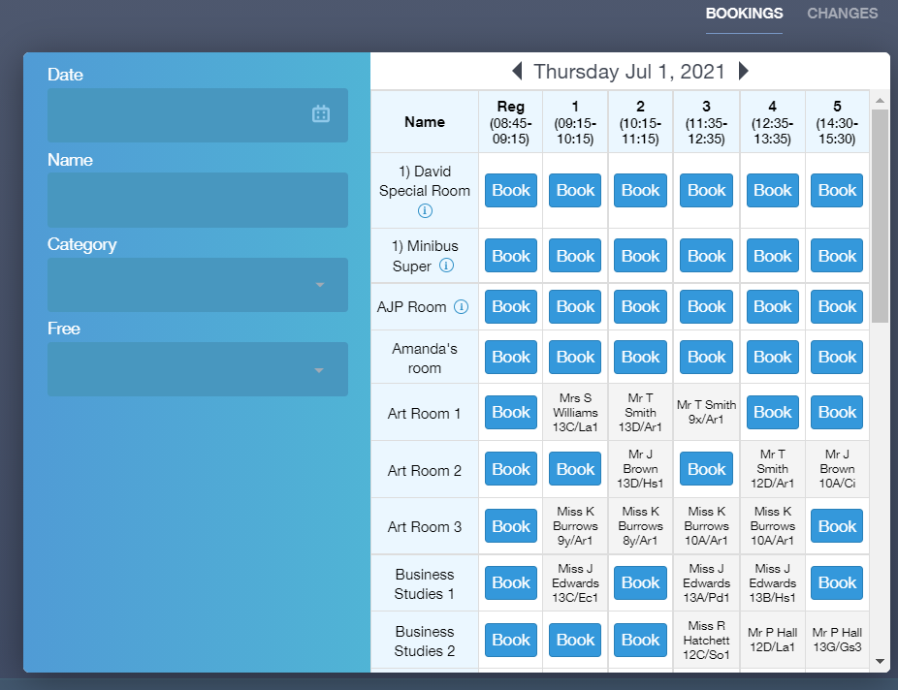
In the left pane, select the booking date and time using Date; you can also use the arrows at the top of the booking table to change the date.
Name: Type in the name of the room, e.g. IT to view IT suites.
Category: You can filter by resource category, which might be a room or resources allocated to a room.
Free: You can filter by period to see whether a room or resource is free.
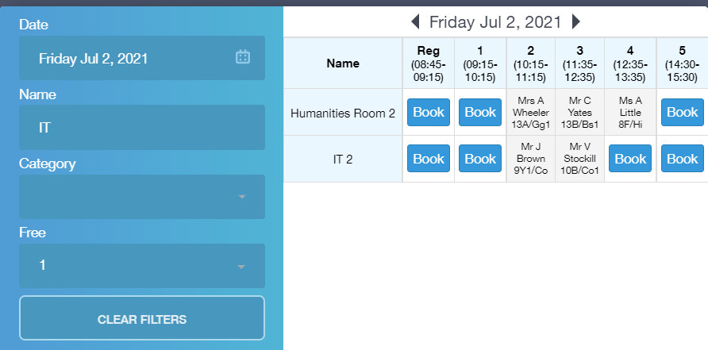
Resource Filters
To book a room, select the blue Book button (this indicates that the rooms are available to book). Timetabled rooms appear in grey, as well as rooms that have been booked. Additionally, booked rooms have an 'i' in a blue circle, which provides further information regarding the room booking.
A window requesting additional information appears and you must select the Book until (consecutive) date, or if you would like to book the room for a certain period weekly, you can select the number of weeks you would like to repeat a booking.
If you work in schools on two-week timetable, you must consider the Week A/ Week B rota when booking on repeat. If you would like to book the same time every week, e.g. Registration, you must book the current week (e.g. Week A) and the number of Week As they would like the booking to repeat (weeks 1, 3, 5, etc...). You must then go back in to book the resource or room for Week B and state the number of weeks you would like the booking to repeat on Week B (weeks 2, 4, 6 etc...). Once the bookings for both weeks A and weeks B have been completed, you will have consecutive bookings for weeks 1, 2, 3, 4 and so forth.
Information: The information box should be filled out with details regarding the resource booking. This is a compulsory field and must be completed to book the room or resource.
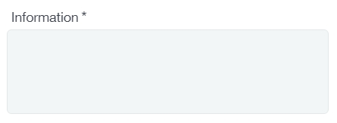
Once the booking information is complete, press the Book button to save the booking. A green 'Period was booked' message appears if the booking is successful. However, a red error message appears to indicate issues with the booking.

Moving a Booking or Lesson
You can move their lessons to another room by selecting the purple Move button.
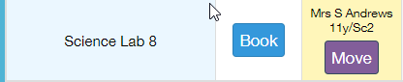
Next, an Edit Event window appears where you can select the room you would like to move to. After selecting a free room, press the Save button.
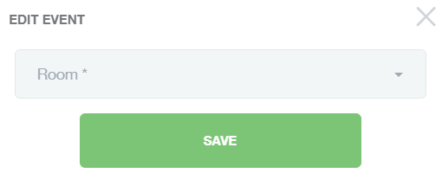
Your lesson will automatically move to the new room.

Delete a Booking
If you no longer need a room you have booked, you can delete the room using the Delete button.
Press the delete button to automatically cancel the room.
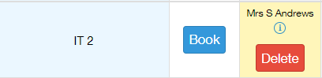

If successful, a green message appears stating ' Period was successfully unbooked' to indicate the room is cancelled.
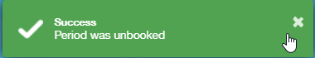

Changes Tab
The changes tab at the top of the booking window lets you know which changes have been made to rooms or resources. You can also view room closures in this area.
Any room changes are detailed in the table under Room Changes. The period, teaching group, teacher, from and to rooms appear in the table as well as the method of change.
Room closures appear above room changes. The reason for the closure and the closure dates will appear in the room closures table as well.
You can print the room changes and closures at the bottom of the table. To print, select the Print button.
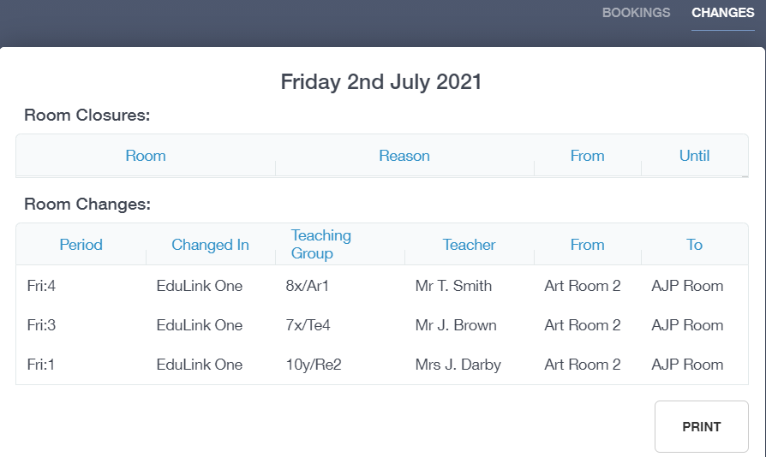
A PDF generates when the print button is pressed. You can print the PDF in the application.
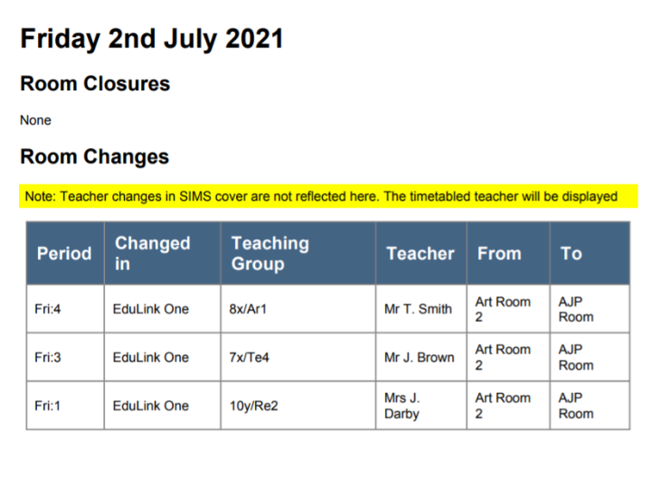

Parents’ Evening
Select the Parents' Evening button to view and book appointments.
You can view Active and Archived events in the Events Table, which provides a list of upcoming parent events. Any old events appear in the archived area.
You need to select the event they want to view by clicking on it.
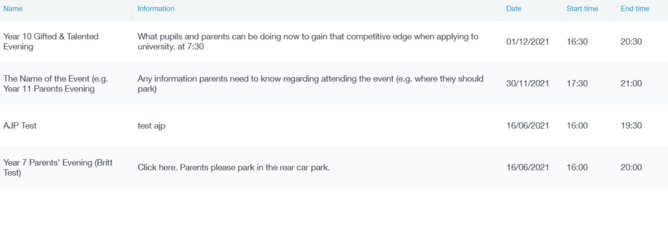
You can view the status of your bookings in the Booking Table window— they will appear as booked or blocked in red.
Slots that appear in grey with N/A as the learner/parent are available time slots.
Slots that appear in white with the learner/ parents details are booked time slots.
Notes: The notes that appear in this area are specific subjects the parent may wish to discuss.
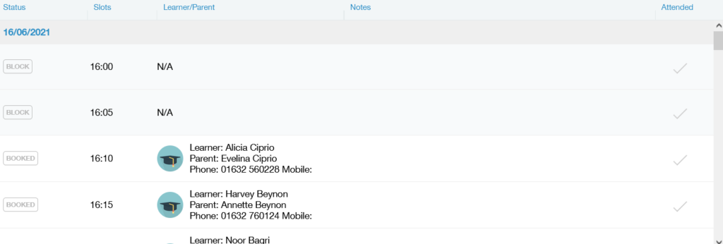

Blocking Time Slots
If the Edulink One Administrator has given you the option, you can block time slots to allow time off from appointments.
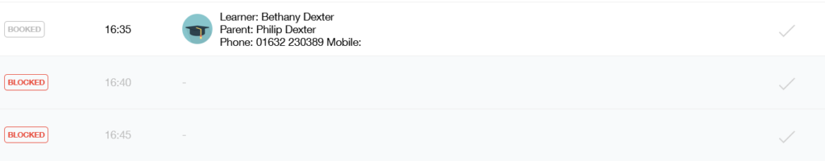
You should select the Block button to the far left to block slots.
Cancel Booking: You can cancel a learner/ parent's booking by selecting the bin icon. This will delete the appointment.
Attended: You need to record if a parent has attended Parents' Evening by clicking on the checkmark. This will turn green.
Note: This only applies to in-person Parents' Evenings. Parents' Evenings that take place via Video Conference are automatically recorded for attendance.
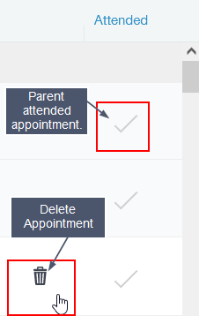

Booking Appointments
You can book appointments on behalf of a learner or their parents. To do this, select the Book button above the Booking Table window.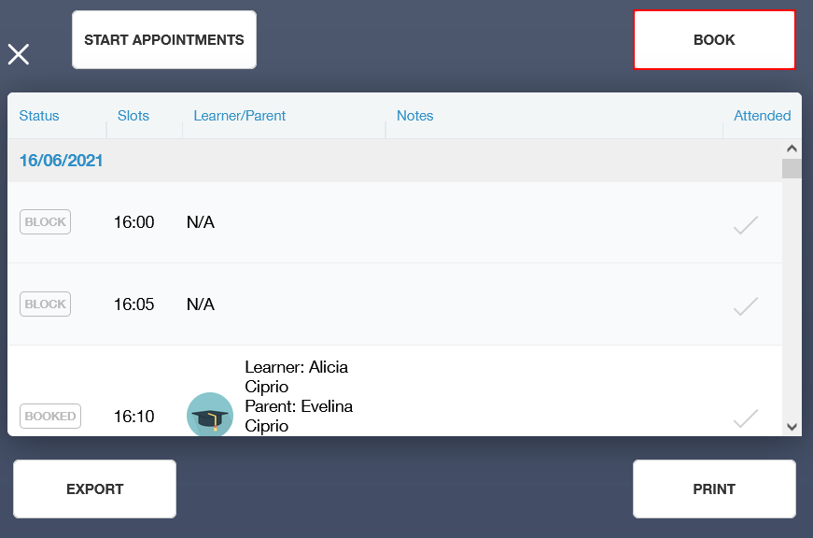
Select the learner and parent that wish to book.
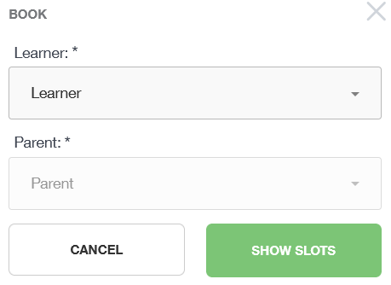
Next, click on Show Slots to view all available time slots. You must select an available slot that appears in white (all booked slots are in red).
Edulink One will return you to the booking table where you can view the booking they have made.
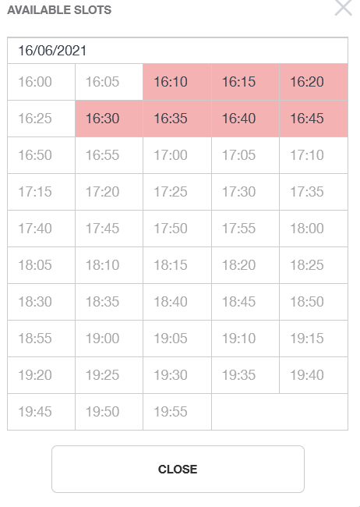

Exporting/ Printing
Export or print your bookings by selecting the Export button or the Print button.
Print View:
A pdf file can be saved or opened in a browser to print.
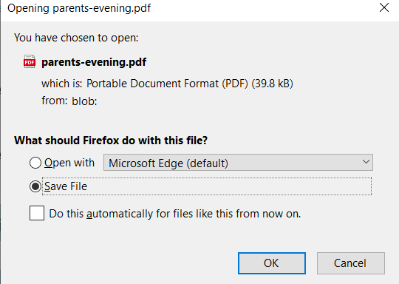
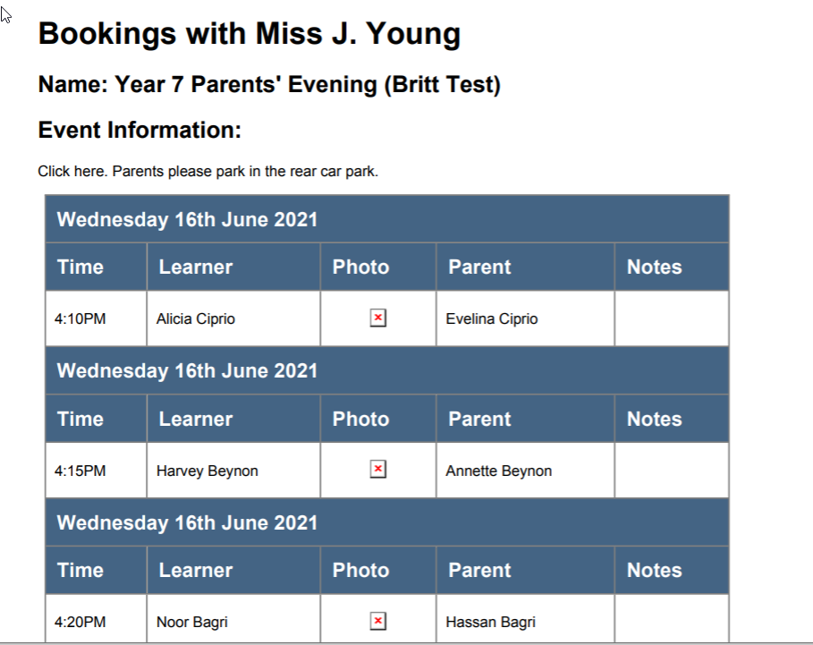
Print will only print your current bookings.
Export View:
Export bookings as a .csv file by clicking Export.
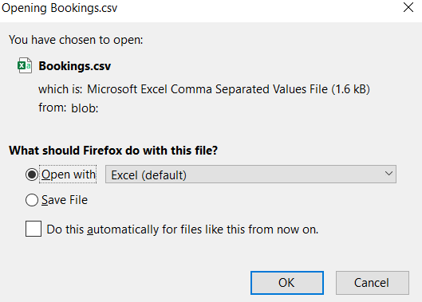
You can view, save, modify or print their bookings as an Excel document.

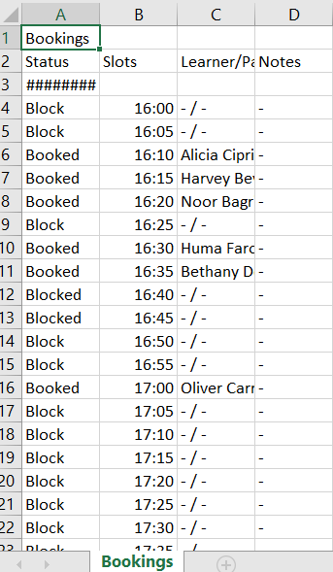

Video Conferencing
Video conferencing is an option that schools might use if face to face appointments are not an option. For this to work, the school's Edulink One administrators must enable this function.
On the day of the parent evening, you must log in to Edulink One and click on Parents’ Evening and Start Appointments.
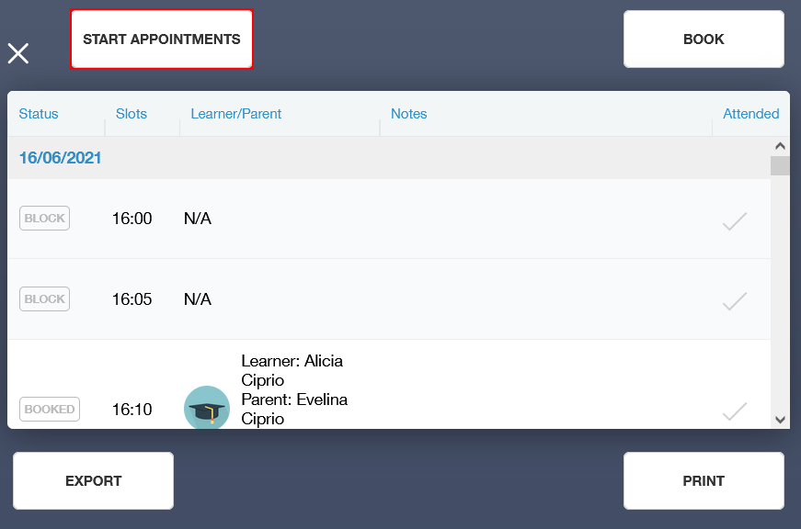
A video conferencing window will appear with the name and start time of the event. You must start the appointments by opening Start Appointments before the first booking on the day of the Parents' Evening.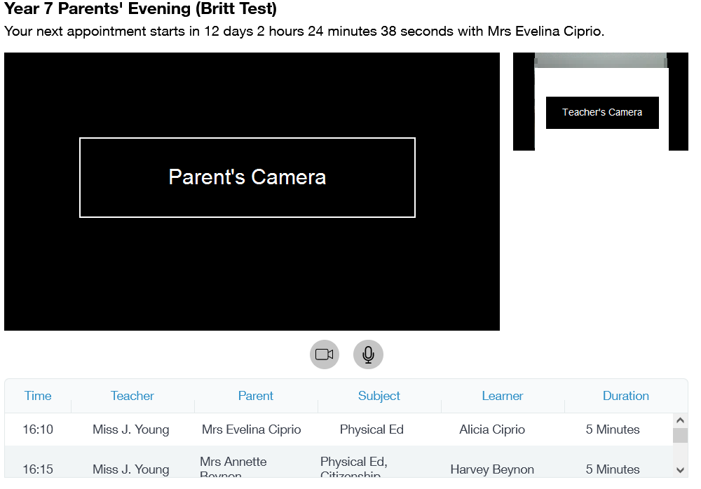
The next appointment is shown at the top and the list of appointments is shown at the bottom.
Please note that you will be cut off automatically at the end of the appointment time. This will be highlighted in the final 30 seconds by a red border.

Analytics

To view analytics reports, you need to log in to Edulink One and click on the Analytics icon.
Within the Analytics function, you can choose from three different types of Reports to gather data, depending on what administrators have enabled. You can also set the From date using the calendar and the To date using the calendar.
You can scroll to view the data from various year groups.

Homework Overview
The analytics for homework are broken down by Year Group and subject. Each Year has a specific graph with subjects along the X-axis. The homework count appears along the Y-axis, as in the table below.
It is a bar chart, and so the subjects that assign the most homework will appear as having a larger bar than those that assign less homework.
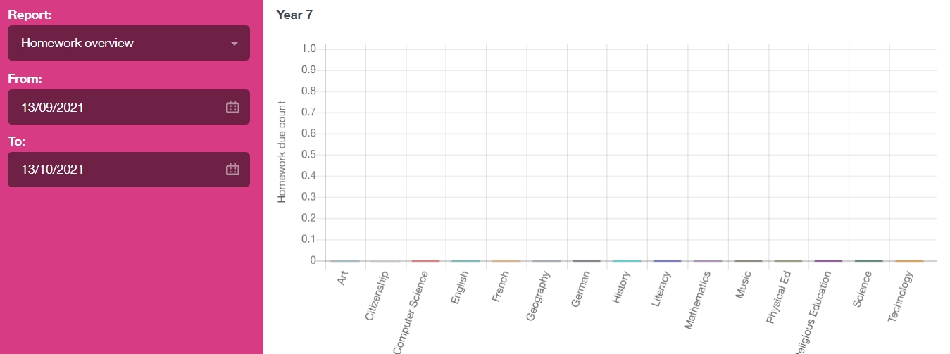
If you click on a subject bar, you can see a breakdown of the homework by teacher in each subject. Teachers that have assigned the most work appear with a longer bar.

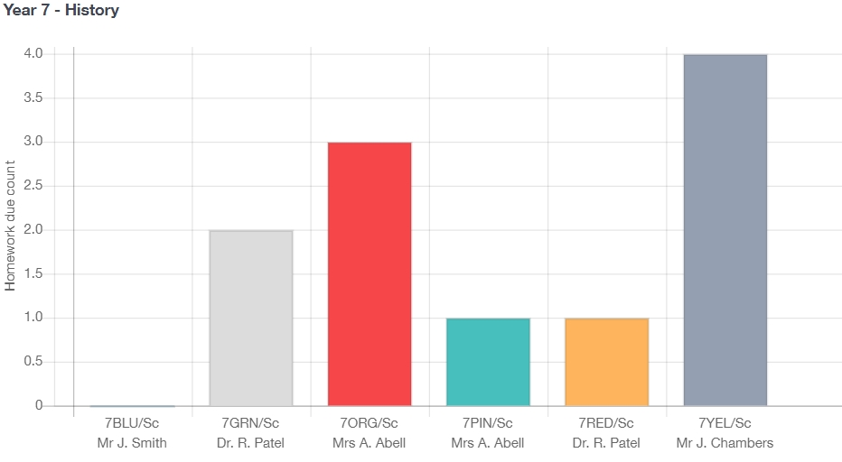

For more on our analytics features, consult our Knowledge Hub at https://support.overnetdata.com/.

